

Insight bulletin

February 2025

A large speech mark, outlined in pink.

“There have been lots of changes in how to access the GP but I feel that the new process has never been explained to patients.”



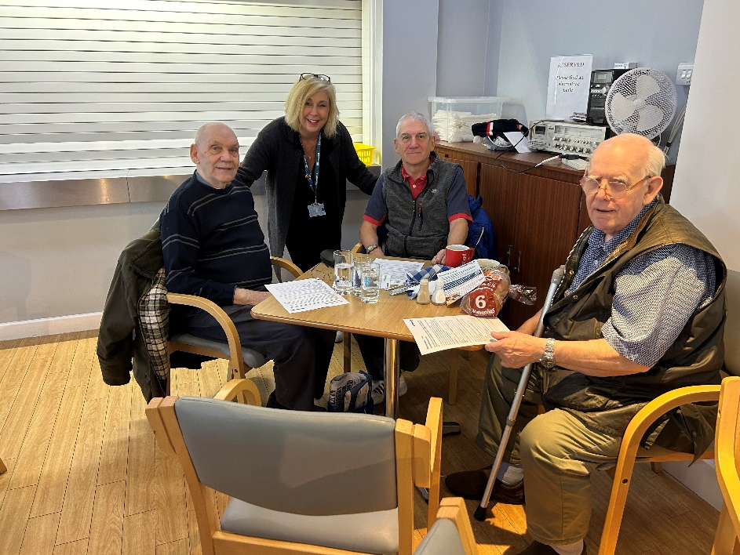

**If you would like a paper copy of this document or require it in an alternative format, please get in touch with** **us.**

# This bulletin: at a glance

## Hot topics

In this bulletin we are focussing on 3 key areas:

* Thanks and praise
* GP practice: personal service seen to be lacking
* Hospitals: waiting times and waiting lists continue to impact patients

As 2024 drew to a close we asked for your honest opinions on our insight bulletin, thank you to all those who responded. In this issue we’ll share what you said! You can also find out about 3 new surveys we have running to support our research projects.

## Who have we been hearing from?

Since our last bulletin we’ve heard from **230\*** people across Surrey, via our Helpdesk or during engagement events in the community.

* **33%** of the feedback relates to GP practices
* **36%** of the feedback relates to hospitals
* The majority of the remaining feedback relates to pharmacy, social care and mental health services
* Of those willing to share, **56%** were aged over 50
* Of those willing to share, **32%** had a long term condition.

* Our December insight bulletin was a ‘year in review’ and didn’t include recent insights; the figures quoted in this bulletin therefore include those we heard from in December 2024 as well as January 2025.

# Thanks and praise

**The NHS has** [**announced**](https://www.england.nhs.uk/2024/11/1400-libraries-now-offering-people-support-to-use-nhs-app/) **that it will be offering the public support in accessing online health services, including the NHS App, at 1,400 libraries across England. We’ve heard positive stories this month from those accessing their GP practices digitally.**

For those who understand and are able to use the digital system, they are impressed by its efficiency.

“Our practice has an excellent email system. You state your problem and who you think might best treat you. They aim to answer within 3 hours.”

225199, Surrey resident

“My GP practice is good and when I last made an appointment I did it online but the reception team said if I wanted to be seen earlier I could just call at 8am, but it wasn't an emergency and I got a scan. It was all good and quite quick.”

226150, Runnymede resident

This resident, living with cancer, praised both the efficiency and the consistency of care offered by their practice over a long period of time.

“I was diagnosed with cancer in 2016 and have had 8 procedures since then as it keeps coming back, from my lungs to my liver. At the moment, we are very lucky. I always get to talk to a doctor and I always get through quickly. In 10 years I couldn't have been treated any better. 10/10 for my practice. I don't think I get any special treatment but I get sent appointments for my blood tests and for my annual flu vaccination.”

225807, Epsom and Ewell resident

# GP practice – personal service seen to be lacking

The lack of a named GP continues to frustrate and confuse some people; this is often the first issue people mention when we talk to them about primary care when we’re out and about in the community.

“The emphasis is on the patient to say what is wrong with them and we might not know! Every time I am seen by different doctors. Where I was before [GP practice in London] I had continuity. Now I don't always know who I am speaking to.”

226127, Runnymede resident

In some instances, people’s fear is related to what might happen, suggesting a possible need for better communication, education and expectation management.

“My son, now deceased, had Muscular Dystrophy and so we had a really close relationship with our named GP. It has changed now and you don’t get to see the same GP… I never get to see the same GP now so I wonder whether they will provide the same service or will it get worse. That’s my only concern.”

225587, Epsom and Ewell resident

“There have been lots of changes in how to access the GP but I feel that the new process has never been explained to patients.”

226102, Chertsey resident

The lack of consistency is seen as a barrier for people having contact with their GP, and it becomes associated with a lack of personal service.

“Now this [GP] is leaving too. I don't feel like I can speak to anyone, there is no consistency.”

226518, Epsom and Ewell resident

# Hospitals: waiting times and waiting lists continue to impact patients

**In January Healthwatch England and a coalition of trade unions, professional bodies, charities and patient groups,** [**called**](https://www.healthwatch.co.uk/response/2025-01-13/joint-letter-about-dangers-corridor-care) **for an end to treating patients in corridors and other inappropriate spaces, declaring it “unsafe and undignified.”**

This month people in Surrey have shared their frustration at extended waiting times to be seen in Accident and Emergency, and the stress and upset which this can cause.

“I had to call an ambulance as I had vomited blood. The crew were very nice but said they couldn't take me to the hospital where I had been 3 weeks ago with the same problem as it was too far. I was seen [in a different hospital] and had blood taken when I had been there for 2 hours and was sitting on a hard seat until 11pm [having been there since 1pm]. My family wanted me to stay but I couldn't stay sitting in that chair all night. I would rate the care as 2/10.”

224478, Mole Valley resident

“I had to go to A&E and sat in a chair for 15 hours in the corridor before being moved to the critical care area. After being there all that time they discharged me at lunchtime [been in since previous afternoon] with no discharge summary.”

226165, Runnymede resident

People have also told us about long waiting lists to be seen in secondary care, following referral from primary care.

“The long wait lists are affecting [my partner’s] mental health. We have complained to our MP but not had a satisfactory outcome. It’s affecting his sleep and work. We don't feel we can get on with our lives. He won't look into mental health support though. He just relies on me.”

224458, Surrey resident

# Current projects: 2 ways to have your say

At Healthwatch Surrey we have a number of key strategic priorities which guide our work. We’ve recently launched 2 new research projects as part of our primary care, mental health and social care priorities and are currently seeking insights.

The more people we hear from the more valuable these insights are, and the more we might be able to affect system change. So please do complete the surveys which are relevant to you and/or pass to your families, friends and contacts.

Previous research reports can be found on our [website](https://www.healthwatchsurrey.co.uk/reports). If you’d like to find out more about shaping future research for Healthwatch Surrey, please [get in touch](https://www.healthwatchsurrey.co.uk/reports) with us today.

## Primary care

Image of a flyer for our survey on domestic abuse:


Does your GP practice understand? Can you help with our research? 
We want to better understand access to and experience of GP practices for people who have experienced or are experiencing domestic abuse. 
Please share your experience through our online survey (with the link and a QR code). Closing date for survey: 31 March 2025.
The image also contains icons of an online survey and speech marks. At the bottom of the image is the Healthwatch Surrey logo.

We are undertaking research to better understand access to and experience of GP practices for people who have experienced or are experiencing domestic abuse. We would like to hear from people who have accessed support through their GP practice, or who have found there are barriers to sharing their experiences with GP practices and therefore to getting appropriate support. One of the ways we are gathering this feedback is [via an online survey](https://www.smartsurvey.co.uk/s/3SO2LM/).

We have established links with East Surrey Domestic Abuse Service (ESDAS), South West Surrey Domestic Abuse Service (SWSDAS) and, through them, the DA SEEN (Surrey Expert by Experience Network).

We are also looking to work with GP practices across Surrey so that we can understand current practice, and to access and capture patient voices as appropriate. This will enable us to work collaboratively with our findings.

If you would like to know more about this project, or support someone who would like further information, please contact Lou Danaher at [louise.danaher@healthwatchsurrey.co.uk](mailto:louise.danaher@healthwatchsurrey.co.uk).

## Mental Health

Image of a flyer for our survey on emotional wellbeing for people with learning disabilities:


• Do you support someone who has a learning disability
• Have they used emotional or mental health services
• Would they have used them, but haven’t been able to?
Can you help with our research? We want to help make wellbeing and mental health services better for people who have learning disabilities.
Please share your experience through our online survey (with the link and a QR code). Closing date for survey: 16 March 2025
The image also contains a photo of 2 people smiling, and an online survey icon. At the bottom of the image is the Healthwatch Surrey logo.


We are exploring access to and experiences of emotional and mental health support for people who have a learning disability. We are talking to people with a learning disability directly but have also launched an [online survey to hear the experiences of those who provide support or care](https://www.smartsurvey.co.uk/s/LDandMentalHealthHWS/).

# Our insight bulletin: your views matter

Our monthly insight bulletin is intended to provide an overview of what residents have talked to us most about over the last month. But is it as useful as it can be? In November we asked you to tell us what you think via a short online survey.

Thank you to those of you who got back to us!

## Results snapshot

### How useful is the insight bulletin?

Over three quarters (**77%**) said that they read the Insight bulletin either ‘always’ or ‘most of the time’.

Over three quarters (**77%**) also said that they find the bulletins either ‘very’ or ‘quite’ useful.

The majority (**69%**) read the bulletins to support professional or paid work, with a large number also reading for ‘general interest’.

A graph showing figures for why people read out Insight Bulletin.

General interest - 46.15%
Professional / paid work - 69.23%
Voluntray work - 7.69%
I don't know - 0%
Other - 7.69%

### What works?

Insights from local people were the most interesting part of the insight bulletin for **69%**, with **54%** and **53%** respectively also saying they find the information on who we've been hearing from and Information on Healthwatch Surrey's latest activity / work the most interesting.

A graph showing figures for the question 'Which parts of the Insight bulletin do you find the most interesting and / or useful?'

Information on who we've been hearing from (numbers and demographic information) - 53.85%

Insights from local people  - 69.23%

Information on national or local health news  - 38.46%


Information on Healthwatch Surrey's latest activity / work - 53.85%

All of the above- 61.54%

None of the above - 0.00%

Other (please specify): - 0.00%



We were pleased that **84%** found the format very or quite easy to read and **62%** thought it was the right length (**31%** thought slightly too long).

### Food for thought?

We had some really constructive feedback, which we will look to act on as we develop future editions of the insight bulletin.

“Whilst it may often be professionals reading the bulletin it may be worth considering **adding some support information into the bulletin** when appropriate to direct people to support if they have been impacted by what they have read...”.

**If you’ve been affected by anything you’ve read in this report – please visit our website for** [further information and support](https://www.healthwatchsurrey.co.uk/information-and-advice/)**.**

“It would be good to hear more from the **social care** side.”

****Please note: Information on our social care outputs can be found in the**** [social care reports](https://www.healthwatchsurrey.co.uk/reports/social-care/) ****section of our website.****

“It would be helpful from my point of view to have the **Place information all together**.”

****Please note: you can find the latest Place reports in the**** [Place reports](https://www.healthwatchsurrey.co.uk/reports/place-reports/)<https://www.healthwatchsurrey.co.uk/reports> ****section of our website.****

# Sharing our insight and raising concerns

Whilst this bulletin accurately reflects what we hear from the individuals we speak to, we are aware that it may not be representative of everyone’s views of a particular service. Multiple references to a specific service may be due to where our community engagement has recently taken place.

If we hear a case of concern regarding patient safety, we immediately signpost the sharer to the appropriate body and escalate the case with the provider/commissioner. All appropriate information and signposting has already been given.

We share our wider themes with Trusts, Integrated Care Systems (ICSs), Surrey County Council, Public Health, Care Quality Commission (CQC), and in various boards and groups across Surrey.

If you would like more information or examples of what people have shared with us, please get in touch with us.

# Community engagement

Below are details of our engagement sessions for February and March, where we visit venues in local communities to listen to what people think about local health and care services, and to ask specific questions related to [our priorities](https://www.healthwatchsurrey.co.uk/about-us/our-priorities/). We also provide information and signposting regarding health and social care. Each month we focus on a different area of the county. In December we were in North West Surrey, followed by East Surrey in January. In February we’ll be focussing our engagement in Farnham. Throughout the year, we also attend events across Surrey to raise awareness of our work.

|  |  |  |  |  |
| --- | --- | --- | --- | --- |
| Date | Place | Time | Open  to | Surrey Area |
| 03/02/2025 | Farnham Hospital | 10am - 12 noon | Public | NE Hants & Farnham |
| 05/02/2025 | The Hop Blossom, 50 Long Garden Walk, Farnham | 2pm -4pm | Public | NE Hants & Farnham |
| 08/02/2025 | Guildford Lunar New Year market, Guildford Cathedral | 10am - 5pm | Public | Surrey Wide |
| 10/02/2025 | Embassy Room, The Vineyard Centre, Church House, Union Road, Farnham | 7.30pm – 9.30pm |  | NE Hants & Farnham |
| 11/02/2025 | Godalming College | 2.30pm -4pm | Public | Guildford & Waverley |
| 17/02/2025 | Community Fridge, St. Mary’s Church, Fetcham | 10 – 11.30am | Public | Surrey Downs |
| 08/03/2025 | Macular Society, Woking | 10.30am -12.30pm | Group | North West Surrey |
| 11/03/2025 | Guildford Baptist Church, Millmead, Guildford | TBC | Group | Guildford & Waverley |
| 19/03/2025 | Wednesday Cafe, St Martins, Old Dean Estate, Camberley | 10 – 11.30am | Public | Surrey Heath |
| 20/03/2025 | Tadworth Leisure Centre | 10am -4pm | Public | East Surrey |
| 25/03/2025 | Oasis Group- St Pauls | 10am -12noon | Public | Surrey Heath |

**Please note: these dates may be subject to change.**

To share an experience with us, or for information and signposting about health and social care, people can also contact our Helpdesk in the following ways:

Phone: 0303 303 0023

SMS (text only): 07592 787 533

Email: [enquiries@healthwatchsurrey.co.uk](mailto:enquiries@healthwatchsurrey.co.uk)

Share your feedback via our website: <https://www.healthwatchsurrey.co.uk/feedback-centre/>

# About Healthwatch Surrey

Healthwatch Surrey champions the voice of local people to shape, improve and get the best from NHS, health and social care services. As an independent statutory body, we have the power to make sure decision makers listen to the experiences of local people.

We passionately believe that listening and responding to local people's experiences is vital to create health and social care services that meet the needs of people in Surrey. We seek out people’s experiences of health and care services, particularly from people whose voices are seldom heard, who might be at risk of health inequalities and whose needs are not met by current services. We share our findings publicly and with service providers and commissioners to influence and challenge current provision and future plans.

We also provide reliable and trustworthy information and signposting about local health and social care services to help people get the support they need.

# Our distribution list

If you would like to be added to or removed from the distribution list for this insight bulletin, please contact our Communications Lead [vicky.rushworth@healthwatchsurrey.co.uk](mailto:vicky.rushworth@healthwatchsurrey.co.uk)



We are committed to the quality of our information.

Every three years we perform an audit so that we can be certain of this.



The Healthwatch Surrey service is run by Luminus Insight CIC, known as Luminus.

Registered office: GF21, Astolat, Coniers Way, Burpham, Surrey, GU4 7HL.