

Insight Bulletin

December 2024

The card is dark purple. At the top, snow is falling onto an open pale purple umbrella. In the middle section of the umbrella are the words ‘Season’s Greetings from Luminus’. Underneath the umbrella are our 5 different services:  Healthwatch Surrey, Independent Health Complaints Advocacy, Giving Carers a Voice and Giving Young Carers a Voice, Combating Drugs Partnership Public Involvement, Community Voice Projects. 
Underneath this are the words:
“In 2024 we have listened to, supported and involved 4791 Surrey residents including carers, young carers, people affected by substance use, people with disabilities and impairments, those living in care homes and people who are neurodivergent. Shining a light on what matters to people. We thank every one of these people and all organisations who have worked with us this year.”
At the bottom of the card is a covering of snow.

We wanted to take this opportunity to wish you all the best over this festive season.

Through all our Luminus contracts we are proud this year to have listened to, supported and involved nearly 5000 Surrey residents. All of our contracts work to ensure that their voices (particularly those who are seldom heard and who may be at risk of health inequalities) are heard by service providers and decision makers, so that everyone receives the support they need for their wellbeing.

**If you would like a paper copy of this document or require it in an alternative format, please get in touch with** **us.**

# 2024: the year in review

2025 promises to be a significant year for health and social care, with a new Government now firmly at the helm and an appetite for positive change following the publication of the [Darzi review](https://www.gov.uk/government/publications/independent-investigation-of-the-nhs-in-england) on the state of the NHS. But whilst we look forward to what 2025 will bring, we also wanted to take this opportunity to look back at 2024, and to celebrate the wonderful work that the staff within our health and social care services do for the people of Surrey, each and every day.

As Lord Darzi notes in his review:

“The British people rely on [the NHS] for the moments of greatest joy - when a new life comes into being - and those of deepest sorrow. We need it when we are suffering from mental distress or hurting from physical pain and for all the times when care and compassion matter most.”

Lord Darzi, Independent investigation of the NHS in England, September 2024

This year, an incredible **1003** people shared their experiences of health and social care with Healthwatch Surrey, through our Helpdesk and when we were out and about in the community. People do come to us with their grievances, concerns and complaints, but they also come to us when they want to acknowledge (and show gratitude) for the care and compassion that they have been shown. You can see more of these heartfelt thanks in the pages that follow.

We were also pleased this year to be commended in the National Healthwatch Impact Awards. This followed a local resident, Chantelle, sharing her experience with us of being unable to access cancer screening services. As a result we were able to ensure she could access appropriate screening, and this, in turn, also helped other people have better experiences going forward. [Our video](https://www.youtube.com/watch?v=y7jVu38Twno) tells Chantelle’s experience.

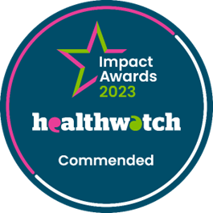

# January

January is a notoriously busy and difficult time for the health service, but residents praised the way in which they were treated with compassion and dignity in both primary and secondary care.

“I attended Accident and Emergency (A&E) following a GP appointment. I received a prompt response in A&E and my waiting time was 1 hour 15minutes. The longest wait was once I had gone through to the assessment area. I waited 4 hours to see a doctor and have a plan of action. I was continually updated about this though. I was treated with respect at all times and felt very reassured that I was in safe hands. During my stay I had extensive investigations and when admitted to the ward I generally had excellent care given. Staff spoke and treated me with both respect and dignity. In the past I have received negative responses due to mental health diagnosis but during this admission I felt that was respected and I was treated fairly, regardless of my diagnosis.”

207800, Guildford resident

“I have always had positive experiences with my GP practice. I find it very easy to book an appointment and always find the care received helpful and delivered in a compassionate and caring way. The GPs I have seen have always been professional and executed excellent professional medical advice and care. The GP and practice nurse go beyond what I expect and often ask about other health issues not related to what I’m presenting with.”

207801, Guildford resident

### How were we helping the community at the start of the year?

Between January and March 2024, we supported **130** people through our Helpdesk.

# February

People shared positive stories about maternity services and community pharmacy in February, the latter being particularly appreciated for their proactive approach.

“I had my baby 7 months ago. I gave birth at East Surrey hospital. I wasn’t kept in; it was quick and straightforward. I was really happy with the care. He was born on a really busy day but I was looked after. There isn’t anything I would improve, it was a really good experience.”

209668, Surrey Heath resident

“Very impressed that (the local pharmacist) rang me to check I was getting on ok with the inhaler I had been recently prescribed - he reminded me to take it with me at all times, especially due to a patch of cold weather we were due.”

209552, Surrey Heath resident

### What were we doing in February?

At the start of the year we helped in the development and organisation of an inaugural lived experience conference, celebrating the importance of co-production in developing mental health services. This provided a unique opportunity to connect with a diverse range of people with lived experience of mental services who are actively involved in various projects and programmes working with mental health providers.

# March

The speed and efficiency of referrals between primary and secondary can have a big impact on patients, at what can be a particularly stressful time.

“I was fast tracked on a 2 week [pathway] for blood in my urine with no other symptoms. I was referred by GP, had a phone call the same afternoon with an appointment 9 days later for a cystoscopy. Phone call three days after referral with an appointment for a CT scan with dye on day 13 after referral. Results were given to me over the phone by cystoscopy doctor 4 days later. I was very impressed.”

211784, Surrey resident

The ongoing care provided via condition-specific clinics was also praised in March.

“I attend 2 clinics, the diabetic clinic at my surgery and the eye clinic at Frimley Park. Both of them are excellent services.”

212052, Surrey Heath resident

### What impact did we have in March?

In March Healthwatch Surrey were invited to participate in a Care Quality Commission (CQC) workshop as part of the design for their new national strategy on dementia. Our volunteer, Robert Hill, represented the voices of Surrey residents joining a conversation, along with over 40 other Local Healthwatch, to share what we’ve each heard regarding dementia services. This helped determine how the CQC could support the future monitoring and assessment of dementia services and what could be learned from people’s experiences.

# April

People talked to us about the important role which clear communication played in their experience in April.

“I'm here today for an outpatient appointment with respiratory. I had a letter confirming my appointment which was very clear - it contained all the information I needed - it just asked me to call and confirm the appointment which I did.”

213341, Waverley resident

“I'm here for an appointment at the eye clinic. It’s been a good experience. I didn't have any phone calls, but didn't really need one. I think the hospital is well signposted, I haven't got lost!”

213333, Guildford resident

**What were we doing in April?**

Local residents and community groups shared their concerns about the negative impact which the closure of several pharmacies – in Thames Ditton, Cranleigh, Merrow and Burpham - were having on them. We wanted to ensure that the level and nature of the impact of the closure of these pharmacies was having on the local population was considered by those looking at pharmacy provision. **429** people told us about how they were affected. Based on the survey findings we developed a series of [recommendations](https://www.healthwatchsurrey.co.uk/report/what-were-hearing-about-pharmacy-provision-summary-pharmacy-closures-impact-on-surrey-residents/) for the Surrey Pharmaceutical Needs Assessment (PNA) Steering Group, and some significant changes to the assessment criteria were made as a result, ensuring that pharmacy provision was evaluated based on what really matters to people.

# May

Feedback is often focussed on clinical staff but we were reminded about the important role which non clinical members of the healthcare team play in May, when a resident shared their experience about a [social prescriber](https://www.england.nhs.uk/personalisedcare/social-prescribing/).

“I've had 2 telephone appointments [with the GP] but then they referred me to physio and social prescribing. I was referred to the social prescribers as I need help with housing. [The] social prescriber has been excellent. It has really helped me. Really good things are happening and changing now, she has helped me to find out stuff, whereas I was doing all that on my own in the past and it's overwhelming.”

214915, Mole Valley resident

There was also positive feedback on dentists.

“I had intermittent pain in a back tooth so called the dentist and was given an appointment a few days later. The dentist couldn't have been kinder. She identified a crack in my back tooth and filled it then and there, explaining everything to me as she went along. I felt fully involved in my care and appreciated that she took the time to help save the tooth. This was all on the NHS.”

214931, Guildford resident

**How were we affecting change in May?**

In May we visited the Safe Haven in Epsom, arranged in partnership with Combating Drugs Partnership Public Involvement (CDPPI), another service of [Luminus Insight CIC](https://luminus-cic.uk/). We spoke with service users, staff and volunteers. By partnering with CDPPI we were able to facilitate an information session between Safe Haven and [i-access](https://www.surreydrugandalcohol.com/) staff, so that both could more appropriately signpost and direct to the other vital service.

# June

There was praise for the urgent and emergency services in June:

“Thank you for your great ambulance service today. My wife and I were due to go on holiday today, but unfortunately I fainted. My wife called an ambulance and they were fantastic at getting me back on my feet. Thank you all!”

217106, Surrey resident

“Phoned 111. Decision was taken to send an ambulance. Ambulance arrived quickly. Paramedics excellent and I was taken to hospital.”

209810, Surrey resident

**How were we supporting Surrey residents in June?**

We identified that searching for ‘complaint’ on the Surrey Heartlands ICB GP website directed users to an old complaints page containing incorrect signposting. Following our feedback, Surrey Heartlands worked with their developers to remove the duplicate page, meaning that people will have access to the correct, clear, information when seeking out how to raise a complaint.

We also contributed to continuous improvements being made to the websites by sharing examples of where people have been confused by how to contact their GP practice online and how to register as a carer with them.

# July

Feedback is an essential tool for helping health and social care services to improve. But do people know why and how to feedback? We were pleased to hear positive stories on that in July.

“Nothing I would improve about the services around here. I know how to complain if I need to.”

219256, Tandridge resident

“I’d be happy to complain if needed.”

218274, Surrey resident

### What impact did we have in July?

In July we published our ‘[Who can help me plan for my future as an older person?’ report](https://www.healthwatchsurrey.co.uk/report/who-can-help-me-plan-for-my-future-as-an-older-person/) looking at the journey self-funders (people paying for their own care home accommodation) may take to arrive in a residential care home setting.

Surrey County Council (SCC) and Age UK Surrey used our findings to adapt their ‘Planning for Your Future’ campaign materials, so that they now more directly reflect what the public told us they want and need to know. SCC will also be undertaking specific activities with care providers to ensure that information on what happens when care home residents’ money runs out is consistently provided to residents, carers and families.

In addition, what people told us about their lack of awareness of the costs of care and the wide range of preventative community services available will now be a key focus for SCCs ‘Planning for your Future’ awareness day in 2025. They are also aiming to do some activity with neighbouring authorities to amplify the messages.

# August

GP practices are the topic we’ve heard most about across the year. They are praised when they are seen to be responding to individual needs.

“The surgery here is so good. I can’t say enough good things about it. I’d give them 10/10. If you need an appointment, come in the morning and they’ll get you one if they can. I cannot fault them. I came in once for an appointment about earache and went out with blood pressure taken, diagnosis and treatment. They are very thorough.”

219259, Tandridge resident

“Excellent [experience]. GP phones when he says he will. Easy to make an appointment by phone and online.”

220298, Surrey resident

### How did we have an impact at a national level in August?

A resident contacted our Helpdesk because they were unable to find a GP to register with. We usually advise people to use the national ‘Find a GP’ website hosted by NHS England. However, when this person used this service the first practices that were suggested by the website told them they lived outside the catchment area. We raised the issue with Surrey Heartlands who told us that they were eligible to register with a practice further down the list.

After discussing the information on the NHS website, it became clear that the order in which GP practices appeared was how close to each practice someone lives but wasn’t necessarily reflective of catchment areas. This was raised with the NHS England digital team.

Following our feedback, NHS Digital made a permanent change to the national ‘Find a GP’ web page to make it clearer, meaning people will find it easier to register in future.

# September

People often talk to us about the specific individuals who have had an impact on them during their care and treatment journey, and what a difference they made to their experience.

“[The lady at the hospital] reception really helped me out with some complications I have had with the operation. She told me to give the paperwork to her and she would sort it out. She was then able to get hold of the relevant department and get it sorted for me. She was fantastic and I just want to congratulate her on a fantastic service.”

222047, Runnymede resident

“When I was at Royal Surrey County Hospital, everyone was so helpful, directing me to where I needed to go. Staff even come up to me and asked me if I needed help. I can't fault anyone I have come into contact with through this. They are worth their weight in gold.”

222015, Surrey Heath resident

**Who were we talking to in September?**

In September, to coincide with the new academic year, we visited 4 Freshers Fairs across Surrey and spoke to **670** students!

Chatting to the young people gave us valuable insights into what matters to them, which in turn will inform what we share with service providers, as well as guiding our strategic priorities. Almost half of those we spoke to stated that mental health services were important, supporting our focus on young people as part of our mental health priority.

# October

One of the 3 [strategic shifts](https://www.gov.uk/government/publications/working-group-tasks-10-year-health-plan/tasking-statements-for-the-10-year-health-plan-working-groups) the Government has identified as being key to achieving transformational change in the health system is the shift from analogue to digital. At the same time, however, it is widely recognised that access to healthcare services should remain channel agnostic, and services are often praised when they are.

“I always call the GP for an appointment. I don’t do online as it is difficult for me. I can get an appointment when I need one.”

223709, Guildford resident

“I have trouble using the on line system to make appointments at the GP Surgery. I usually have to make contact by phone. The GP surgery are very good about calling me in for vaccinations etc. I can usually make an appointment (phone consultation or face to face with nurse/GP) by phone.”

223710, Guildford resident

### What was keeping us busy in October?

In the final quarter of the year we heard from **196** people who consider themselves to be carers. Our influence via the Carers Partnership Group – where we questioned how the joint carers team measure progress and whether they use any of the outcomes which carers themselves say are important to them - has led to the Joint Carers Team more actively listening to the patient voice when planning and assessing services.

Following feedback from Healthwatch Surrey, The Surrey Safeguarding Adults Board (SSAB) website is also now more comprehensive and helpful for carers.

# November

People often praise services and individuals when they’re seen to be proactive, helping people to navigate what is an undeniably complex system.

“The staff [at Royal Surrey County Hospital] that I have interacted with prior, during and after were fantastic and knowledgeable and supportive to my wife. The lady who gave us the advice after the [cancer] surgery were excellent. When you are a patient you don't know what is a big problem and a little problem, but they were always happy to help. They also helped liaise with the correct teams to get the issue resolved. They were kind and considerate in the way that they talked to us as well.”

222567, Surrey resident

“I attend urology every 5 weeks for a flush out. No problems and nurse always makes an appointment before I leave.”

223717, Guildford resident

**What impact were we having in November?**

Earlier in this quarter we published a [report](https://www.healthwatchsurrey.co.uk/report/neurodivergent-peoples-experiences-of-outpatients-in-surrey-hospitals-september-2024/) looking neurodivergent people’s experiences of outpatients in Surrey hospitals. As the quarter progressed we have been pleased to hear how the report has been picked up by a number of system partners – including the Director for Children, Mental Health, and Learning Disabilities at Frimley ICB, the System Quality Group at Heartlands ICB and Royal Surrey Foundation Trust – and is being used to inform system level changes to improve experiences for this group of patients.

# December

People also share with us when they feel individuals have shown additional compassion and understanding of their wider life situation.

“I just wanted to once again commend the stoma nurse service at Royal Surrey County Hospital. My dad, aged 88, has a stoma and I spoke to the stoma nurses the other day. They had gone to visit dad at home as they became aware that he was getting through more stoma bags than his prescription allowed him, which meant he was often running out and calling them as an emergency. They were calling me as they were concerned when they visited about his welfare and how he was coping. They were very understanding of his situation and had already been in touch with both the GP and Fittleworths (who send out the stoma bags) to a) alert them as to why more bags are currently needed and b) to order enough bags to last over the Christmas period. They also chatted to me for a considerable time to try and better understand the situation and ensure I also understood the new instructions they had left for dad. They were very kind, patent and a fab service.”

Waverley resident

Our volunteers are at the heart of what we do at Healthwatch Surrey and contribute their time, experience and expertise in so many ways. We celebrated this contribution at our wreath making celebration event in December.

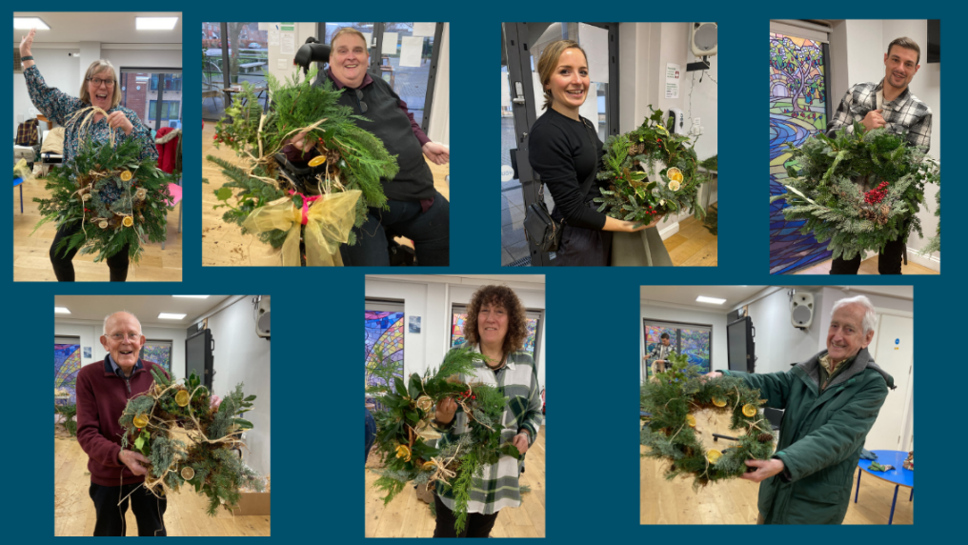

Everyone at Healthwatch Surrey wishes you all the best during this festive season,

and a healthy and happy 2025.

# About Healthwatch Surrey

Healthwatch Surrey champions the voice of local people to shape, improve and get the best from NHS, health and social care services. As an independent statutory body, we have the power to make sure decision makers listen to the experiences of local people.

We passionately believe that listening and responding to local people's experiences is vital to create health and social care services that meet the needs of people in Surrey. We seek out people’s experiences of health and care services, particularly from people whose voices are seldom heard, who might be at risk of health inequalities and whose needs are not met by current services. We share our findings publicly and with service providers and commissioners to influence and challenge current provision and future plans.

We also provide reliable and trustworthy information and signposting about local health and social care services to help people get the support they need.

# Our distribution list

If you would like to be added to or removed from the distribution list for this Insight Bulletin, please contact our Communications Lead [vicky.rushworth@healthwatchsurrey.co.uk](mailto:vicky.rushworth@healthwatchsurrey.co.uk)



The Healthwatch Surrey service is run by Luminus Insight CIC, known as Luminus.

Registered office: GF21, Astolat, Coniers Way, Burpham, Surrey, GU4 7HL.