

Insight Bulletin

September 2024

A large speech mark, outlined in pink.

“At no point was I told how large the scar would be and I was very distressed to find that I had a 6.5cm wound. A facial wound, whilst not life threatening, is a really big thing to deal with and at no time was I signposted or given any mental health support. It was a really distressing experience.”



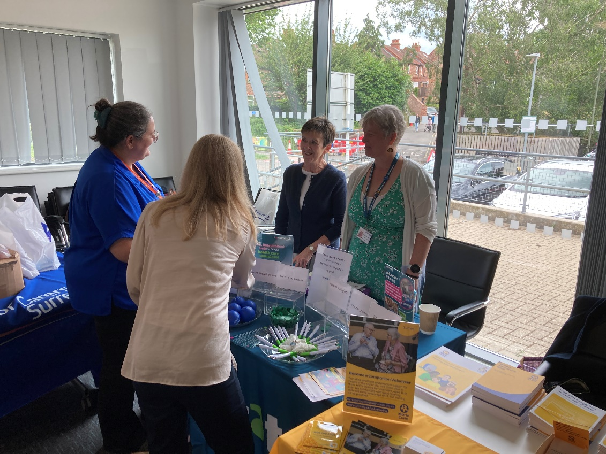

**If you would like a paper copy of this document or require it in an alternative format, please get in touch with** **us.**

# This bulletin: at a glance

## Hot topics

In this bulletin we are focussing on 5 key areas:

* Thanks and praise
* Lack of signposting and clear communication to patients
* Referral delays impacting patients
* Primary care: access issues
* Extended waiting times

## Who have we been hearing from?

Since our last bulletin we’ve heard from **262** people across Surrey, via our Helpdesk or during engagement events in the community.

* **37%** of the feedback relates to GP practices.
* **32%** of the feedback relates to hospitals
* Of those happy to disclose their gender, **56%** identified as female.
* Of those willing to share their age, **53%** were aged over 50
* Of those willing to share, **35%** had a long term condition.

# Thanks and praise

**Some people have shared really positive experiences with us this month, both from a primary and secondary care perspective.**

Positive feedback is often related to the provision of a service which is both timely and efficient.

“My daughter broke her arm yesterday. [The hospital] were great, we were in and out in 2 hours, X-rayed and with cast. She has a follow up appointment already booked for 2 weeks’ time.”

219258, Tandridge resident

“He called this morning and was helped over the phone, he has an appointment later on today. They do see you quickly [at the GP practice] and I have a good service there [NHS dentist] too.”

219253, Tandridge resident

Effective integration of services is also beneficial for patients and is recognised as such by service users.

“My wife made the [GP] appointment for me today, it’s a same day appointment. I have regular prescriptions of inhalers that are sent straight to the Boots down the road. I don’t ever need to chase. The service here is great. There’s nothing I would improve about the services around here. I know how to complain if I need to.”

219256, Tandridge

“The surgery here is so good. I can’t say enough good things about it. I’d give them 10/10. If you need an appointment, come in the morning and they’ll get you one if they can. I cannot fault them. I came in once for an appointment about earache and went out with blood pressure taken, diagnosis and treatment. They are very thorough. The pharmacy at Boots is also excellent. Between the 2 they will sort you out. They liaise well together.”

219259, Tandridge resident

Service users also praise clear communication which is tailored to their individual needs.

“I was referred with seizures by my GP. The appointment took a long time to come through but once through had an appointment with a specialist within 2 weeks. He confirmed it wasn’t epilepsy but took lots of time to explain everything to me.”

218178, Surrey resident

# Lack of signposting and clear communication to patients

### Lack of appropriate signposting to support services

Despite the wealth of support services available to patients, many services are under utilised as there is a lack of signposting between them. We often hear from people who might have some needs met but would benefit from being told about or referred for additional support:

“[following an operation] at no point was I told how large the scar would be and I was very distressed to find that I had a 6.5cm wound. For several days I felt unable to leave my home due to this, making me feel unattractive and not wanting to go out anywhere in case people stared at me. A facial wound, whilst not life threatening, is a really big thing to deal with and at no time was I signposted or given any mental health support. It was a really distressing experience.”

219683, Woking resident

## Lack of clear communication

We repeatedly hear that a lack of clear communication from healthcare professionals can leave patients feeling confused and anxious. This can be concerning when they are faced with particularly worrying health concerns:

“I am currently receiving treatment for ovarian cancer. I was diagnosed with this 18 months ago and had major surgery followed by radiotherapy and chemotherapy last year. I was put on a suppressant drug but unfortunately that did not work. My current treatment plan is to receive chemotherapy every 4 weeks to stop the cancer spreading further and hopefully to reduce it.

Last week I was due to have my blood test at my GP surgery on Thursday, this blood test then determines whether or not I can receive my chemotherapy the following Monday. On the morning of the blood test, I received a text from my GP surgery to say that due to staff illness there was no blood test that day and cancelling my appointment. I was absolutely flabbergasted that this was happening and in disbelief rang the surgery to talk to them. I was panicking that my chemotherapy would not be able to go ahead. The receptionist I spoke to was really unhelpful - she offered me an appointment the following day or the Monday even though I was trying to tell her that that was too late. She did not seem to grasp the fact that unless my blood test results were good enough, I would not be able to get my treatment.”

217383, Surrey resident

“I am a blind lady who needs melatonin to aid with sleep as my brain thinks night is daytime and daytime is night. With melatonin I can have a night’s sleep, but my GP will not prescribe it and I can’t understand why. They haven’t ever given me a reason as to why it can’t be on my repeat.”

219166, Reigate and Banstead resident

“I attended my appointment alone on 19 July to be told that my tumour was a rare Merkel Cell Carcinoma. When I asked what the plan was it soon became clear that there wasn’t one and was told that I needed to be discussed at an multi disciplinary team meeting to decide on the next plan. There wasn’t really anything more to say at this point, so I left without understanding if all of the tumour had been removed or what the plan was going to be. I was completely distressed and upset all of the way home. I had brought no-one with me for support as we had stupidly assumed that it couldn’t possibly be cancer as it wouldn’t have taken so long to contact me if it was.”

219683, Woking resident

# Referral delays impacting patients

Several people in this report period have talked to us about extended waits for referrals and the impact this has on both their emotional and physical health. Often a lack of communication around referral times has exacerbated the issue.

“I had a potential bleed at the back of my throat, and it had gotten so bad that I could not go to bed because I was worried it would get worse. My GP was aware of this problem, and had referred me to ENT (Ear, Nose and Throat), but I was just added on to a waiting list. I requested my GP try to expedite my referral, as I knew that the problem was getting worse, but they told me that they ‘are not allowed to do that’.”

219258, Tandridge resident

In these 2 examples, patients should have been seen within 14 days as an Urgent Suspected Cancer (USC) referral.

“The clock started ticking from my first referral and from that point to when I was told that I had a rare Merkel cell carcinoma it was 135 days. Once I got to the ultrasound appointment it was clear that the scan was showing that the lump was not a cyst but was a tumour with a blood supply. The lump was not on the skin but in the subcutaneous layer and I did query whether dermatology was the right place to be referred to at the time. [The dermatologist] diagnosed this as a vascular tumour in her letter to hospital. She politely advised that she wasn’t the right person to deal with this and that she would refer me on to the Maxillofacial Team for them to see me and carry out treatment/diagnosis. Again, I was referred on an urgent 14 day referral which took 19 days to be fulfilled.”

219683, Woking resident

“The specialist agreed it was a basal cell carcinoma – but that due to the positioning of the growth, my mum would need to be referred to the Maxillofacial service at Royal Surrey to have it removed. Following this, we did not hear anything and so I rang the dermatology service to find out what was going on. They confirmed the referral had been made as urgent on the 18 week pathway and recommended I ring the Maxillofacial department at Royal Surrey to find out what was happening.

On ringing the Maxillofacial department, a very helpful person explained that the referral had been received by them and that the wait was 52 weeks. She explained they had a 2 week wait for cancer referrals, a 6 – 8 week wait for urgent referrals and a 50 – 55 week non urgent referral. Their records did not show the referral being marked as urgent, so mum had been put on the 52 week list. When I explained the referral had been marked as urgent, they suggested I ring the dermatology service back as it wasn’t showing as urgent their end. I did do this and the dermatology service assured me it had been marked as urgent. I queried the fact that the waiting times didn’t seem to tally – they said they would check and ring me back. I haven’t heard any more.”

Waverley resident

# Primary care: access issues

In this report period, **97** people spoke to us about their GP practice.

We continue to hear from people who are struggling to access their GP practice – this is often related to confusion around digital processes and/ or issues with telephone lines.

“I am writing to raise a safeguarding concern. A few weeks ago I had a potentially cancerous mole removed from my head. It appears to have grown back. A pharmacist today said he did not like the look of it. Accordingly I attended my GP practice to seek an appointment. This was refused by the receptionist. She stated that I had to use the new online system. But this only has about 5 categories of illness and mine was not one of them. So I could not get an appointment online. This system has unquestionably been introduced to prevent older people and people who are not good with technology from getting an appointment. Unfortunately it is almost impossible to get through to on the telephone.

I do have problems with the phone system though. The call back system doesn’t work – it will keep cutting you off so you have to keep ringing back. It can make on the day appointments harder to make.”

219258, Tandridge resident

# Extended waiting times

**A recent** [**report**](https://www.kingsfund.org.uk/insight-and-analysis/data-and-charts/patient-waiting-times) **from the Kings Fund has noted that the time it takes for a patient to be seen or treated by a particular service or health practitioner is often used, alongside other metrics, as one measure of quality of care. The report also noted that – though different teams and organisations across the health and social care sector are responsible for achieving different waiting time targets - patient waiting times across those different services often correlate. Improvements to waiting times in one service are often related to, or dependent on, improvements to waiting times in another service**.

People have told us about their concern around extended waiting times and the impact it has on their daily life and their clinical prognosis.

“My daughter has been experiencing a lot of abdominal pain, bleeding etc. She went to her GP and they referred her for some investigations. My daughter let the GP know that her sister has inflammatory bowel disease (IBD) and almost died due to complications from the IBD. However, [the hospital] did not conduct the investigations as an urgent, meaning my daughter had to chase them multiple times. Once she had finally had the investigations, they said that they had found signs of inflammation, and that she would need to meet with a consultant. The appointment that she was given was over a year away. There was no diagnosis given and no mention of treatment.”

220103, Surrey resident

“I first had a Doppler test done on both of my lower legs back in I think October or November last year at my doctor’s surgery. I then had a Doppler test done on both of my lower legs at hospital back in January 2024. I then received in the post a letter from the Vascular Surgery department dated May 2024. The actual appointment isn't until [end of] September 2024 and then I don't know when I will eventually have the surgery.”

219560, Surrey resident

“I complained to PALS and the response was ‘too bad, there are big waiting lists, you will just have to wait’.”

218182, Reigate and Banstead resident

“I have been waiting months for an appointment at my local hospital and eventually got an appointment but not until [late] September 2024 at the Vascular department for pre assessment before getting a date for the actual surgery. It is because I have been diagnosed with having very narrow arteries in both of my legs. I have roughly worked it out I would have been waiting about 18 weeks since I got diagnosed.”

216759, Surrey resident

There is a feeling that extended waiting times have a disproportionate impact on those on lower incomes, who are unable to access any private services or care.

“I’ve been waiting 18 months to get a hearing aid. I went to hospital for my initial appointment a year and a half ago. I have been to Specsavers and they said that it would cost at least £400 and I just don’t have that kind of money.”

217034, Woking resident

# Sharing our insight and raising concerns

Whilst this bulletin accurately reflects what we hear from the individuals we speak to, we are aware that it may not be representative of everyone’s views of a particular service. Multiple references to a specific service may be due to where our community engagement has recently taken place.

If we hear a case of concern regarding patient safety, we immediately signpost the sharer to the appropriate body and escalate the case with the provider/commissioner. All appropriate information and signposting has already been given.

We share our wider themes with Trusts, Integrated Care Systems (ICSs), Surrey County Council, Public Health, Care Quality Commission (CQC), and in various boards and groups across Surrey.

If you would like more information or examples of what people have shared with us, please get in touch with us.

# Community engagement

Below are details of our upcoming engagement sessions where we visit venues in local communities to listen to what people think about local health and care services, and to ask specific questions related to [our priorities](https://www.healthwatchsurrey.co.uk/about-us/our-priorities/). We also provide information and signposting regarding health and social care. Each month we focus on a different area of the county. Last month this was Farnham and through September we’ll be focusing on Surrey Heath. Throughout the year, we also attend events across Surrey to raise awareness of our work.

|  |  |  |  |  |
| --- | --- | --- | --- | --- |
| Date | Place | Time | Open  to | Surrey Area |
| **05/09/2024** | Age UK Planning for Your Future event,  Cobham Village Hall | 11am - 1pm | **Public** | **Surrey Downs** |
| 09/09/2024 | Canalside Community Fridge, Woking | 10am - 1pm | Public | Guildford and Waverley |
| 16/09/2024 | Neurodiversity - Parent Support Group, St Martin’s, Old Dean, Camberley | 10am - 11:30am | Group | Surrey Heath |
| **30/09/2024** | Cancer support group  Frimley | 10.45am –  12 noon | Group | Surrey Heath |
| **23/10/2024** | Runnymede Foodbank, Chertsey | **10am - 1pm** | Public | North West Surrey |

**Please note: these dates may be subject to change.**

To share an experience with us, or for information and signposting about health and social care, people can also contact our Helpdesk in the following ways:

Phone: 0303 303 0023

SMS (text only): 07592 787 533

Email: [enquiries@healthwatchsurrey.co.uk](mailto:enquiries@healthwatchsurrey.co.uk)

Share your feedback via our website: <https://www.healthwatchsurrey.co.uk/feedback-centre/>

# About Healthwatch Surrey

Healthwatch Surrey champions the voice of local people to shape, improve and get the best from NHS, health and social care services. As an independent statutory body, we have the power to make sure decision makers listen to the experiences of local people.

We passionately believe that listening and responding to local people's experiences is vital to create health and social care services that meet the needs of people in Surrey. We seek out people’s experiences of health and care services, particularly from people whose voices are seldom heard, who might be at risk of health inequalities and whose needs are not met by current services. We share our findings publicly and with service providers and commissioners to influence and challenge current provision and future plans.

We also provide reliable and trustworthy information and signposting about local health and social care services to help people get the support they need.

# Our distribution list

If you would like to be added to or removed from the distribution list for this Insight Bulletin, please contact our Communications Lead [vicky.rushworth@healthwatchsurrey.co.uk](mailto:vicky.rushworth@healthwatchsurrey.co.uk)



We are committed to the quality of our information.

Every three years we perform an audit so that we can be certain of this.



The Healthwatch Surrey service is run by Luminus Insight CIC, known as Luminus.

Registered office: GF21, Astolat, Coniers Way, Burpham, Surrey, GU4 7HL.