

Insight Bulletin

July 2024

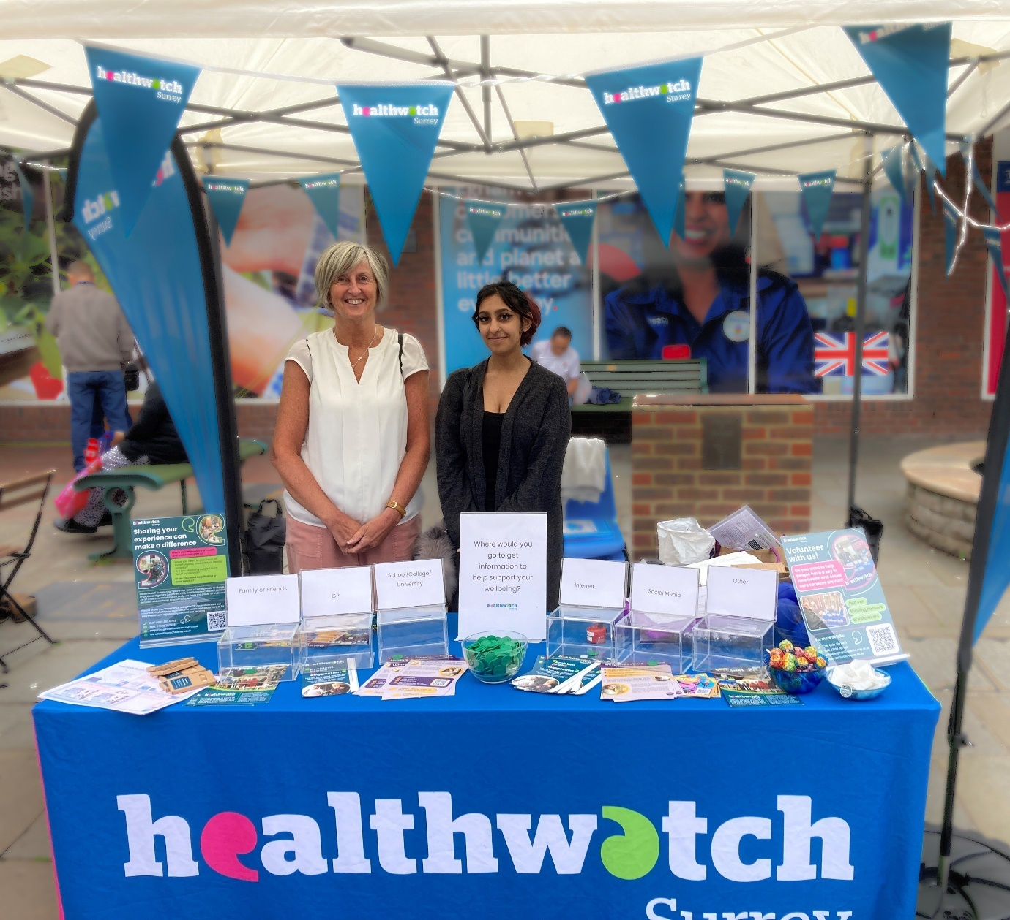

**If you would like a paper copy of this document or require it in an alternative format, please get in touch with us.**

# The value of listening: the Healthwatch Surrey Annual Report 20230-2024

**“Listening to a patient or carer is not a ‘nice to have’** – it is part of the fundamentals of delivering not only care with dignity and respect but also high quality, safe, and effective care.”

Kings Fund, 2023 ([Patient experience: who is listening?](https://www.kingsfund.org.uk/blog/2023/10/patient-experience-who-listening))

In July we published [our 2023-2024 Annual Report](https://www.healthwatchsurrey.co.uk/report/the-value-of-listening-our-annual-report-2023-2024/), with the key theme recognising the value of listening. The report highlights some of our key impacts in 2023-2024 – a year in which we heard from over 1600 people and published 26 reports about people’s experiences of health and social care services across Surrey.

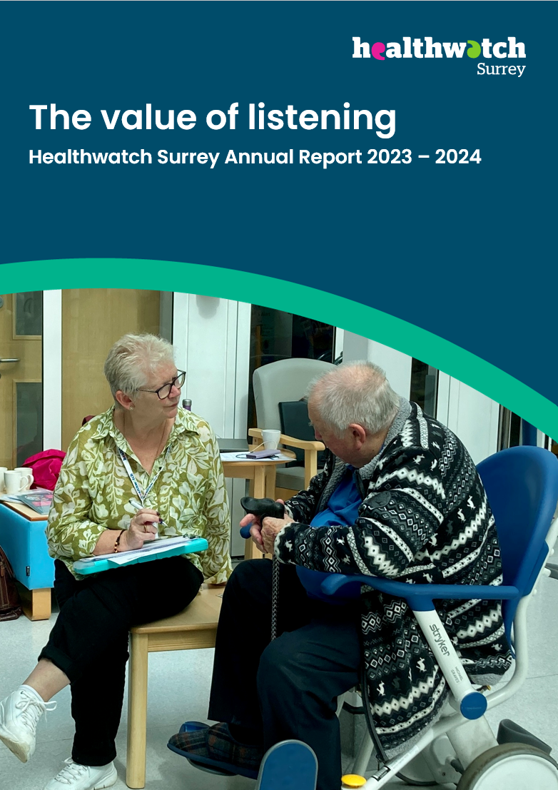

# This bulletin: at a glance

## Hot topics

In this bulletin we are focussing on 5 key areas:

* Thanks and praise
* Unpaid carers: barriers to care (for them and those they care for)
* Dentistry: concern and confusion around NHS dentists
* Mental health: accessing appropriate care
* The importance of peer support for Early Years parents: spotlight on Godalming
* Pharmacy: the value of pharmacy and the impact of closures

## Who have we been hearing from?

Since our [last bulletin](https://www.healthwatchsurrey.co.uk/report/insight-bulletin-may-2024/) we’ve heard from **198** people across Surrey, via our helpdesk or out on engagement events in the community.

* **32%** of the feedback has been related to GP practices.
* Of those happy to disclose their gender, **56%** identified as female.
* Of those willing to share their age, almost half **(46%)** were aged over 50

We’ve heard the views of additional people via a series on-line surveys looking at specific topics.

# Thanks and praise

**Some people have shared really positive experiences with us this month.**

**In this example, a resident really appreciated it when the system fully supported their individual requirements.**

“I'm really happy with my GP practice. I have been really well supported by them. I'm dyslexic and so we've sorted out a system where they know that calling me is best, they also phone/ text me to remind me of appointments coming up. I can cope with a short text, that has been helpful. When I call to book appointments I have found that I can get an appointment quickly.”

214912, Mole Valley resident

In this example a resident was happy to be receiving individualised care from diverse parts of the health system.

“It looks like [my son] may be diagnosed as dyspraxic, the team supporting him gave him an autism test but that was ruled out. What is really good is that he is now receiving physio via Epsom Hospital alongside Mindworks therapy. The physio team knew it was a struggle for me to get him and my four year old to Ashstead using public transport where the physio is held. They also saw that my daughter was disrupting the sessions, so they suggested an alternative. They altered the arrangement and they now come to his school to do the physio which makes it easier for everyone.”

214912, Mole Valley resident

# Unpaid carers: barriers to care (for them and those they care for)

**The All-Party Parliamentary Group (APPG) on Carers has published a report calling for an ambitious new National Carers Strategy to be developed, to ensure that those providing unpaid care get the support, recognition and value they need and deserve. Across the UK, 5.7 million people support and help to look after family members, friends or neighbours.**

In this report period we heard from **21** people who considered themselves to be carers.

### Struggling to access the right care and support

People told us that they find it difficult to access the care and support they need for those they care for, and this is often due difficulties navigating a complex, disjointed system.

“[My daughter] has an on-going physical condition - low immunity and another condition with acute allergies. It’s been two years since her diagnosis but we’re not getting the help we need for her mental or physical condition (her physical condition impacts her mental health). She’s had 40 admissions to A&E and I had to instigate the referral to Community Mental Health Recovery Services (CMHRS). She has 7 consultants but none of them are talking to each other. And the GP won’t get involved – he won’t see us and just sends us to a hub or suchlike. I’m not sure the GP is the right place for us – the other day he handed me all our medical records, I don’t think they want us there. I have a life limiting condition too and I’m really struggling.”

213940, Epsom resident

### Carers’ own needs not prioritised

For many, the time and energy needed to care for a loved one takes its toll on their own emotional and physical health.

“I don't feel like a wife now, I feel like his carer. I'm up and down the stairs all the time, to give him things and get things. I'm 86, it’s exhausting.”

215143, Elmbridge resident

Many don’t recognise themselves as being a carer, and don’t get any encouragement to do so.

“I don't think they recognise that I'm her carer. I've never been offered any carer's support. Her needs have to be prioritised above mine.”

212924, Tandridge resident

*“*I haven’t really thought of myself as a carer even though I know I care for him. It takes its toll.”

215143, Elmbridge resident

# 

# Dentistry: concern and confusion around NHS dentists

**Findings from the** [**Dental Annual Review**](https://www.gdc-uk.org/about-us/our-organisation/reports/working-patterns-data) **have shed new light on NHS dentistry, revealing that only 15% of responding dentists are fully NHS. We continue to hear from people struggling to access dental care across Surrey*.***

In this report period, **54** people spoke to us about dental provision.

### Struggling to find an NHS dentist

People tell us that they are unable to find an NHS dentist, leading many to give up and survive without dental care. Those who have sought private treatment tell us they find it difficult to afford.

“I've been trying to find a local dentist who will take on NHS patients most have a waiting list for a wait of over 6 months so I have to suffer or will end up having to pay private but really can't afford it so what am I meant to do.”

205992, Mole Valley resident

“My dentist is private - what's the point in trying to get an NHS one, they all charge you.”

209770, Mole Valley resident

In some cases changes at a dental practice left people rejected from their NHS dental practice and consequently without routine dental treatment.

“My NHS Dentist is about to take all of their services private. I was sent a letter saying I have the choice of either joining their payment plan or trying to find another NHS dentist. There aren't any others locally and it’s frustrating as I have been going to this practice for years. I don't feel this is very fair.”

**201918, Spelthorne resident**

### Confusion around dental care charges and NHS acceptances

People are frustrated about the lack of clarity around whether dentists are or aren’t accepting new NHS patients - many told us they had called multiple dentists who were listed as accepting NHS patients, only to be told of long waiting lists or that they were no longer accepting them.

“As someone who is currently exempt from dental charges, I have been told that I need to have root canal treatment. Unfortunately, this is to rectify an existing root canal that has become infected. My NHS dentist states that this cannot be done as an NHS patient and I will have to have this done privately. Are you able to offer any clarity on whether my prescribed treatment (root canal) would be covered under the NHS?”

206734, Surrey resident via Healthwatch England

“Have just checked the Dental practices in the Guilford/Woking Area, not one is taking on over 18's as NHS patients. What a mockery.”

210707, Woking resident

For those lucky enough to find NHS care, confusion remains about what charges they are expected to pay and why.

“I was struggling to find an NHS dentist, but then I was able to find a fairly local dentist that was taking NHS patients. When I registered myself and my wife, I did so as an NHS patient that receives free dental care, as we receive pension credit. When we registered we provided the surgery with copies of the exemption certificates and other relevant information that would mean we would not be charged. However, when we went to book in for an appointment, we were told we would need to pay privately for care. We had to pay £30 for a standard appointment, £85 for my wife to see a specialist and we had to pay £200 upfront to be registered. My wife has a root canal that needs treatment, and we are concerned that we are not going to be able to afford treatment.”

**192997,** Elmbridge resident

# Mental health: accessing appropriate care

**In a** [**report**](https://www.childrenscommissioner.gov.uk/resource/childrens-mental-health-services-2022-23/) **from the Children’s Commissioner, it was noted that 1 in 5 children and young people aged 8 to 25 in England now have a probable mental health condition.**

In this report period, **19** people spoke to us about their mental health, many of whom were frustrated at not being able to access the care and support they need. This leads some people to think that mental health support is seen as less significant than support for other conditions.

“Horrific experience. Denied transition support from CAMHS at age 18. Can't access stepped care, so goes without, unless becoming suicidal. Do no harm? You want harm before support! Stuck, housebound, severe anxiety, but still no. If mental health support was appendicitis, you'd want it to explode and cause sepsis before going on a 6 month waiting list for a few weeks of input.”

212435, Surrey Heath resident

In this example, a family faced barriers to accessing the additional support they required to support their mental health care journey.

“I’m helping out a Syrian refugee family whose daughter has been referred to STARS. The referral has been delayed because of a court case involving the daughter’s father who has sexually abused her, but finally came through two weeks ago. The family need an interpreter but Mindworks are saying they can’t provide one, and that interpreters are only provided in primary care. “

214513, Waverley resident

# The importance of peer support for Early Years parents: spotlight on Godalming

**This month we’ve been talking to parents of 0-5s in the Godalming area about the practical and emotional support available to them, and where the gaps in provision lie.**

The parents we spoke to commented on the importance of their peers in light of the decline of professional family and health visitor support following the newborn stage.

“Well supported in hospital. My mother came over from Mumbai and left when he was [a few] months old. But my wellbeing since the birth has been bad.”

214121, Godalming resident

“There was a big difference between the support and care I received with my first child to the third. The support available to me has gotten worse with each child.”

214120, Godalming resident

“I think there is a lot of anxiety when you first have a child and I think giving parents advice early or access to some kind of app early so people can look up concerns, as and when, would be helpful. I shared a leaflet with my NCT group I had found from a London children’s hospital, it was like a booklet with common concerns addressed. I thought that was excellent and they’ve all said they’ve referred to it too. NCT helped me with information and advice about birthing and my health, it’s also been a good way to meet people locally.”

214098, Godalming resident

“If I had a worry I would go to Mum first, call friends and would ring the [health visitor] advice line, but so far I haven’t needed to call.”

214090, Godalming resident

### Parents unaware what support is available

A lot of parents told us that they simply weren’t aware of the sources of support which are open to them, in the first two cases below the health visitor drop in clinic, which people thought to be invaluable once found.

“Wellbeing for me is a mix of practical and emotional support. I have been ok and not had to access additional support. I don’t actually know where I would go if I needed it.”

214117, Godalming resident

“I did not realise this clinic [health visitor drop in] was still running until today when my cousin suggested we came down. My 2 year old has a squint and so it’s great I’ve been able to come and get some advice today, they’ve been really helpful and will be following up with me after this chat today.”

214088, Godalming resident

“I didn’t think to go the health visitors first. Now I’ve found this clinic it’s really handy. I can drop in as and when which has helped me.”

214092, Godalming resident

“I’ve never really thought about what wellbeing means to me. It could be physical or mental. I don’t know what is out there myself.”

214122, Godalming resident

“I was happy with the hospital and the visits from the health visitor after. I feel well supported at the moment and not in need of any outside help. I have friends locally and I look to them for support. I wouldn’t know where to go officially.”

214123, Godalming resident

### The impact of the cost of living crisis

The cost of groups for parents to meet peers is a real concern, meaning that some will not be getting the peer support that others find so valuable:

“I need to go to groups that aren’t too expensive to attend. The cost of living has really hit us hard. I like the stay and play here, it has helped me make friends.”

214123, Godalming resident

“There aren’t enough places in Godalming to take young children. This playgroup is only an hour and there are only a few others around. It’s hard to make friends but I do try to go out for coffee with the people I know to help my mental health. But there is nowhere to go when the weather is poor.”

214120, Godalming resident

# Pharmacy: the value of pharmacy and the impact of local closures

**In April 2024 Healthwatch England released their report “**[**Pharmacy: what people want**](https://www.healthwatch.co.uk/report/2024-04-30/pharmacy-what-people-want)**” exploring the current state of pharmacy services and offering recommendations for healthcare leaders and the wider sector. The report is based on a national poll as well as interviews undertaken by local Healthwatch, including Healthwatch Surrey.**

In addition to contributing to Healthwatch England’s national report, we have also been working with 2 specific communities in Guildford and Waverley (Cranleigh and Burpham/Merrow) to explore how people have been affected by recent closures and what people want from their local pharmacy provision.

**429** people completed our survey, either on-line or via a paper copy.

### Findings at a glance:

* Residents value the service and clinical expertise which their local pharmacy can provide – this supports the [Healthwatch England report](https://www.healthwatch.co.uk/sites/healthwatch.co.uk/files/Pharmacy%20what%20people%20want.pdf) which found that pharmacies are often the most visible and accessible part of the health system.
* 64% of people would consider going to their pharmacy instead of their GP practice for minor illnesses or health advice.
* The impact of the closure of one pharmacy on the alternative provision in the area is a huge concern for local residents – if alternatives don’t meet their needs in terms of capacity, space or opening hours the value of the service is hugely reduced.
* Travel distance from home is the most important core indicator for people when visiting a pharmacy, but this is more complex than a crude mileage value – people need to be able to walk or have reliable / accessible / affordable public transport options.
* The ease of getting to a pharmacy impacts how often 71% of people go
* Good customer service is also considered to be critically important, but people’s confidence in this is eroded if a pharmacy is seen to not have sufficient capacity.

“LloydsSainsburys was within walking distance. Boots Merrow was across from my GP practice. I now have to drive to the only remaining pharmacy in the area for all prescriptions. Parking is a nightmare and when I finally get there, the queues are an hour long with 10-15 people waiting. It’s just impossible. The store is tiny and simply cannot accommodate so many customers. The staff are run off their feet. Just awful.”

**Guildford resident**

“I couldn’t get prescriptions anymore because the other local pharmacy had opening hours that were too short and always has an incredibly long wait. Had to sign up for an online pharmacy.”

Guildford resident

# Sharing our insight and raising concerns

Whilst this bulletin accurately reflects what we hear from the individuals we speak to, we are aware that it may not be representative of everyone’s views of a particular service. Multiple references to a specific service may be due to where our community engagement has recently taken place.

If we hear a case of concern regarding patient safety, we immediately signpost the sharer to the appropriate body and escalate the case with the provider/commissioner. All appropriate information and signposting to complaints processes has already been given.

We share our wider themes with Trusts, Integrated Care Systems (ICSs), Surrey County Council, Public Health, Care Quality Commission (CQC), and in various boards and groups across Surrey.

If you would like more information or examples of what people have shared with us, please get in touch with us.

# Community engagement

During May and June our engagement team focussed their visits in Surrey Downs and North West Surrey. Through July we’ll be focusing on East Surrey.

|  |  |  |  |  |
| --- | --- | --- | --- | --- |
| Date | Place | Time | Open  to | Surrey Area |
| 03/07/2024 | Fordbridge Centre, Ashford | 10am – 12noon | Public | North West Surrey |
| **04/07/2024** | **The Woodhouse Centre, Oxted** | **10.30am – 12.30pm** | **Public** | **Surrey Downs** |
| **10/07/2024** | **Community Clinic day** | **10am – 12:30pm** | **Public** | **Surrey Downs** |
| **12/07/2024** | **Health and Wellbeing Event for people living with cancer and their families** | **10am – 3pm** | **Public** | **Surrey wide** |
| **18/07/2024** | **East Surrey Hospital** | **10am – 12noon** | **Public** | **East Surrey** |
| **23/07/2024** | **Lingfield Parish Church** | **TBC** | **Public** | **East Surrey** |
| 24/07/2024 | St Martins, Old Dean, Camberley | 10am –  12noon | Public | Surrey Heath |
| 25/07/2024 | Lingfield GP Surgery | 10am –  12noon | Public | East Surrey |
| 30/07/2024 | Regent House, Horley | 10am –  12noon | Public | East Surrey |

**Please note: these dates may be subject to change.**

To share an experience with us, or for information and signposting about health and social care, people can also contact our Helpdesk in the following ways:

Phone: 0303 303 0023

SMS (text only): 07592 787 533

Email: [enquiries@healthwatchsurrey.co.uk](mailto:enquiries@healthwatchsurrey.co.uk)

Share your feedback via our website: <https://www.healthwatchsurrey.co.uk/feedback-centre/>

# About Healthwatch Surrey

Healthwatch Surrey champions the voice of local people to shape, improve and get the best from NHS, health and social care services. As an independent statutory body, we have the power to make sure decision makers listen to the experiences of local people.

We passionately believe that listening and responding to local people's experiences is vital to create health and social care services that meet the needs of people in Surrey. We seek out people’s experiences of health and care services, particularly from people whose voices are seldom heard, who might be at risk of health inequalities and whose needs are not met by current services. We share our findings publicly and with service providers and commissioners to influence and challenge current provision and future plans.

We also provide reliable and trustworthy information and signposting about local health and social care services to help people get the support they need.

# Our distribution list

If you would like to be added to or removed from the distribution list for this Insight Bulletin, please contact our Communications and Involvement Officer [vicky.rushworth@healthwatchsurrey.co.uk](mailto:vicky.rushworth@healthwatchsurrey.co.uk)



We are committed to the quality of our information.

Every three years we perform an audit so that we can be certain of this.



The Healthwatch Surrey service is run by Luminus Insight CIC, known as Luminus.

Registered office: GF21, Astolat, Coniers Way, Burpham, Surrey, GU4 7HL.