Healthwatch Surrey logo

**The value of listening**

**Healthwatch Surrey Annual Report 2023 – 2024**

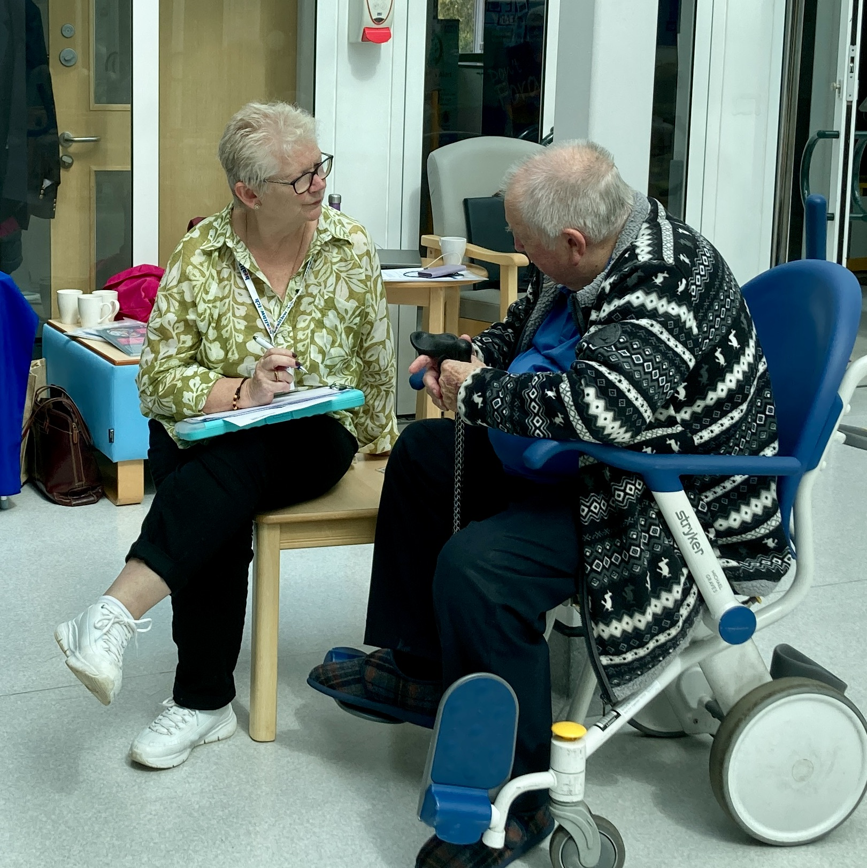

The value of listening

Healthwatch Surrey Annual Report 2023 – 2024

**If you would like a paper copy of this document or require it in an alternative format, please get in touch with us.**

# Contents

Contents 2

Message from our Contract Manager and Co-Chairs 3

About us 4

Our year in review 5

How we’ve made a difference this year 6

Your voice heard at a wider level 7

Listening to your experiences… 8

Hearing from all communities 13

Advice and information 16

Our volunteers 19

Our finance and future priorities 21

Statutory statements 23

Healthwatch Surrey 26

“**Listening to a patient or carer is not a ‘nice to have’** – it is part of the fundamentals of delivering not only care with dignity and respect but also high quality, safe, and effective care.”

Kings Fund, 2023 ([Patient experience: who is listening?](https://www.kingsfund.org.uk/blog/2023/10/patient-experience-who-listening))

# Message from our Contract Manager and Co-Chairs

From left to right, photos of: Sam Botsford, Healthwatch Surrey Contract Manager; Deborah Mechaneck
Co-Chair of Luminus Board (Luminus, home of Healthwatch Surrey) and Local Healthwatch Advisory Group member; Jason Davies, Co-Chair of Luminus Board (Luminus, home of Healthwatch Surrey).

This year, Healthwatch Surrey has received health and social care experiences

from over 1600 people, a 20% increase from last year. In addition, we’ve given information and support to over 800 Surrey residents through our Helpdesk and Independent Health Complaints Advocacy services. We would like to thank everyone who has taken the time to share their experience and also our volunteers who have been instrumental in helping us hear more from local people. As a result, we’ve helped a wide range of individuals across Surrey, and collated and shared what we are hearing to help improve services.

This year we have continued to get to know our local communities and what matters to them by continuing to visit community settings to meet local residents and community leaders. We listen to what’s strong and working well and what can be improved. We’ve seen a huge shift to online services in recent years, and this year we’ve also focussed on helping people take advantage of these services, including supporting people to learn how to use the NHS App. Following an introduction by Healthwatch Surrey, we were delighted that a local Muslim women’s group was supported by Tech Angels (a service provided by Surrey Coalition). As seen in our work towards [ensuring equity of GP access](https://healthwatchsurrey.sharepoint.com/sites/Team/Shared%20Documents/Communications/Annual%20Report/Annual%20report%202023%20-%202024/DRAFT%20-%20Healthwatch%20Surrey%20Annual%20Report%202023-2024.docx#Ensuring_equity_of_GP_access), we also advocated for accessible services.

We have championed a person centred approach to decision making: sharing individual stories, collaborating with VCSE (Voluntary, Community and Social Enterprise) colleagues and other Healthwatch, and publishing reports based on what people have told us matters to them.

# About us

## Healthwatch Surrey is your local health and social care champion

Healthwatch Surrey champions the voice of local people to shape, improve and get the best from NHS, health and social care services. As an independent statutory body, we have the power to make sure decision makers listen to the experiences of local people.

We passionately believe that listening and responding to local people's experiences is vital to create health and social care services that meet the needs of people in Surrey. We seek out people’s experiences of health and care services, particularly from people whose voices are seldom heard, who might be at risk of health inequalities, and whose needs are not met by current services. We share our findings publicly and with service providers and commissioners to influence and challenge current provision and future plans.

We also provide reliable and trustworthy information and signposting about local health and social care services to help people get the support they need.

### Our priorities

Deciding priorities helps us to focus our resources and be clear with health and social care commissioners and services about what we work on and where additional resources will be needed to provide insight and support. Our core priorities, as the name suggests, are at the heart of what we do and tend to be fixed from year to year, but our thematic priorities are based on what we are hearing from local people and set as areas for us to focus our resources on. Further information about [our priorities](https://www.healthwatchsurrey.co.uk/about-us/our-priorities/) is on our website.

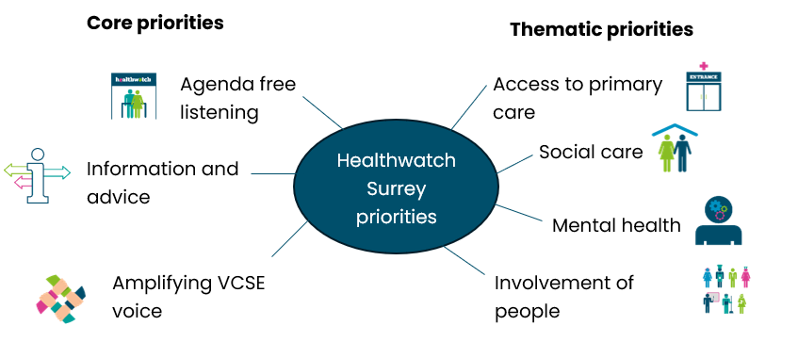

# Our year in review

## Reaching out

**1632** Surrey residents shared their experiences about health and social care with us, helping to raise awareness of issues and improve care.

**824** Surrey residents sought advice and support from our Helpdesk and Independent Health Complaints Advocacy (IHCA) service.

## Making a difference to care

This year we published **26** reports about people’s experiences of health and social care services across Surrey. These can be found on the [reports page of our website.](https://www.healthwatchsurrey.co.uk/reports)

Our most influential reports this year, were our hospital feedback reports which we collated into a [video summary](https://www.healthwatchsurrey.co.uk/report/summary-involvement-of-people-feedback-in-hospitals-march-2024/). This has also been incorporated into one [hospital’s complaints and compliments website page](https://ashfordstpeters.nhs.uk/complaints-and-compliments).

## Health and social care that works for you

We’re lucky to have **40** volunteers, who this year gave **232** days to make care better for our communities.

We’re funded by our local authority. In 2022-23 we received **£488,210** for delivery of local Healthwatch. This was **1.2%** **more** than the previous year.

We employ **8.5** staff (full time equivalent) who help us carry out this work.

# 

# How we’ve made a difference this year

|  |  |  |
| --- | --- | --- |
| **Spring** | Icon of an ambulance | Icon of a barrier |
|  | South East Coast Ambulance NHS Foundation Trust (SECAmb) began development of a digital information resource on how to use their services, following our feedback on the dangers associated with service confusion. | The needs of migrants will now be factored into the [Integrated Care Board](https://www.healthwatchsurrey.co.uk/information-and-advice/find-services/local-commissioners/)’s (ICB) operational and financial planning after we highlighted the barriers that this community face when trying to access healthcare. |
| **Summer** | Icon of 3 people in a discussion | Icon of a mobile phone. |
|  | We facilitated joint working between voluntary sector colleagues from across Surrey and Surrey County Council (SCC) to champion the inclusion of more people’s voices in future additions to the Joint Strategic Needs Assessment. | We championed the use of the NHS App across Surrey, freeing up vital face to face space for those who are not able, or who choose not to manage their care digitally. |
| **Autumn** | Icon of a person pointing to information on a board | Icon of a leaflet |
|  | Our [guidance](https://www.healthwatchsurrey.co.uk/wp-content/uploads/2023/12/Healthwatch-Surrey-guidance-on-involving-people-in-Patient-Safety-Incident-Response-Plans-November-2023.pdf) on involving people in Patient Safety Incident Response Framework (PSIRF) Plans played a pivotal role in the development of First Community Health and Care’s plan. | Our contribution to a patient information leaflet produced by the Community Respiratory Service ensured that patients are now armed with accessible and clear information about the service. |
| **Winter** | Icon of people facing someone who is speaking to the group. | Icon of a hospital |
|  | We played an integral part in the development and organisation of an inaugural lived experience conference, celebrating the importance of co-production in developing mental health services. | Thanks to the findings of our [Feedback in hospitals report](https://www.healthwatchsurrey.co.uk/report/summary-involvement-of-people-feedback-in-hospitals-march-2024/) there have been fundamental shifts in policy and focus across all 5 hospital trusts in our area, with patient experience and involvement now being given a more central role. |

Your voice heard at a wider level

**We collaborate with a number of strategic partners to further our reach in the local community, and to ensure that the experiences of people in these communities influence decisions made about services at a system level.**

Healthwatch Surrey actively pursues opportunities to work more closely with our voluntary sector colleagues. This year we conducted a series of joint engagements with Marie Curie, helping us reach a broader spectrum of our local population.

“The partnership with Healthwatch Surrey has been invaluable. It’s been really useful attending events Healthwatch Surrey have set up through existing partnerships they have. Listening and learning the way Healthwatch Surrey asks questions and gains information (especially more difficult topics and how to open up discussion areas) has been helpful too, along with talking about and sharing the challenges we both face as organisations in the community.”

**Marie Curie Engagement Officer, May 2023**

This year, as Portfolio lead for “Voice” in Surrey’s VCSE Alliance, we continued hosting VCSE Voice Group meetings with our voluntary sector colleagues across Surrey, creating more opportunities for the voices of all Surrey residents to be heard. In August, the group met with SCC to discuss how we can champion more people’s voices in future additions to the Joint Strategic Needs Assessment (the starting point for future commissioning decisions about health and care services), ensuring commissioning of services is truly responsive to people’s needs.

People across Surrey often tell us they don’t feel heard by mental health services ([Children’s and Young People’s Emotional Wellbeing and Mental Health needs](https://www.healthwatchsurrey.co.uk/wp-content/uploads/2021/10/Healthwatch-Surrey-Childrens-EWMH-insight-summary-October-2021-003.pdf)). We were therefore proud to play an integral part in the development of an inaugural lived experience conference, celebrating the importance of co-production in developing mental health services. We also signposted the team leading the review of discharge from mental health services to groups and organisations, enabling people with direct experience of services to be heard.

This year we participated in 2 [Accessible Information Standard](https://www.england.nhs.uk/about/equality/equality-hub/patient-equalities-programme/equality-frameworks-and-information-standards/accessibleinfo/) Working Group meetings with Surrey Heartlands, VCSE organisations and service providers. We shared people’s experiences, highlighting opportunities for services to improve. We also raised the existence of this group with NHS Frimley, connecting colleagues across the 2 [Integrated Care Systems](https://www.healthwatchsurrey.co.uk/information-and-advice/find-services/local-commissioners/) (ICSs).

# Listening to your experiences…

**Services can’t make improvements without hearing your views. That’s why, over the last year, we have made listening to feedback from all areas of the community a priority. This allows us to understand the full picture, and feed this back to services to help them improve.**

## Improving feedback mechanisms in secondary care

**We spoke to patients at 5 hospital trusts across Surrey to ascertain levels of understanding around feedback opportunities. Thanks to the insights secured (and shared with the Trusts in question) patient experience and involvement is now being given a more central role at the system level, and sharing feedback is now clearer and simpler for patients.**

Our volunteers supported us at our engagement events, where we spoke to almost 100 people about their knowledge of feedback opportunities, whether they felt able to raise concerns and where they would share these concerns if they had them, as well as what could be done to improve their experience.

Only **20%** of respondents had heard of Patient Advisory Liaison Services (PALS) and only **10%** had heard of the Friends and Family Test (FFT).

### What did people tell us about feedback?

People gave various reasons for not offering feedback, including concerns that it might affect the care they receive, not wanting to “get anyone in trouble” and questioning its value and whether it would really make a difference. We challenged Trusts to prioritise patient feedback and to evaluate the visibility, accessibility and ease of their feedback mechanisms.

### What difference did this make?

In light of our findings there have been fundamental shifts in policy and focus across all 5 Trusts, with patient experience and involvement now given a more central role:

* One Trust has committed to a new patient experience plan to improve awareness and use of the Friends and Family Test (FFT).
* In another Trust, a new Learning from Patient Experience Forum has been established, with the sole purpose of raising the profile of patient experience and increasing engagement with the local community.
* A number of on-site changes in the hospital settings will have immediate impact on the visibility of feedback mechanisms. These include: a new poster campaign; the reinstating of a PALS voicemail; digital delivery of the FFT and signposting on hospital radio.

[A video summary of the report findings](https://www.healthwatchsurrey.co.uk/report/summary-involvement-of-people-feedback-in-hospitals-march-2024/), our recommendations and the individual hospital reports and responses can be found on our website.

## Ensuring equity of GP access

We have been working at an individual and system level to ensure that everyone in Surrey can [access GP services](https://www.healthwatchsurrey.co.uk/report/what-were-hearing-about-gp-practice-websites-january-2024/) in a way that suits them.

The NHS App has been a key focus during our community engagement events – enabling us to increase local usage and gather important intelligence to share with decision makers. At a national level we have also utilised our local insights to inform the Patients Association’s [national survey](https://www.patients-association.org.uk/Handlers/Download.ashx?IDMF=2a6bd87f-c205-483d-952a-aac8feba126a) on people’s experiences of using the NHS App, the results of which have yielded invaluable insights in to the use of the App.

Whilst we are supporting those who can and choose to access healthcare digitally through the NHS App and GP websites, we have also been ensuring that those who aren’t able to easily access what they need are listened to. Local people told us that they were being denied temporary registration at the GP – we were able to signpost individuals to the registration needed, but also addressed this at the system level by challenging the ICB to standardise registrations and improve communication to patients.

### What difference did this make?

* We have encouraged communities across Surrey to download and use the NHS app, enabling them to book appointments and order repeat prescriptions at a time that is convenient for them, and freeing up face to face space for those who are not able, or who choose not to manage their care digitally.
* A local Muslim women’s group has now had the support of the Tech Angels to access the NHS App, after an introduction from Healthwatch Surrey.
* The national survey on the App, led by the Patients Association, has enabled more people to have their say and become an integral part of the future development of the service.
* Thanks to our insights and challenge, Surrey Heartlands have committed to clarifying the contractual obligations around temporary registration requests with practices and supporting them in their communication, meaning that patients across Surrey Heartlands should now receive a consistent response and not be unfairly denied access.

“It used to be really easy to book my appointments via the NHS App but it kicked me out recently and I just ended up getting rid of the App. I didn't re download it but I'll definitely re download it now after our chat.”

Reigate and Banstead resident

## 2 ways we have made a difference in the community

## Ensuring patient voices are heard

**Healthwatch Surrey provides a vital link between services and the communities they serve.**

We collaborated with other local Healthwatch to provide South East Coast Ambulance NHS Foundation Trust (SECAmb) with regular examples of patient feedback. As a result of some of the issues raised by Healthwatch around patient confusion and safety whilst waiting for an ambulance, SECAmb has recently produced a digital information resource on how to use their services.

In addition, along with service users and carers, we will be supporting SECAmb to create methods of gathering direct feedback from those who may have experienced delays. This will enable the service to continue to learn and improve.

SECAmb said that our insights allowed them:

“The opportunity to understand what our patients are saying in order for us to continuously improve."

“Healthwatch Surrey have supported SECAmb immensely over the last year. They have helped us in accessing patient and public involvement in our Community Forum, providing constructive feedback on projects we have worked on to develop and support our patient and public engagement and answered several queries. It has been a pleasure to work collaboratively with Healthwatch Surrey and we are very grateful for the information and support they provide to us. Whilst we continue to learn from the insights and data regarding negative patient experience that Healthwatch Surrey share with us, it was fantastic earlier this year to be able to log a compliment which was passed to the relevant SECAmb staff involved from positive feedback sent directly to us by Healthwatch Surrey.”

****Deputy Director of QI & Patient Experience****

## Learning and improving by involving people

**Healthwatch Surrey recognises that all feedback, whether it be concerns, compliments or complaints, is valuable in helping services and organisations learn and improve. This year we have worked closely with the** [**Integrated Care Board**](https://www.healthwatchsurrey.co.uk/information-and-advice/find-services/local-commissioners/) **(ICB) and providers to ensure that the patient perspective is key at a system level.**

Informed by local people’s experiences of the complaints process, as well as previous [research on cases supported by the Independent Health Complaints Advocacy (IHCA) service](https://www.healthwatchsurrey.co.uk/wp-content/uploads/2023/01/Maximising-the-Learning-from-Complaints-_-Learning-from-Advocacy.pdf), we were invited to review the Surrey Heartlands complaints satisfaction survey. Our input has ensured that the survey prioritises feedback, so the complaints team can really learn from people’s experiences and improve their responses.

Using evidence that people share with us about how they want to receive information and what they need to know, we also contributed to the development of a patient information leaflet produced by the Community Respiratory Service, Surrey Downs Health and Care Partnership. Patients are now armed with accessible and clear information about the community respiratory service and are more empowered to access it.

Our [guidance](https://www.healthwatchsurrey.co.uk/wp-content/uploads/2023/12/Healthwatch-Surrey-guidance-on-involving-people-in-Patient-Safety-Incident-Response-Plans-November-2023.pdf) on involving people in Patient Safety Incident Response Plans has played a pivotal role in the development of First Community Health and Care’s plan, and has been used to create guidance to help other providers.

“First Community received valuable feedback from Healthwatch on our Patient Safety Improvement Plan. The feedback has helped First Community consider how to elevate the public voice throughout the plan and extend the work around health inequalities and patient safety. We are grateful to Healthwatch for their curiosity and challenge to help us move forward.”

Head of Quality at First Community Health and Care

# Hearing from all communities

**Over the past year, we have worked hard to make sure we hear from everyone within our local area. We consider it important to reach out to the communities we hear from less frequently, to gather their feedback and make sure their voice is heard, and services meet their needs.**

## Supporting asylum seekers

Surrey Heartlands Integrated Care Board (ICB) is factoring the needs of migrants in to their operational and financial planning, following insights gathered by Healthwatch Surrey.

We gathered the views of refugees and asylum seekers at a listening event in Guildford and Waverley. We heard that asylum seekers are managing their healthcare whilst addressing several challenges, including needing to access their GP via hotel staff, language barriers and navigating a different approach to intervention and treatment. For some this meant that they were unable to access healthcare and/or that care was inadequate.

We raised the issues we’d heard with the System Quality Group (JIG) and our insight was utilised to support the work of the Rapid Needs Assessment, covering key areas such as primary care, mental health, women and children and safeguarding.

As a result of what people shared, Surrey Heartlands ICB has committed to ensuring that the needs of migrants will be factored into the future planning of services.

## Highlighting the views of those with mental health needs

Thanks to intervention from Healthwatch Surrey the views of a local community group are being heard by a key provider.

We were contacted by a community engagement officer at Runnymede Borough Council who highlighted the challenges experienced by local residents in accessing appropriate mental health support. They noted that there were limited services available locally, meaning people were required to travel to get the care they require.

We visited a community group in Addlestone to discuss the challenges that had been raised and then connected the group with the [HomeFirst team](https://www.sabp.nhs.uk/our-services/mental-health/homefirst).

### Thanks to our intervention

The HomeFirst team is working with residents to more clearly understand complex mental illness and how services can provide better support to prevent hospital admissions.

## Recognising the integral role of carers

In 2021 we explored [the impact of hospital admission and discharge on the wellbeing and outcomes of patients and their carers](https://www.healthwatchsurrey.co.uk/report/thematic-priority-report-carers-experiences-of-hospital-discharge-summer-2021/). Patients and carers told us that their needs are often not being met when they are discharged from hospital. As a consequence, many are struggling, ultimately putting pressure back onto the already overstretched system. In early 2024 we revisited this project, checking in with all the trusts to ascertain progress against the recommendations we’d made to them.

A number of changes and updates have been implemented since we made our recommendations:

* Work to proactively identify unpaid carers (via a carers information page on patient electronic records, training on the recognition of unpaid carers and a focus on carer identification in multi disciplinary team meetings)
* A review of hospital / carer communication (including the development of a booklet to provide information about the discharge process and the launch of a new app which provides recognised carers with proxy access to a patient’s records)
* The implementation of a professional handover process to carers.

Thanks to our intervention, carers are now more visible and acknowledged within the discharge process, helping to improve outcomes and experiences for them and the patients they care for.

“...this data is really helpful and gives invaluable insight into our discharge processes”.

Hospital Trust

# Advice and information

## Helpdesk

**Our Helpdesk provides reliable and trustworthy information and signposting about local health and social care services to help you get the support you need.**

**This year we’ve helped people by:**

* **Providing up to date information people can trust**
* **Helping people access the services they need**
* **Ensuring information available to people is clear and accessible**
* **Empowering people to understand their rights.**

## Local insights leading to national changes

Precise, easy to find information is essential when people are seeking health information online.

An experience shared by Healthwatch Surrey led Surrey and Sussex Pharmacy to challenge NHS England (NHSE) on the clarity of their on-line information about Covid tests. NHSE have now reconfigured this information on the national website to make it clearer and easier to understand and navigate.

Kathy* contacted our Helpdesk, explaining she was eligible to get free lateral flow tests but was confused about how to access these. The NHS England website had directed her to her 5 local pharmacies, none of which had any stock or were even aware this was a service they provided. We contacted the regional pharmacy team, Surrey and Sussex Pharmacy, to share Kathy’s experience and asked for clarity regarding available services. We shared this information with Kathy, who confirmed that the process was now much clearer. We were also able to update [our own signposting information](https://www.healthwatchsurrey.co.uk/news/free-covid-tests/) to help future enquiries.

Following our escalation, Surrey and Sussex Pharmacy raised the issue with NHS England and requested that the information about Covid tests on their national website be made clearer and easier to navigate.

## Empowering people to understand their rights

People’s rights are an integral part of our person centred health system, but people must be aware of them.

Annabel* received a letter from her GP practice informing her that her address was no longer in the practice’s catchment area, so she would need to register elsewhere. She had been with the practice and in the same address for over 20 years so found the letter upsetting and unsettling. She had contacted the Practice Manager for clarification but had received no response.

We escalated this to the Surrey Heartlands Primary Care Lead who confirmed that deregistering existing patients is in breach of regulations. They instructed the practice to reassure Annabel directly, which she appreciated. They also sought assurance from the Practice Manager that no further letters like this would be sent, meaning others won’t face the same confusion and worry.

Healthwatch Surrey ensured that regulations were being followed and patients were being reassured.

* Names have been changed to protect identities.

## Independent Health Complaints Advocacy

In partnership with Surrey Independent Living Charity, we provide an Independent Health Complaints Advocacy service to support people through the whole NHS complaints process.

Rose* had been asked to attend an examination at hospital following concerns with her cervical smear test result. She was anxious about the procedure, which was exacerbated by an hour long wait due to a system error regarding the order people were seen.

During the appointment Rose was given no explanation as to why other people were in the room. Rose asked the consultant to use the 3-2-1 technique, warning her when they would be touching her, but they didn't do this. One person also made an unprofessional comment regarding her choice of contraception. Rose found the whole experience stressful, scary and physically painful, and it caused her a lot of distress.

Our advocate supported Rose to draft a complaint.

### Outcome

The hospital investigated and apologised for the distress Rose experienced. They recognised that:

* Rose should have been informed about the delay with her appointment. Processes have now been put in place to alert patients in the waiting room of any delays.
* There should have been better communication with Rose throughout the procedure. The hospital is now drafting a new sexual safety policy and have agreed to share this with Rose once it is completed.

Rose was happy with the outcome and felt the advocate helped her to express herself and made her feel empowered in highlighting the issue. The changes will mean other people won’t experience the same issues.

* Names have been changed to protect identities.

# Our volunteers

**We’re supported by a great team of volunteers. Thanks to their efforts in the community, we’re able to further understand what is working and what needs improving.**

**This year our volunteers:**

* **Raised awareness about Healthwatch Surrey in their local area**
* **Supported us on engagement sessions**
* **Attended workshops to help our projects**
* **Supported and took part in our surveys**
* **Provided their own health and social care experiences**
* **Via our Reading Panel, helped us prepare for/attend meetings and ensured public facing copy meets the needs of local people.**

|  |  |
| --- | --- |
| “Representing Healthwatch Surrey at the Sexual Health Outreach Group and advocating for Surrey patients and residents has been very rewarding and influenced services in Surrey. Commissioners and service providers value our continued focus and questioning about services being accessible for all groups. They have taken action to provide information in different formats and enabled more residents to access key sexual health services.  As a Local Healthwatch Advisory Group member, I also support the team to set priorities, giving a perspective on local health and social care services which have been commissioned and also highlight gaps and services requiring improvement. This role shines a spotlight and gives candid insights onto the local health and social care sector.  As a volunteer with Healthwatch I really can make a difference to services I care passionately about.” | Liz  Liz one of our volunteers standing in front of the Healthwatch Surrey banner. |

|  |  |
| --- | --- |
| “I feel volunteering is a great way of giving something back to our NHS and learning new skills by gaining experience of working in a healthcare environment and assisting the community.  I have found my work very rewarding and stimulating whilst helping the NHS and the community to understand that feedback is very positive and further helps NHS services.  Being part of the reading group ensures information provided by services is clear and accessible to the general public.  I have found this to be a very positive experience working alongside the Team.” | ShaunShaun one of our volunteers at an engagement session, sitting in his wheelchair, holding a cup of team. |

## Do you feel inspired?

We are always on the lookout for new volunteers. Please visit the [volunteering page of our website](https://www.healthwatchsurrey.co.uk/get-involved/volunteer/) for further information.

# Our finance and future priorities

**To help us carry out our work we receive funding from our local authority under the Health and Social Care Act 2012.**

## Our income and expenditure

|  |  |
| --- | --- |
| Income | |
| Local Healthwatch Contract | £488,210 |
| Additional income from Surrey County Council including Independent Health Complaints Advocacy contract | £97,275 |

|  |  |
| --- | --- |
| Expenditure | |
| Staffing costs | £370,686 |
| CIC costs | £21,644 |
| Operational costs | £193,631 |

## Next steps

**Over the next year, we will keep reaching out to every part of society,   
ensuring we hear from people who may not otherwise contact us, so that those in power hear everyone’s views and experiences. We also continue to work with system partners in both the NHS and social care, to ensure that at**

**every level, staff strive to listen and learn from people to make care better.**

Our core priorities in the coming year continue to be:

* Listening to people’s experiences and feeding back what we hear
* Information and signposting.

Our thematic priorities are:

* Access to primary care
* Social care
* Mental health
* Involvement of people.

In addition we also ensure that we:

* Amplify voice within the VCSE (Voluntary, Community and Social Enterprise) sector
* Assess our long term impact.

Further details regarding these are detailed on [our priorities page](https://www.healthwatchsurrey.co.uk/about-us/our-priorities/) of our website.

# Statutory statements

**The Healthwatch Surrey service is run by Luminus Insight CIC.**

**Registered office: GF21, Astolat, Coniers Way, Burpham, Surrey, GU4 7HL**

**Healthwatch Surrey uses the Healthwatch Trademark when undertaking our statutory activities as covered by the licence agreement.**

## The way we work

### Involvement of volunteers and lay people in our governance and decision making

We have a Local Healthwatch Advisory Group, made up of volunteers who advise and support our Healthwatch Surrey Contract Manager and team about the priorities we work on and how we use our statutory powers. Our Local Healthwatch Advisory Group meets monthly.

The Directors of Luminus Insight CIC Board hold overall accountability for all our services, including our Healthwatch Surrey service. The Board meets in public quarterly.

### Methods and systems used across the year to obtain people’s experiences

We use a wide range of approaches to ensure that as many people as possible can provide us with insight into their experience of using services. During 2023/24, our Helpdesk has been available by phone, text and email. We also have a web form on our website and people can reach us through social media. We have also run several surveys, both online and available in paper format. In addition, and to ensure we hear from those who may not otherwise contact us, we visit a wide number of community settings to hear people’s experiences.

We ensure that this annual report is made available to as many members of the public and partner organisations as possible. We will publish it on our website and reference it on social media.

### Responses to recommendations

Over the year, we had 3 occasions where we did not receive responses in a timely manner to reports and letters where a response was requested. There were no issues or recommendations escalated by us to Healthwatch England Committee, so no resulting reviews or investigations.

### Taking people’s experiences to decision makers

We ensure that people who can make decisions about services hear about the insights and experiences that have been shared with us.

In our local authority area, for example, we share information with the Adult and Health Select Committee, Surrey Safeguarding Adults Board and Surrey County Council Adult Social Care Partner Update meeting.

We also take insight and experiences to decision-makers in Surrey Heartlands and Frimley Health. For example, we attend the Surrey Health and Wellbeing Board, Surrey Heartlands Integrated Care Partnership (ICP), Prevention and Wider Determinants of Health Board, Joint Strategic Needs Assessment (JSNA) Oversight Group, and contribute to the quality committees across both Surrey Heartlands and Frimley Health.

We also hold regular what we’re hearing meetings with the Care Quality Commission (CQC), Public Health, Adult Social Care, Surrey Hospitals and at Place (the 6 health areas across Surrey). All of the Boards, forums and meetings we attend are detailed on the final page of our latest [Work plan](https://www.healthwatchsurrey.co.uk/report/work-plan-2024-2025/).

In addition, we share our data with Healthwatch England to help address health and care issues at a national level.

### Healthwatch representatives

Healthwatch Surrey is represented on Surrey’s Health and Wellbeing Board by Kate Scribbins, our Luminus Chief Executive. During 2023/24 she has effectively carried out this role by consistently advocating for greater involvement of people in the design of services and raising when services do not appear to be meeting needs (e.g. highlighting the impact of pharmacy closures, which has contributed to the reopening of the Pharmaceutical Needs Assessment).

## Thank you

We would like to thank everyone who gave their time and shared their experiences with us throughout this year.

We would also like to thank our volunteers who supported us in so many different ways, to all the places who welcomed us for engagement sessions, and to local community members and system partners who have supported our work.



# Dark Blue page background for final pageHealthwatch Surrey

Website: www.healthwatchsurrey.co.uk

Phone: 0303 303 0023

SMS (text only): 07592 787533

Email: [enquiries@healthwatchsurrey.co.uk](mailto:enquiries@healthwatchsurrey.co.uk)

Address: Freepost RSYX-ETRE-CXBY, Healthwatch Surrey, Astolat,

Coniers Way, Burpham, Guildford, Surrey, GU4 7HL

Facebook logo Healthwatch Surrey

X (Twitter) logo HW_Surrey

Instagram logo Healthwatch_surrey

Healthwatch Surrey



The Healthwatch Surrey service is run by Luminus Insight CIC.