Work plan

  - 2024 - 2025

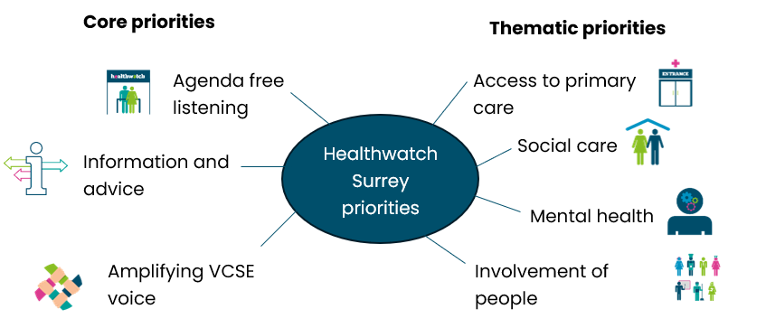

Prioritising helps us to focus our resources and be clear with the health and social care commissioners and services about what we plan to work on and where additional resources will be needed to enable us to provide insight and support.

Our core priorities, as the name suggests, are at the heart of what we do and tend to be fixed from year to year, but our thematic priorities are changeable, based on what we are hearing from local people and set as areas for us to focus our resources on.

This work plan is an internal document, agreed with our Local Healthwatch Advisory Group and sets out our planned activities and outcomes for the year ahead.

Priority area | Planned activities and outcomes
Agenda free listening | Activities:  - 1 x place report or equivalent feedback mechanism per month based on listening events, escalations, general insight and it’s impact.  - To raise awareness through website news and social media content to encourage people to share their experiences  Long term outcomes:  By ensuring we are hearing from a range of local people and amplifying their voice, local services will be delivered to meet people’s needs and ensure a good experience.
Information and advice | Activities:  - 1 Helpdesk and Independent Health Complaints Advocacy awareness raising event per month  - Our volunteers will also raise awareness of these services as brand ambassadors within their local communities and through volunteer led engagement sessions.  - Through our communications, we will promote the Helpdesk and Independent Health Complaints Advocacy service, also sharing the impact of these services.  Long term outcomes:  - An increase in the number of people contacting Healthwatch Surrey to either share their experiences or to get information and advice.  - Able to evidence our involvement in influencing system partners.
Amplifying VCSE voice | Activities:  - We will continue to work with our VCSE partners and help to raise issues with appropriate system partners or link them to the relevant decision makers  - To work with the VCSE Voice Group to share what we are hearing from the people we serve  - To work with VCSE partners and system partners to share insight relating to the Accessible Information Standard and raise awareness of the impact on people when this isn’t adhered to.  Long term outcomes:  - Issues raised by local people with VCSE partners are heard by the relevant decision makers  - The Voice group will work effectively and collaboratively towards shared aims and confidently describe the impact this has had.
All thematic priorities | Activities:  - 1 x workshop for each priority to agree a project plan – this will be held with volunteers or relevant VCSE organisations/system partners. Develop a project plan following this meeting.  - Each month, in that month’s Place, hold 1 listening event for each priority. This will ask local people their experience in relation to the specific priority.  - A specific piece of research to understand in further detail a topic we have been hearing about.  - Raise escalations with relevant service providers and commissioners  - Ensure Healthwatch Surrey volunteers are engaged appropriately with each priority (through the reading panel, workshops, research.  - Liaise with communications for promotion of work, surveys, reports and impact  - Ensure the impact of the work undertaken is clear to all parties.
Access to primary care | Long term outcomes:  - Primary care is meeting the needs of local people  - Better information and advice is available  - Integration of services mean better access to primary care
Social care | Long term outcomes:  - As a team we have a sound understanding of social care  - We can better support local people  - We can better support social care  - Social care listen more to feedback from local people  Overall outcome: Services get better as a result
Mental health | Long term outcomes:  - Effective signposting helping people find support  - Better relationships with all parts of the system who hear feedback on services  Overall outcome: Healthwatch Surrey challenge services to reflect people’s needs
Involvement of people | Long term outcomes:  - Feedback is understood as a requirement for informed decision making  - Equity in listening  - Promotion of Healthwatch Surrey
In line with our priorities we commit as a staff team, Local Healthwatch Advisory Group and volunteers to attend these Boards and Committees. | - Health and Wellbeing Board  - Adult and Health Select Committee  - Surrey Heartlands Integrated Care Board  - Surrey Heartlands Integrated Care Partnership (ICP)  - Children, Families, Lifelong Learning and Culture Select Committee  - Prevention and Wider Determinants of Health Board  - Joint Strategic Needs Assessment (JSNA) Oversight Group  - Quality Performance and Assurance Committee  - Disability Partnership Board  - Carers Partnership Board  - Carers Providers  - Surrey Heartlands Healthcare Inequalities (core 20plus5) and NHS long term plan prevention plan meeting  - Surrey Heartlands JIG  - Surrey Heartlands Health and Care Professional Committee  - Surrey Heartlands Access Board  - Surrey Heartlands Accessible Information Standard Working Group  - Surrey Charities Forum  - VCSE Alliance & VCSE Voice Group  - Surrey Heartlands Digital Inclusion Community  - Communications Groups across Surrey Heartlands, Frimley Health, VCSE groups and Surrey Council  - Healthwatch England Networking meetings  - Boards and committees supporting primary care across Surrey Heartlands and Frimley  - What we’re hearing meetings with Care Quality Commission (CQC), Public Health, Adult Social Care, Surrey Hospitals and at Place.  - Surrey County Council Adult Social Care Partner Update meeting  - Surrey Safeguarding Adults Board  - Surrey Safeguarding Childrens Partnership Engagement Group  - Surrey and Borders Partnership Quarterly update meeting  - Place Engagement meetings  - Place Quality meetings  - Surrey Care Quality Quarterly Strategy meeting  - Dementia Action Strategy Board  - Independent Mental Health Network  - User Voice and Engagement Coordination Group  - Co-production and Insight Group  - Surrey Heartlands Participation and Involvement Group  - LeDeR Governance Panel meetings  - Sexual Health Operational Group  - Patient Experience meetings (various)  - East Surrey First Community Forum  - Place Board meetings  - East Surrey Data Insights

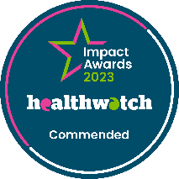
We are proud to be commended in the National Healthwatch Impact Awards, recognising our work helping to improve local NHS and social care. You can view our video highlighting how feedback from local people has been used to make positive changes to health and social care support.

We are committed to the quality of our information.
Every three years we perform an audit so that we can be certain of this.

The Healthwatch Surrey service is run by Luminus Insight CIC, known as Luminus.
Registered office: GF21, Astolat, Coniers Way, Burpham, Surrey, GU4 7HL.

