What we’re hearing

about pharmacy provision in Thames Ditton

  - May 2024

“As I don’t drive and the bus services are infrequent in my area, I have to go out of my way and make special journeys into Esher to get medication and / or seek medical advice. I have to walk and it takes me 30-40 minutes each way which can be problematic as I have an arthritic knee. I need ready and regular access to a pharmacy for both myself and my husband, who has many medical issues, so the closure of this local pharmacy is having a bad impact on us.”

If you would like a paper copy of this document or require it in an alternative format, please get in touch with us.

Contents
Background 3
Survey findings: executive summary 4
Recommendations 4
Detailed survey findings 5
Who did we speak to? 5
The value of pharmacy 6
Thames Ditton Pharmacy closure: what issues were identified? 7
Who is most impacted? 8
To note 9
About Healthwatch Surrey 10
Contact us 10

Background
At the time of the last Pharmaceutical Needs Assessment (PNA) in October 2022 Elmbridge had 20 pharmacies per 100,000 population, one less than the average of 21 per 100,000 across England.*

Local residents and community groups were concerned about the negative impact which the closure of Boots Pharmacy on Thames Ditton High Street was having/will have on their community and shared these concerns with Healthwatch Surrey. We were also being notified about other pharmacy closures across Surrey – 16 since the publication of the PNA in 2022 – and the impact these were having.

In light of the directive from the Surrey Health and Wellbeing Board meeting in March 2024, requesting that the Surrey PNA be re-opened, we set out to build an accurate picture of the level and nature of the impact which the closure of the Boots in Thames Ditton was having / will have on the local population.

Our main engagement mechanism was an online survey. In addition to this we also:
- Held 2 engagement events where we spoke to local people face to face (at a GP surgery and a community hub, including a food bank)
- Ensured paper surveys were available.

The survey was open for approximately 1 month and was promoted via social media, local community groups, local councillors and in local shops.
Uptake of, and enthusiasm for, the survey was high due to strong local feeling about the closure.

* We are aware that there is no set value or expectation set nationally on the ratio of pharmacies per 100,000 people because local geography, population and needs vary and crude rates should not be used as a measure in isolation to compare pharmaceutical provision across local authority areas (Surrey Health and Wellbeing Board, Pharmaceutical Needs Assessment, October 2024).

Survey findings: executive summary
- Residents value the service and clinical expertise which their local pharmacy can provide, but many don’t feel able to travel to get this.
- Travel distance from home is the most important factor for people when visiting a pharmacy, but this is more complex than a crude mileage value – people need to be able to walk or have reliable / accessible / affordable public transport options.
- The closure of Boots in Thames Ditton has left many people without a pharmacy in walking distance. This has had a significant impact on local residents, but it has particularly affected people who are less mobile and need regular medication (many of whom are elderly), those with young children and those with financial concerns.
- Many of those affected are not online, and therefore their voices may not be heard as part of the insights gathering being undertaken by the PNA steering committee.

Recommendations
Based on the survey findings, Healthwatch Surrey have recommended the following to the Surrey PNA Steering Group:
- When evaluating existing / changes to pharmacy provision, the real impact on local residents - based on what they are saying, not a generic distance metric - should be considered.
- How easily residents can walk / get public transport to a pharmacy, and specific local needs in this regard, should help to determine what is considered as “acceptable”.
- Local residents should be kept informed about changes to pharmacy provision in their area, including alternatives in light of planned closures. This recommendation reflects that of Healthwatch England at a national level.
- A range of opportunities to for people to share their views should be offered to residents across Surrey, including non digital methods.

Detailed survey findings

Who did we speak to?
A total of 211 people completed our survey or spoke to us directly about how they were impacted by the closure of Boots on Thames Ditton High Street.
- 45% (95 people) stated that they were impacted by the closure
- Of those impacted, 56% (53 people) were over age 60 and 34% (32 people) were over 70.

Bar chart showing ages of those impacted by the closure of Boots Thames Ditton
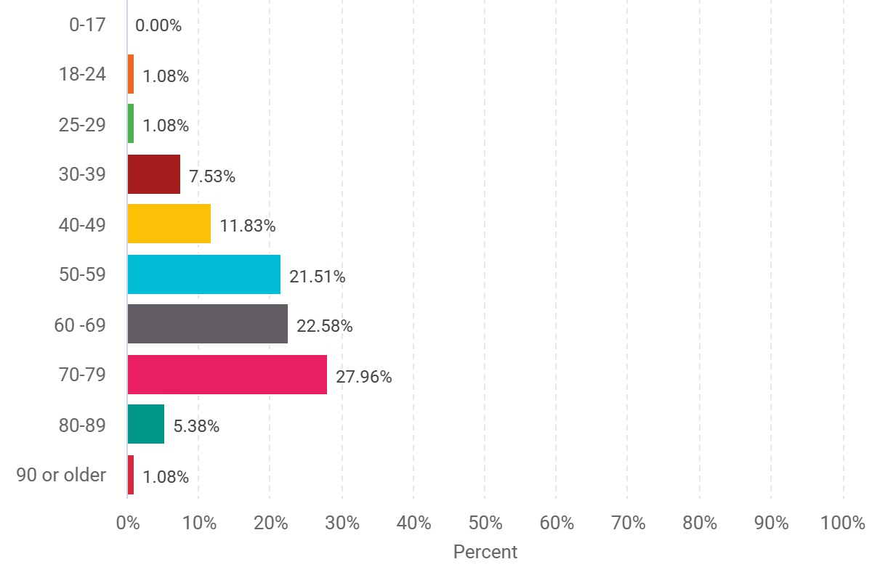

“Have been going to this pharmacy for 34 years, during which time I have become less active due to arthritis. Now aged 77 years of age, I will have to walk further or take the car to collect prescribed medications.”

The value of pharmacy
A national survey conducted by Healthwatch England, with support and input from Healthwatch Surrey, found that only 2% of people have never used a community pharmacy, which underlines the important role community pharmacies play within the health system. Older people were more likely to have used a community pharmacy than younger people in the last three months, reflecting their generally higher needs.

In Elmbridge, 75% (152 people) of our survey respondents would consider going to their pharmacy instead of their GP practice for minor illnesses or health advice. However, for 73% (148 people) the ease of getting to a pharmacy impacted how often they went.*

Bar chart showing those would consider going to their pharmacy instead of their GP practice for minor illnesses or health advice.

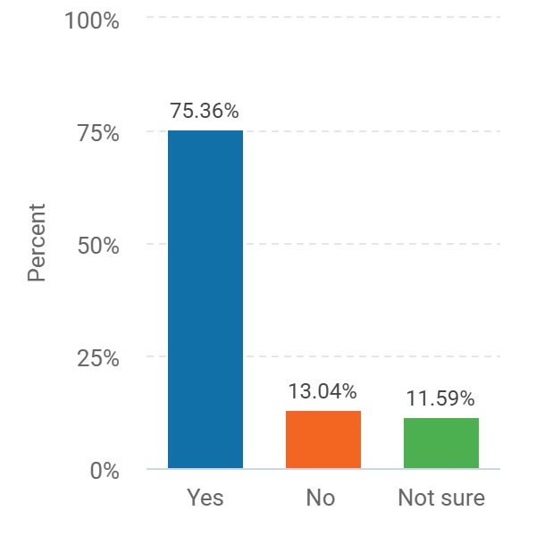

*Statistics are based on those who completed the on-line survey who stated that they live in Elmbridge (203 people)

Thames Ditton Pharmacy closure: what issues were identified?

Accessibility
The closure has left many in the village without a pharmacy within easy walking distance, in an area with limited public transport options.
Whilst this is just an inconvenience for some, many are concerned about how they will now obtain vital medications when they need them.

“I used to use Boots in Thames Ditton village, a short walk for me. I now have to go much further to Thorkhill – it’s a 40 minute round trip walking for me.”

Bar chart showing factors people consider when choosing a pharmacy

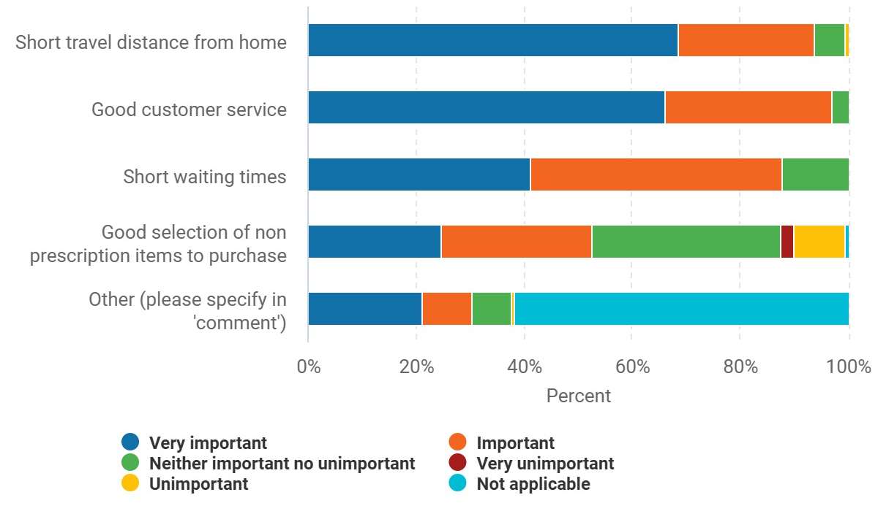

Use of pharmacy
We are aware that GPs in the area are under increasing pressure, with local people feeling frustrated by, amongst other issues, lack of face to face appointments and busy phone lines.

Pharmacy First can only work to relieve some of this pressure if people have a pharmacy which is convenient to get to.

Local residents have told us that the closure of the Thames Ditton pharmacy means that they are now less likely to use pharmacy services, including the expertise and clinical advice of the pharmacist.

“I now have to drive to my nearest pharmacy. I am less likely to pop in for advice or treatment for minor ailments, allergies etc. I’m not sure yet how I will access my regular prescription.”

“We now have to drive to the next nearest pharmacy. It's a long way to walk and there is no public transport that can get us there. So we only go now to collect prescriptions.”

“I travel further for prescriptions and don't pick up non-urgent things like face wash or hay fever tablets.”

Who is most impacted?

Older people and less mobile
Older people and those less mobile, who simply can’t walk the extra distance, are particularly impacted.

“What was an easily accessed excellent local service now involves using buses and makes what should be ‘just popping in to collect my pills’ an expedition.”

“Pharmacy fine and all pleasant and helpful. Not good was having to wait in the rain for an hourly bus and same to return when I am no longer young and fit.”

Young families
Those with young children have also been particularly affected.

“[the closure will have a] huge adverse impact. There is no walkable pharmacy which is hugely inconvenient when you have a baby. Being able to walk to somewhere close by, put the baby in a pram and go with you was so valuable and to be able to pick up emergency items and prescriptions for them.”

“I really struggle now with a baby and a child. I have to visit the pharmacy many times and I don’t drive. It’s incredibly difficult to rely on the kindness of strangers all the time in order to get to a pharmacy, and of course people don’t often have time to plan ahead going to a pharmacy when there is a direct need. The health of our family is definitely suffering.”

“[the impact will be] significant - it is my local pharmacy for myself and my child, no other options in walking distance causing us difficulties.”

Those with financial constraints
We also heard from people – usually frequent pharmacy users - who are concerned about the financial impact of having to travel.

“It will have a big impact. I used the pharmacy regularly and could walk to it. Next nearest pharmacy is much further away and now involves a car trip and there is nowhere free to park.”

“At Thames Ditton food bank we have about 20 elderly people who use the craft table in our community space. They all use Boots so will be really affected. They are most worried about the cost of delivery for their medications.”
Food bank manager

We would like to extend our thanks to all those who shared their experiences with us, and to those who helped to promote the survey within the community.

To note
Any urgent or concerning experiences within this report have been escalated to the appropriate teams. All appropriate information and advice and signposting to complaints processes has already been given.
If you would like more information or examples of what people have shared, please get in touch.

About Healthwatch Surrey
Healthwatch Surrey champions the voice of local people to shape, improve and get the best from NHS, health and social care services. As an independent statutory body, we have the power to make sure decision makers listen to the experiences of local people.

We passionately believe that listening and responding to local people's experiences is vital to create health and social care services that meet the needs of people in Surrey. We seek out people’s experiences of health and care services, particularly from people whose voices are seldom heard, who might be at risk of health inequalities and whose needs are not met by current services. We share our findings publicly and with service providers and commissioners to influence and challenge current provision and future plans.

We also provide reliable and trustworthy information and signposting about local health and social care services to help people get the support they need.

Contact us
Website: www.healthwatchsurrey.co.uk
Phone: 0303 303 0023
Text/SMS: 07592 787533
Email: enquiries@healthwatchsurrey.co.uk
Address: Freepost RSYX-ETRE-CXBY, Healthwatch Surrey, Astolat, Coniers Way, Burpham, Guildford, Surrey, GU4 7HL.
healthwatchsurrey
HW_Surrey
healthwatch_surrey
Healthwatch Surrey

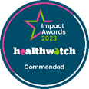
We are proud to be commended in the National Healthwatch Impact Awards, recognising our work helping to improve local NHS and social care. You can view our video highlighting how feedback has enabled us to make positive changes to health and social care services.

We are committed to the quality of our information.
Every three years we perform an audit so that we can be certain of this.

The Healthwatch Surrey service is run by Luminus Insight CIC, known as Luminus.
Registered office: GF21, Astolat, Coniers Way, Burpham, Surrey, GU4 7HL.

