What we’re hearing

about pharmacy provision in Guildford & Waverley

  - May 2024

“The Merrow Park closure had a big impact. The pharmacy was part of the community, conveniently located and brilliant for advice for minor ailments. It has become much harder to get prescriptions, and even harder to get advice instead of going to the GP as it feels like pharmacy staff in our remaining pharmacy on Epsom Road are doing their best, but too busy. There is no privacy. The pharmacy is small, and I don't feel I can take the time to talk to staff as so many people are waiting in line.”

If you would like a paper copy of this document or require it in an alternative format, please get in touch with us.

Contents
Background 3
Survey findings: executive summary 4
Recommendations 5
Detailed survey findings 6
Who did we speak to? 6
The value of pharmacy 7
Guilldford & Waverley pharmacy closures: what issues were identified? 9
Who is most impacted? 12
To note 14
About Healthwatch Surrey 14
Contact us 14

Background
We were hearing from local residents and community groups who were concerned about the negative impact which the closure of the ‘Little Boots’ Pharmacy on Cranleigh High Street, Boots, Merrow Park and Lloyds in Sainsburys, Burpham were having/will have on them. We were also being notified about other pharmacy closures across Surrey –16 since the publication of the PNA in 2022 - and the impact these were having.

We set out to build an accurate picture of the level and nature of the impact which the closures in Cranleigh, Merrow and Burpham were having / will have on the local population.

Our main engagement mechanism was an online survey. We also had paper copies of the survey available, and, following requests from local residents, ensured these were available for distribution to community groups.

The survey was open for approximately one month and was promoted via social media, local community groups, local councillors and in local shops.
Uptake of, and enthusiasm for, the survey was high due to strong local feeling about the closure.

Survey findings: executive summary
- Residents value the service and clinical expertise which their local pharmacy can provide – they are often the most visible and accessible part of the health system.
- The impact of the closure of one pharmacy on the alternative provision in the area is a huge concern for local residents – if alternatives don’t meet their needs in terms of capacity, space or opening hours the value of the service is hugely reduced.
- Travel distance from home is the most important core indicator for people when visiting a pharmacy, but this is more complex than a crude mileage value – people need to be able to walk, or have reliable / accessible / affordable public transport options.
- Good customers service is also considered to be critically important, but people’s confidence in this is eroded if a pharmacy is seen to not have sufficient capacity.
- Some of those affected are not online, and therefore their voices may not be heard as part of the Citizens Panel.

Recommendations
Based on the survey findings, Healthwatch Surrey have recommended the following to the Surrey Pharmaceutica Needs Assessment (PNA) Steering Group:
- When evaluating existing / changes to pharmacy provision, the real impact on local residents - based on what they are saying, not a generic distance metric - should be considered.
- Consideration of alternative pharmacy provision must take in to account opening hours and capacity to deal with increased customer numbers.
- How easily residents can walk / get public transport to a pharmacy – and specific local needs in this regard based on local demographics- should help to determine what is considered as “acceptable”.
- Local residents should be kept informed about changes to pharmacy provision in their area, including alternatives in light of planned closures. This recommendation reflects that of Healthwatch England at a national level.*
- A range of opportunities to for people to share their views should be offered to residents across Surrey, including non-digital methods.

* “[we recommend] Better communication of pharmacy closures and transparency on temporary closures.” Pharmacy: what people want. Healthwatch England, April 2024. Available at: https://www.healthwatch.co.uk/sites/healthwatch.co.uk/files/Pharmacy%20what%20people%20want.pdf

Detailed survey findings

Who did we speak to?
A total of 218 people completed our survey.
- 60% (41 people) of those in Cranleigh stated that they were impacted by the closure of the Boots pharmacy on the High street
  - Of those impacted, 60% (24 people) were over age 60 and 40% (16 people) were over 70.*
- 89% (129 people) of those in Guildford were impacted by the closure of Boots, Merrow or Lloyds in Sainsburys, Burpham, with many stating that the closure of both had been particularly difficult
  - Of those impacted, 44% (56 people) were over age 60 and 16% (20 people) were over age 70**

Bar chart showing ages of those impacted by the closure of Boots on the High Street in Cranleigh.

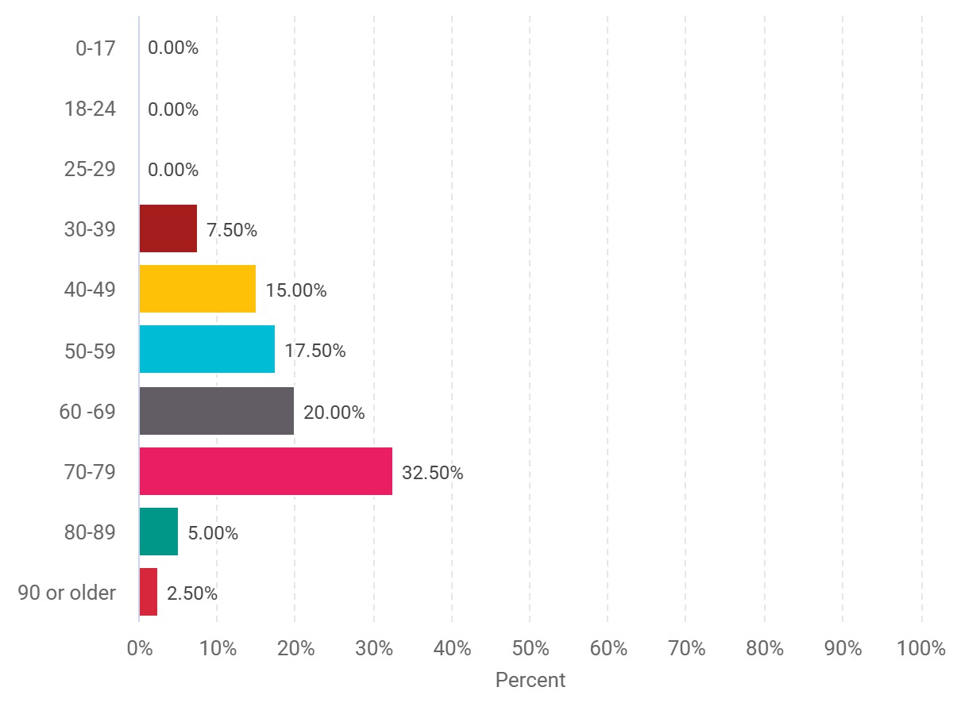

*One of the 41 people chose not to answer the question regarding their age.
** One of the 129 people chose not to answer the question regarding their age.

Bar chart showing ages of those impacted by the closure of Boots, Merrow or Lloyds in Sainsburys, Burpham.

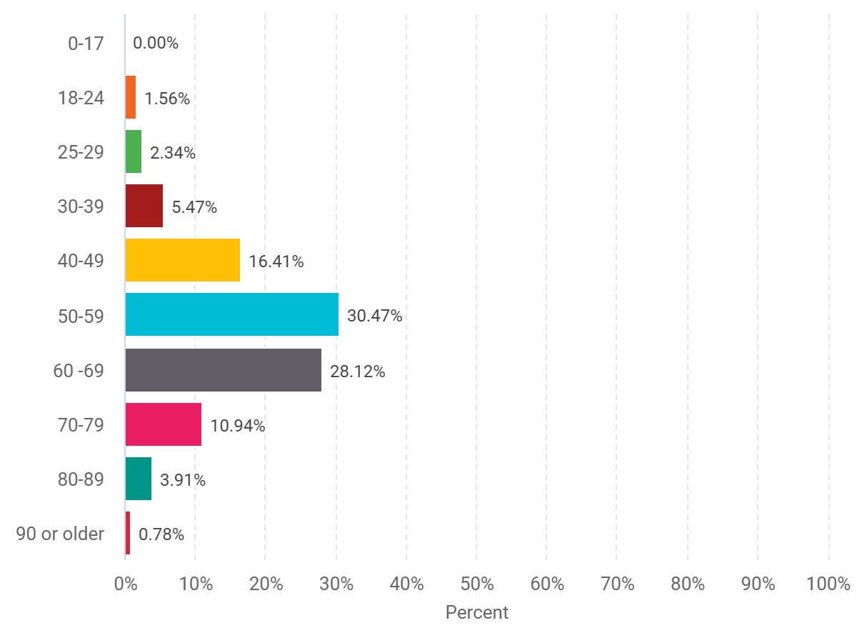
“As the pharmacy was opposite the doctors’ surgery it was most convenient for the elderly. Due to the closure and no use of a car the only suitable pharmacy is in Guildford – a bus ride is the only solution.”
Guildford resident

The value of pharmacy
A national survey conducted by Healthwatch England –with support and input from Healthwatch Surrey - found that only 2% of people have never used a community pharmacy, which underlines the important role community pharmacies play within the health system. Older people were more likely to have used a community pharmacy than younger people in the last three months, reflecting their generally higher needs.

In Cranleigh, 51% (39 people) would consider going to their pharmacy instead of their GP practice for minor illnesses or health advice. However, for 61% (45 people) the ease of getting to a pharmacy impacted how often they went.*

In Guildford, 75% (109 people) would consider going to their pharmacy instead of their GP practice for minor illnesses or health advice. Here, for 81% (118 people) the ease of getting to a pharmacy impacted how often they went.**

Pie chart showing those in Cranleigh who would consider going to their pharmacy instead of their GP practice for minor illnesses or health advice.

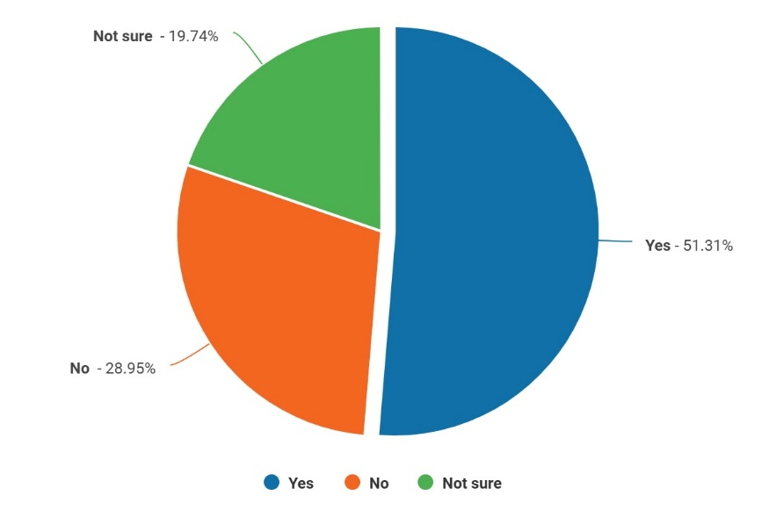

Those in Guildford who would consider going to their pharmacy instead of their GP practice for minor illnesses or health advice.

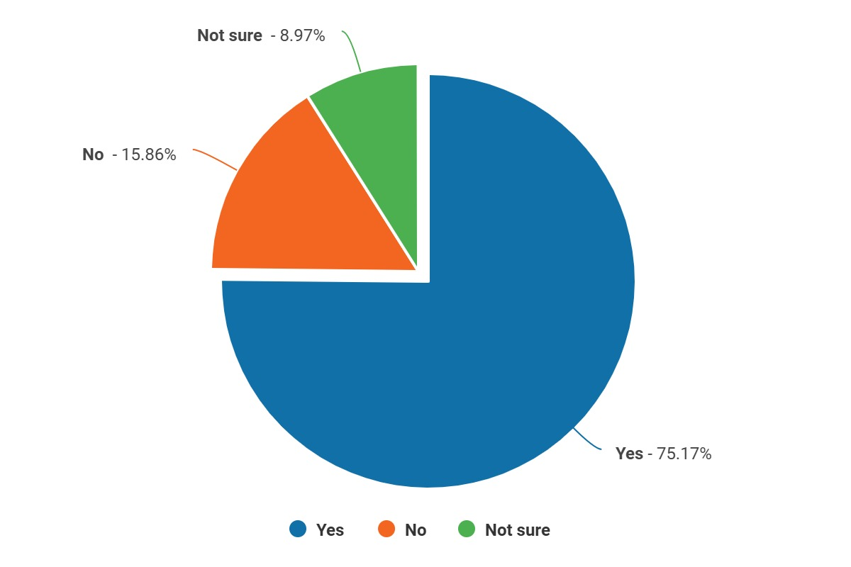

*Statistics are based on those who completed the on-line survey who stated that they live in Waverley (76 people)
**Statistics are based on those who completed the on-line survey who stated that they live in Guildford (145 people)

Guildford & Waverley pharmacy closures: what issues were identified?

The knock on effect of closures
One of the biggest issues identified is the impact that the closure of one pharmacy has on another, in terms of waiting times and capacity to deliver clinical care. This impact erodes people’s confidence and belief in the value that their pharmacy can offer, particularly when good customer service is very highly valued.

- In Cranleigh, 96% (73 people) thought that good customer service was either “important” or “very important” when considering which pharmacy to visit.*
- In Guildford, 95% (138 people) thought that good customer service was either “important” or “very important” when considering which pharmacy to visit.**

Bar chart showing the factors people in Cranleigh consider when choosing a pharmacy.

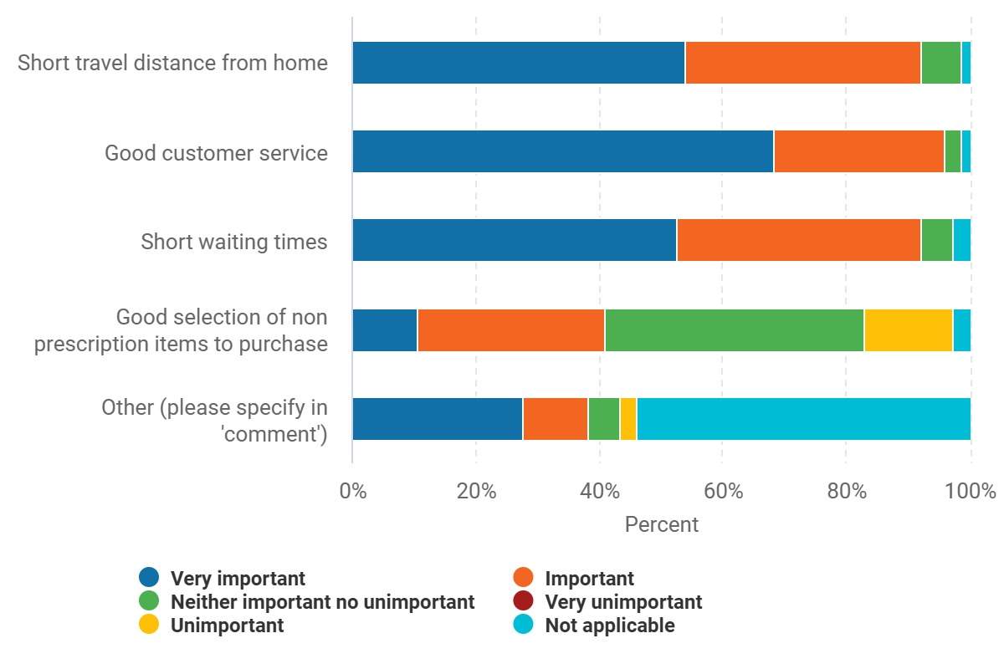

Bar chart showing the factors people in Guildford consider when choosing a pharmacy.

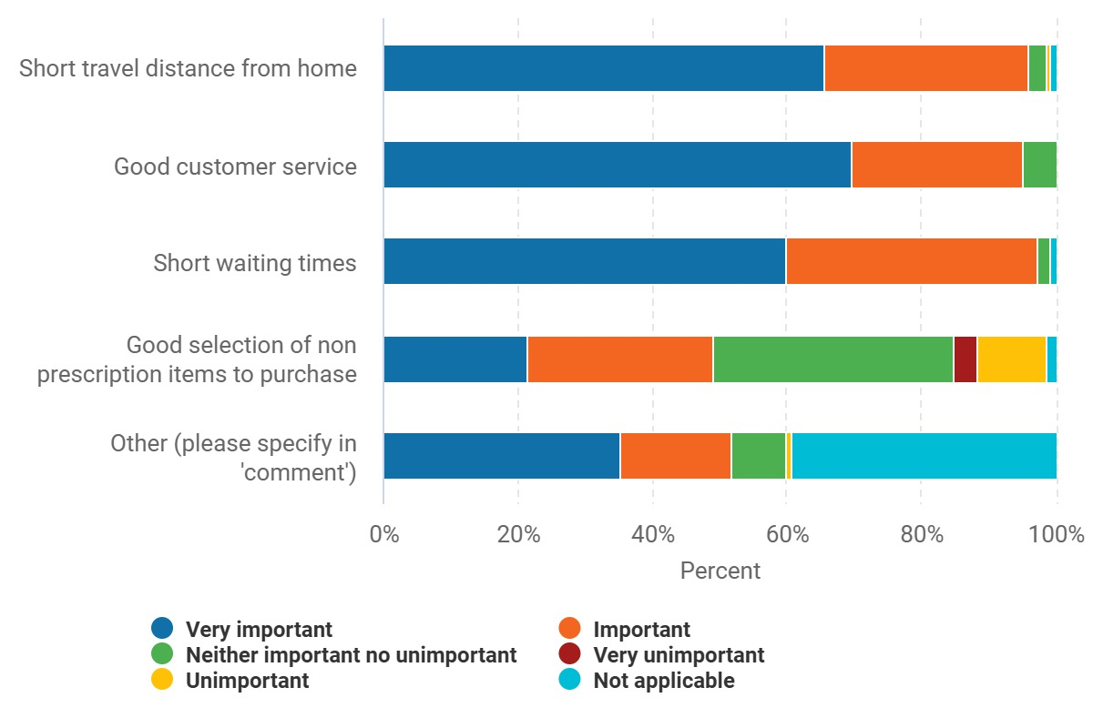

“All their customers had to go to the two remaining pharmacies who are unable to cope with the increased demand, leading to long queues.”
Cranleigh resident

“Lloyds Sainsburys was within walking distance. Boots Merrow was across from my GP surgery. I now have to drive to the only remaining pharmacy in the area for all prescriptions. Parking is a nightmare and when I finally get there, the queues are an hour long with 10-15 people waiting. It’s just impossible. The store is tiny and simply cannot accommodate so many customers. The staff are run off their feet. Just awful.”
Guildford resident

*Statistics are based on those who completed the on-line survey who stated that they live in Waverley (n=76)
**Statistics are based on those who completed the on-line survey who stated that they live in Guildford (n=145)

Use of pharmacy
National research from Healthwatch England has found that, in general, people welcome Pharmacy First (for 5 of the 7 conditions in this directive, more people were more likely to go to a pharmacy than unlikely).

However, Pharmacy First can only succeed if people’s belief and confidence in pharmacy is maintained. Many people felt that the alternative pharmacy provision in the area did not meet their needs, both from a capacity and an operational perspective.

“Long waiting times for OTC meds and prescriptions and overworked pharmacists - so how on earth are they going to cope with people using them rather than the doctor?”
Cranleigh resident

“Although there is another pharmacy within our catchment, it is very small (approximately 30 square metres serving space) and unable to cope with the areas of Merrow and Burpham combined.”
Guildford resident

“[it’s an] Inconvenience, would use [the now closed pharmacy] when also doing a shop. Free Parking outside and disabled parking, so access with my disabled daughter was easier.”
Guildford resident

“It has caused extra waiting times at other pharmacies in the area, including the one I use most often. This was also a late-night pharmacy.”
Guildford resident

“I couldn’t get prescriptions anymore because the other local pharmacy had opening hours that were too short and always has an incredibly long wait.”
Guildford resident

Locality and accessibility
Nationally, an average of 43% of people said a pharmacy would be their first choice (amongst a range of 12 services), because it is easier for them to get to than other services.

- In Cranleigh, 92% (70 people) thought that travel distance from home was either “important” or “very important” when considering which pharmacy to visit.*
- In Guildford, 96% (139 people) thought that travel distance from home was either “important” or “very important” when considering which pharmacy to visit.**

These figures reflect those of the October 2022 Pharmaceutical Needs Assessment (78% cited “it is close to where I live” as the most important factor in pharmacy location).

“[the closure has had a] huge impact. Meant that everyone goes to Boots in Merrow. No choice. Had to drive 20 mins to another pharmacy to try to get the urgent steroid I needed.”
Guildford resident

*Statistics are based on those who completed the on-line survey who stated that they live in Cranleigh (n=76)
**Statistics are based on those who completed the on-line survey who stated that they live in Guildford (n=145)

Who is most impacted?

Older people and less mobile
Older people and those less mobile, who find the extra travel distance difficult, are particularly impacted.

“I now have to drive 5 miles or take a return bus journey which would take a minimum of one and a half hours, if the bus actually runs and the pharmacy is quick. I have mobility problems so I opt for the drive to Fairlands.”
Guildford resident

“[the impact is] profound. I have had my driving licence revoked and now have to travel on two buses to access medications vital to my health at least twice a week.”
Guildford resident

Those with financial constraints
We also heard from people – usually frequent pharmacy users - who are concerned about the financial impact of having to travel.

“This pharmacy was in walking distance from home and my GP practice. After closure I had to drive to the next closest one which became completely overwhelmed. When it became impossible to use this one I resorted to using the next closest in Guildford town centre which involved a much longer journey, was time consuming and expensive as had to pay for parking.”
Guildford resident

“In the beginning I used to go to Lloyds pharmacy in Sainsburys. They closed so then I switched to Kingfisher Drive [which is] further to drive. That pharmacy was over 2 miles from home. Bearing in mind that’s a round trip of about 5 miles – [I’m concerned about] the pollution and petrol price.”
Guildford resident

“I can no longer walk to a pharmacy. I have to park in the town centre. Often have to return the following day for items or later on for ‘to follow’ items, meaning I have to pay again.”
Guildford resident

We would like to extend our thanks to all those who shared their experiences with us, and to those who helped to promote the survey within the community.

To note
Any urgent or concerning experiences within this report have been escalated to the appropriate teams. All appropriate information and advice and signposting to complaints processes has already been given.

If you would like more information or examples of what people have shared, please get in touch.

About Healthwatch Surrey
Healthwatch Surrey champions the voice of local people to shape, improve and get the best from NHS, health and social care services. As an independent statutory body, we have the power to make sure decision makers listen to the experiences of local people.

We passionately believe that listening and responding to local people's experiences is vital to create health and social care services that meet the needs of people in Surrey. We seek out people’s experiences of health and care services, particularly from people whose voices are seldom heard, who might be at risk of health inequalities and whose needs are not met by current services. We share our findings publicly and with service providers and commissioners to influence and challenge current provision and future plans.

We also provide reliable and trustworthy information and signposting about local health and social care services to help people get the support they need.

Contact us
Website: www.healthwatchsurrey.co.uk
Phone: 0303 303 0023
Text/SMS: 07592 787533
Email: enquiries@healthwatchsurrey.co.uk
Address: Freepost RSYX-ETRE-CXBY, Healthwatch Surrey, Astolat, Coniers Way, Burpham, Guildford, Surrey, GU4 7HL.
healthwatchsurrey
HW_Surrey
healthwatch_surrey
Healthwatch Surrey

We are proud to be commended in the National Healthwatch Impact Awards, recognising our work helping to improve local NHS and social care. You can view our video highlighting how feedback has enabled us to make positive changes to health and social care services.

We are committed to the quality of our information.
Every three years we perform an audit so that we can be certain of this.

The Healthwatch Surrey service is run by Luminus Insight CIC, known as Luminus.
Registered office: GF21, Astolat, Coniers Way, Burpham, Surrey, GU4 7HL.

