Healthwatch Surrey

Enter and View Programme

Priory Court Care Home

January 2023

Table of Contents
Table of Contents 2
1. Summary 3
2.2 Why we visited 3
2.3 Summary of key findings 4
2.4 Acknowledgements 4
2.5 Disclaimer 4
2. What we found 5
2.1 Description of service 5
2.2 Environment 5
2.3 Facilities 6
2.4 Staff 8
2.5 Covid measures 9
3. What we heard 9
3.1 Who we heard from 9
3.2 Daily life 9
3.3 Food 10
3.4 Activities 11
3.5 Care 12
3.6 Feedback from staff 13
3.7 Visiting health care professionals 15
3.8 Visiting 16
3.9 Staying in touch 16
3.10 Feedback 16
4. Next steps 18
5. Service provider response 19
RESPONSES MUST BE PROVIDED WITHIN 10 WORKING DAYS OF RECEIPT OF OUR REPORT TO ENSURE THEY ARE INCLUDED IN THE FINAL PUBLISHED REPORT 20
6. Appendix 20
6.1 What is Enter & View? 20
6.2 Purpose of Visit 21
6.3 Strategic drivers 21
6.4 What we did 21

Summary

Why we visited
During the pandemic, we were not able to carry out any face-to-face engagement at care homes, and therefore we have been concerned that the voice of care home residents has not been heard, and residents and families may be unaware of the existence of Healthwatch as their independent champion. Enter and View is one way Healthwatch Surrey can gather information about services and collect views of service users, their carers and relatives, as well as staff. We are working with Surrey County Council, Surrey Heartlands and CQC on our programme visits to care homes across Surrey and we are carrying out a series of visits during 2022/23.
As well as giving residents an opportunity to share their general views of the care home, our focus is on finding out whether residents and families are aware of or have used any means of providing feedback about the care home.
In addition to face-to-face visits we are also running a survey for friends and family – available at: https://www.smartsurvey.co.uk/s/HealthwatchSurreyCareHomeFamilyFriendsSurvey/ and as paper copies. This will run for a year, links to the survey will be promoted on Healthwatch Surrey’s communication channels and we have encouraged other stakeholders and care homes to also distribute the survey
Details of visit:
Service Address | Priory Court Care Home
Service Provider | Future Care Group
Date and Time | 9th September 1130-1330
Authorised Representatives | Katharine Newman, Errol Miller, Jane Owens, Virginia Fenton.
Contact details | Healthwatch Surrey GF21, Astolat, Coniers Way, Burpham, Surrey, GU4 7HL  enquiries@healthwatchsurrey.co.uk  Helpdesk: Telephone: 0303 303 0023 (local rate number)SMS (text only): 07592 787533

Summary of key findings
Our overall impression of the home was very good. Residents were occupied, clean and tidy and family members were very positive about the care they received. The manager is very proactive, and the staff told us they are happy.
We have three recommendations based on our visit:
- To ensure that the names of the resident’s key worker is displayed in each bedroom.
- To replace the broken slabs in the courtyard garden.
- We recommend that the laundry button system in use at Priory Court is shared by Surrey County Council and Surrey County Council as good practice with other homes.

Acknowledgements
Healthwatch Surrey would like to thank residents, their families, and the staff at Priory Court Care Home, for their contribution to our Enter and View programme.

Disclaimer
This report relates to findings observed on the specific date set out on P3. Our report is not a representative portrayal of the experiences of all residents, their families and staff, only an account of what was observed and contributed at the time.

What we found

Description of service
Priory Court Care Home, Old Schools Lane, Ewell Village, Epsom, KT17 1TJ. Website: https://www.priorycourtcare.co.uk/
Provided by: Future Care Group
Registered manager: Rommel Villanueva
Capacity: 87 residents (CQC) currently 86 residents. At the time of our visit 7 beds were commissioned as Step Down beds. The contract had been initially set up to provide Discharge to Assess beds, these beds became rehab/re-ablement beds.
At the time of our visit, the home was registered as providing care for persons requiring nursing or personal care, and treatment of disease, disorder or injury.
The home is divided into four units; residential (Tulip); residential dementia (Rose); nursing (Sunflower); nursing dementia (Oak).

Environment
The accommodation is split across three floors. Access to the first and second floor is via a staircase and three spacious lifts.
The ground floor is for residents who need residential care. The first floor is for those requiring nursing care and the second floor is for residents with dementia and nursing care needs.
The home was very clean and fresh smelling.
Efforts had been made to ensure there were sensory areas in the home and ‘doll therapy’ was available for people who would benefit from this. There was a commitment to ensuring that the environment was stimulating for residents.
We saw evidence that our visit was expected, with our posters displayed throughout the home. As the home is large, the registered manager had proactively duplicated our posters so that our visit was well advertised throughout the home.

Facilities
We saw a number of attractive lounge areas, which were medium sized and had comfortable seating.

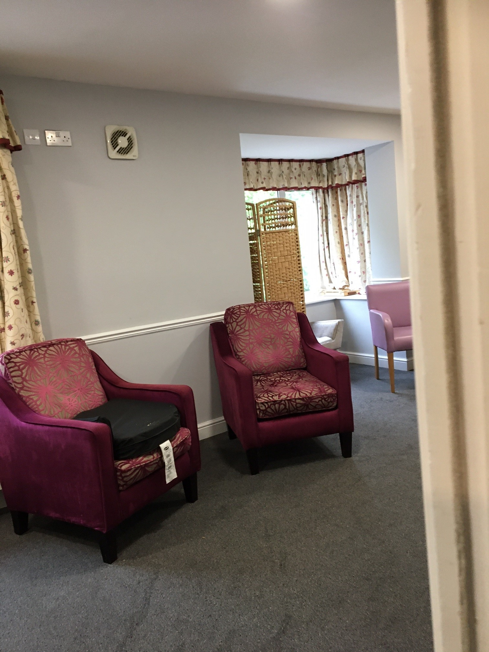
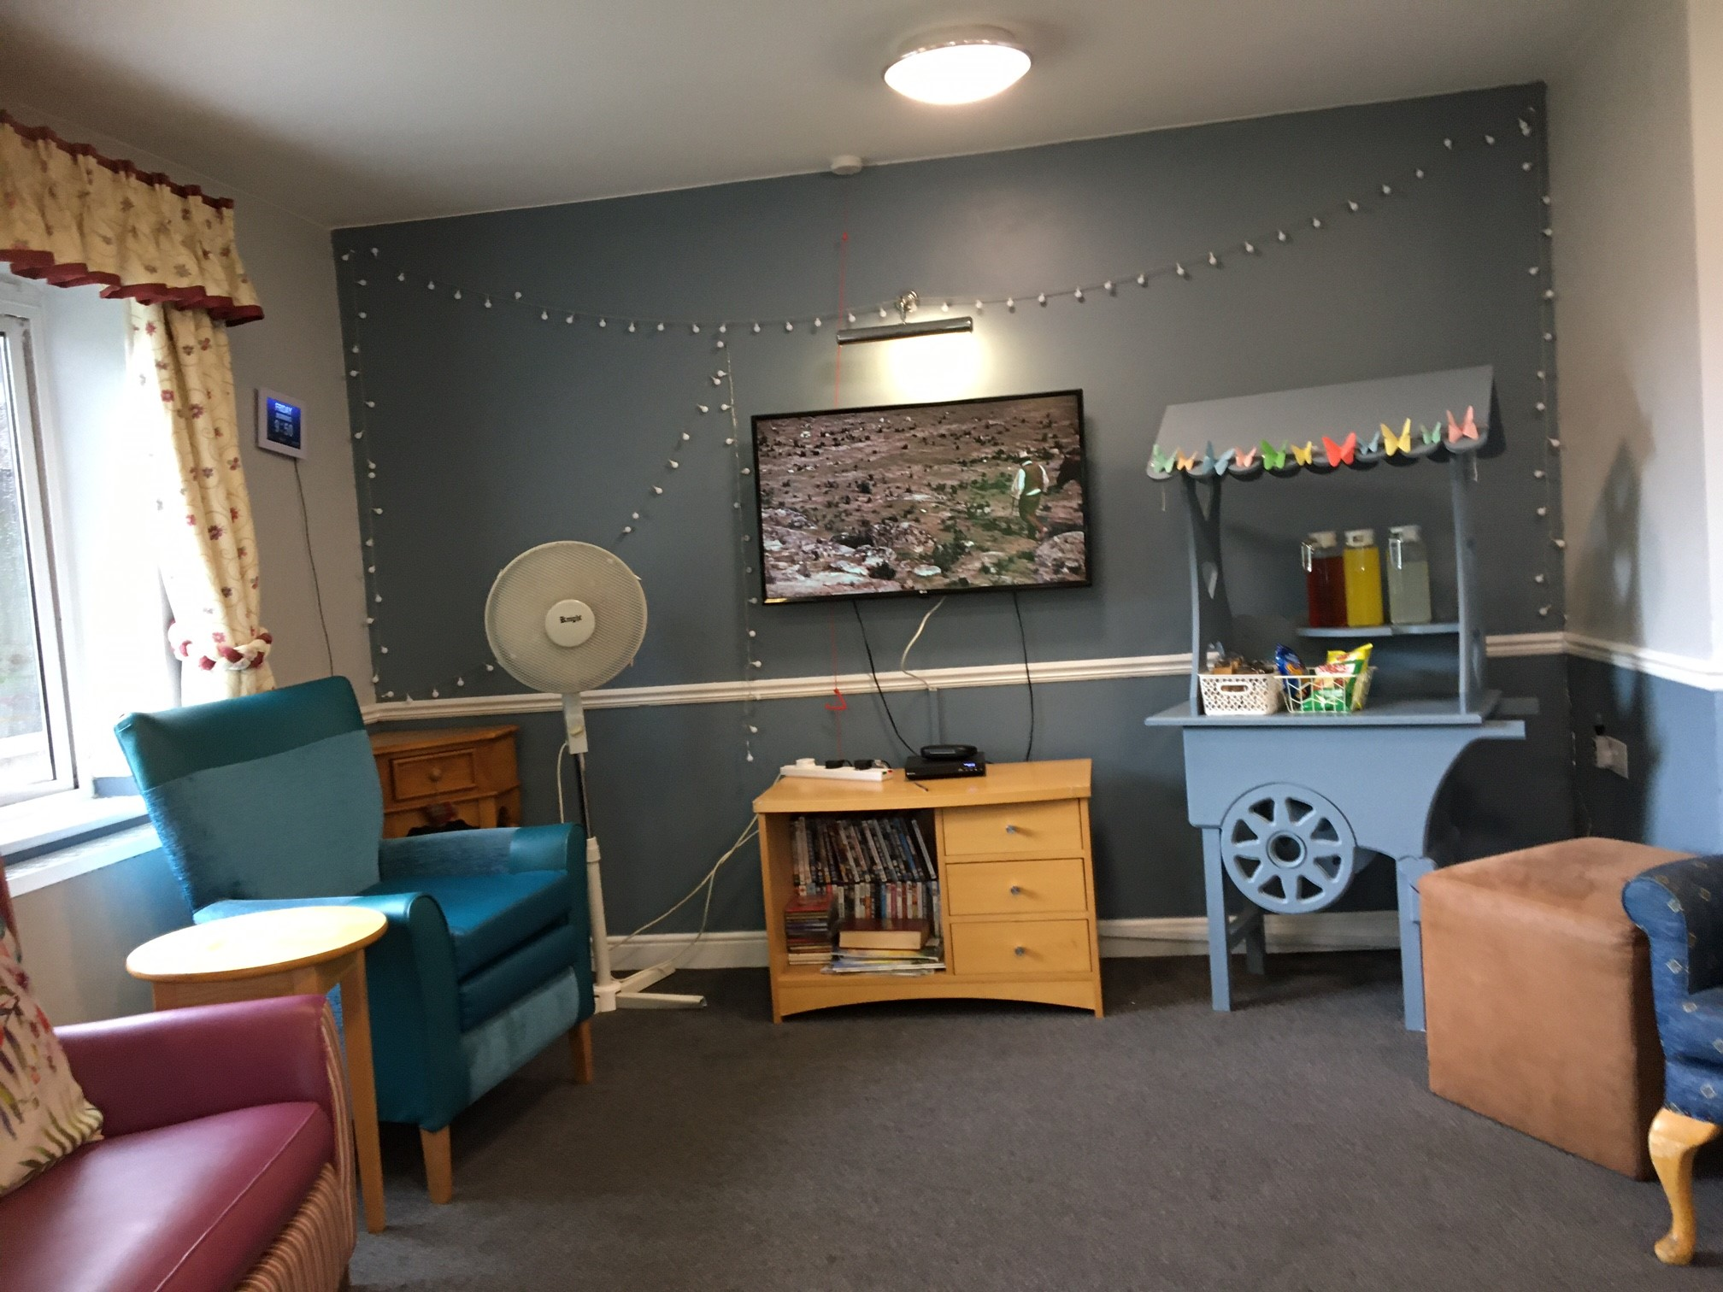
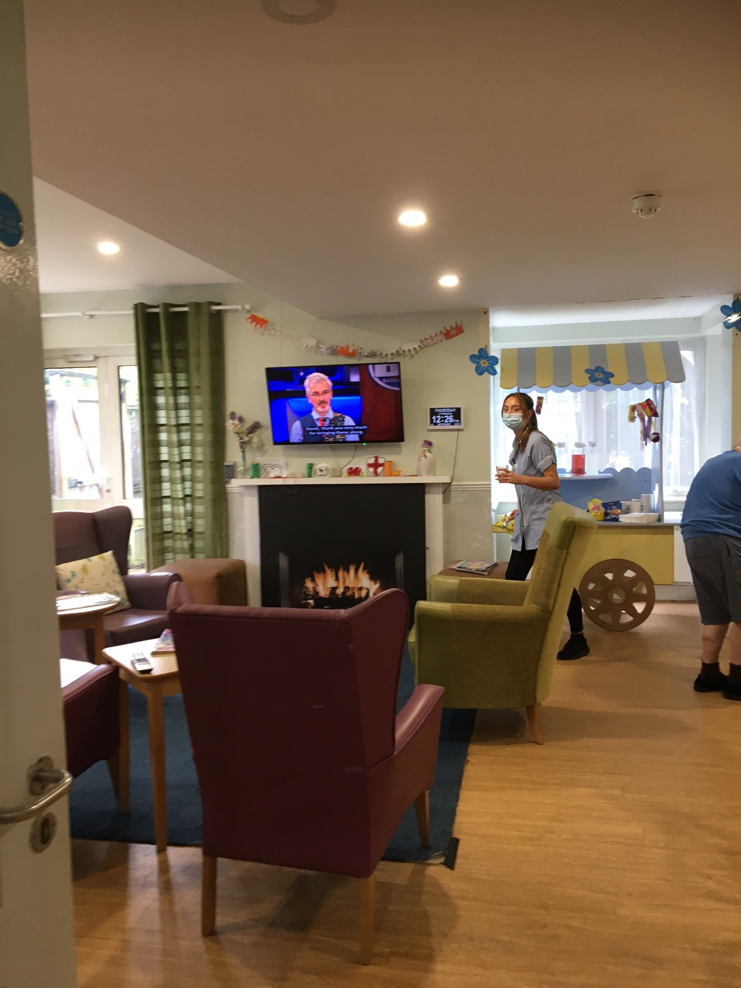

On the second floor (residents with dementia) there is a sensory relaxation room for their exclusive use, where residents can receive aromatherapy-based hand and foot massages. There is adjustable lighting and music. Along the corridor, there are sensory displays.
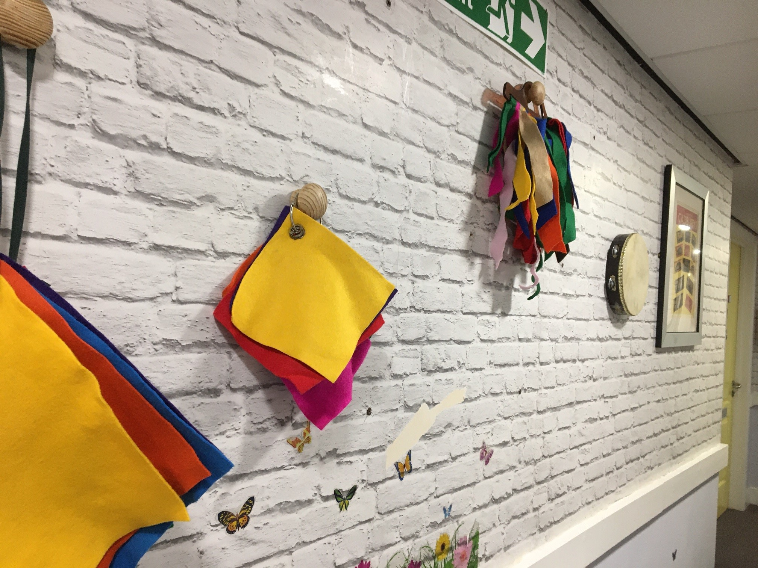
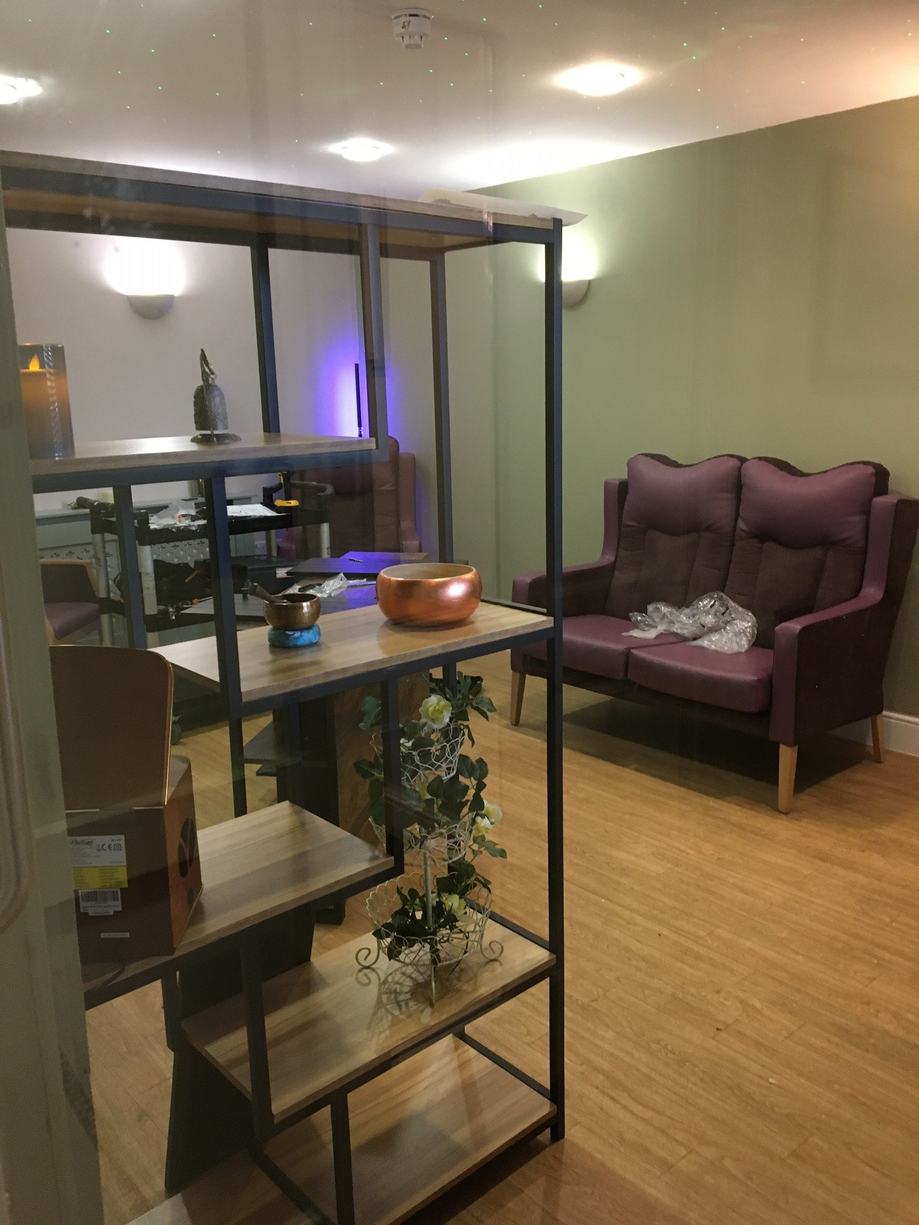

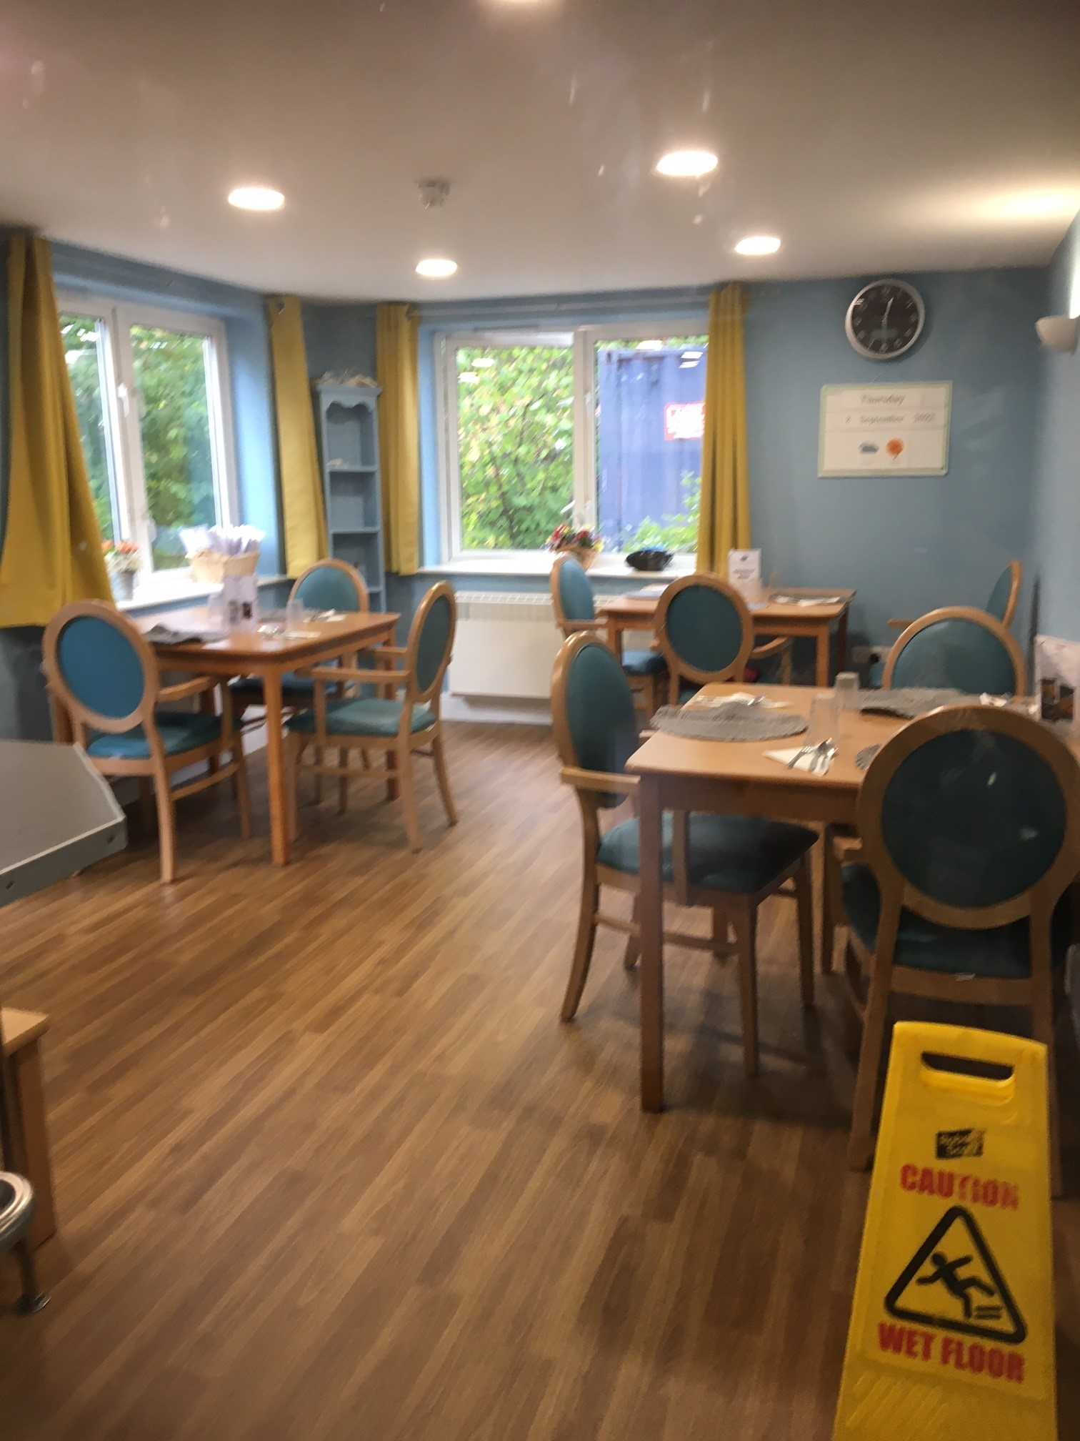

We saw a number of dining areas,
with small tables to encourage sociability.

There is also a cinema room.

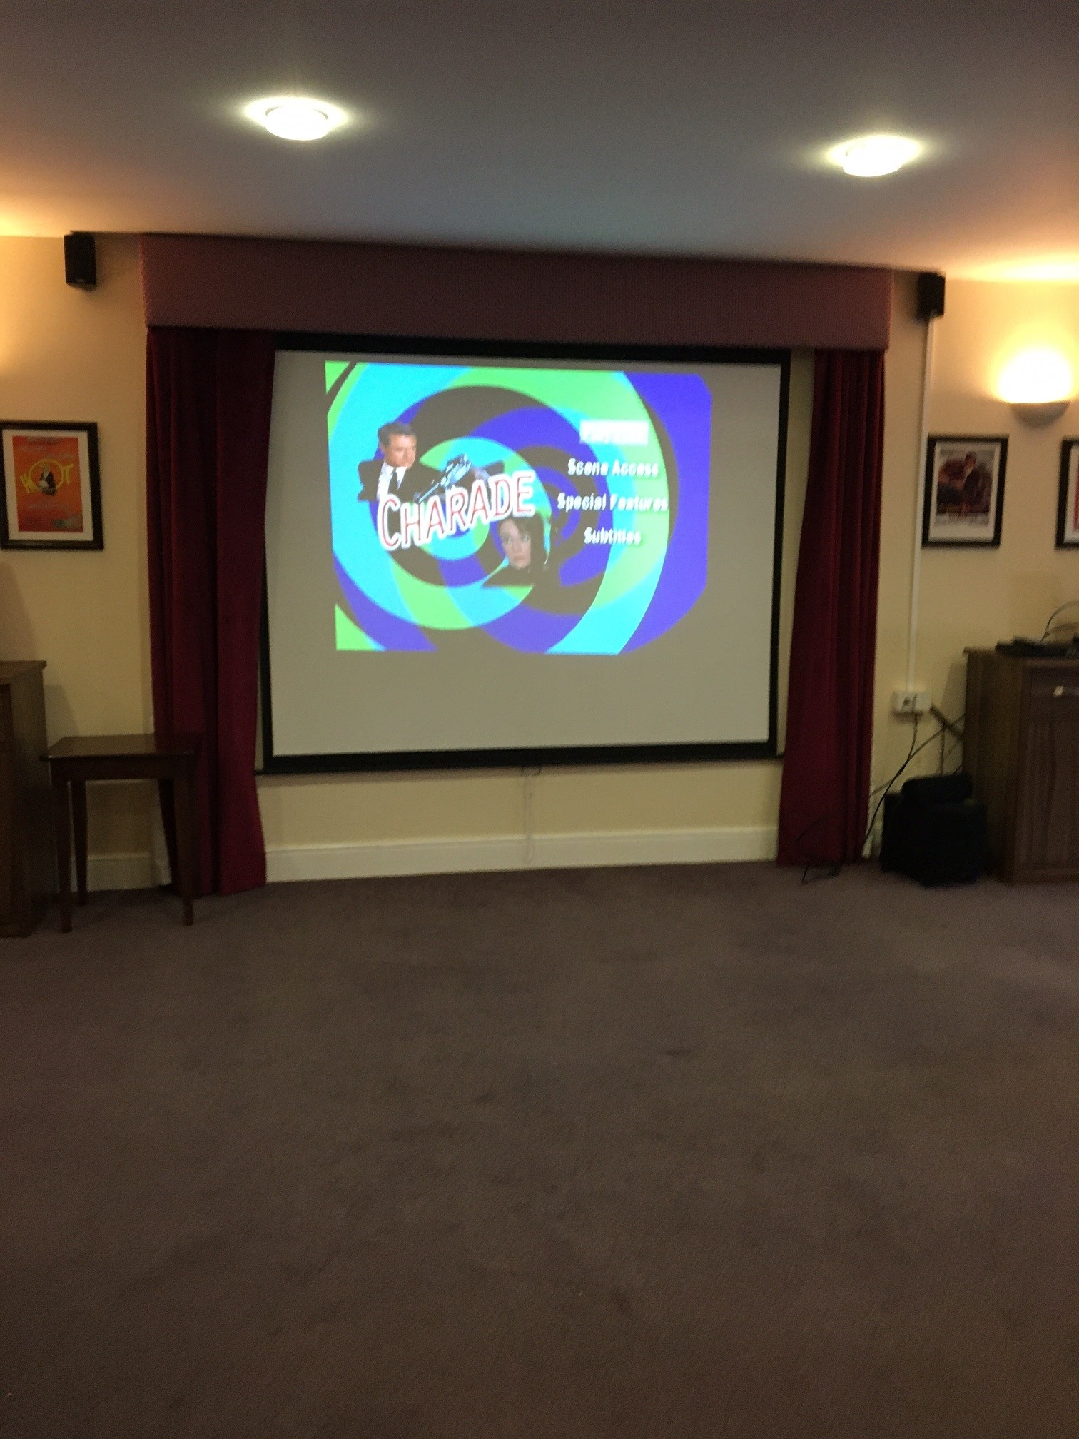

Bedrooms
The bedrooms are personalised as the resident wishes, with curtains, ornaments, photos and pictures, all bedrooms have a WC and basin, some have a shower. All have grab rails, and all are wheelchair accessible , there are some shared wheelchair accessible shower facilities.

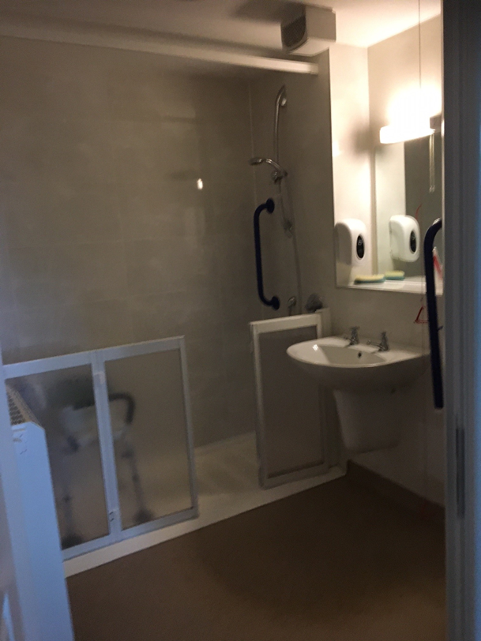
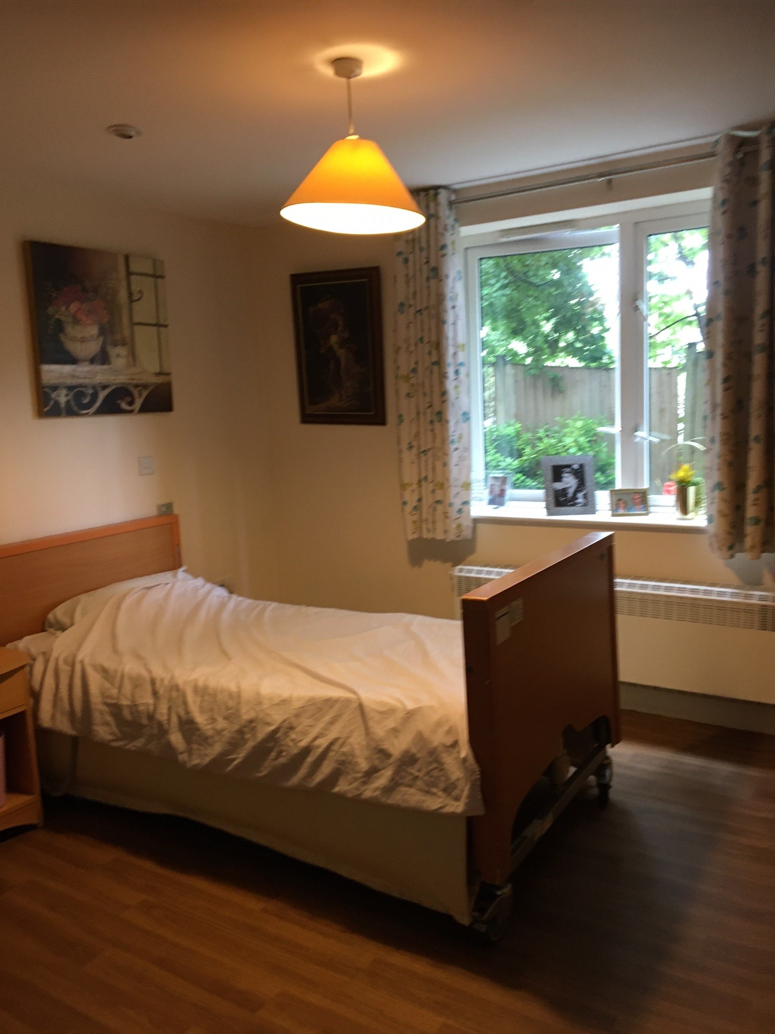

The garden
There was a small courtyard garden. The registered manager pointed out that there were some broken slabs which he planned to replace.
Recommendation: We recommend that these are replaced for added safety.
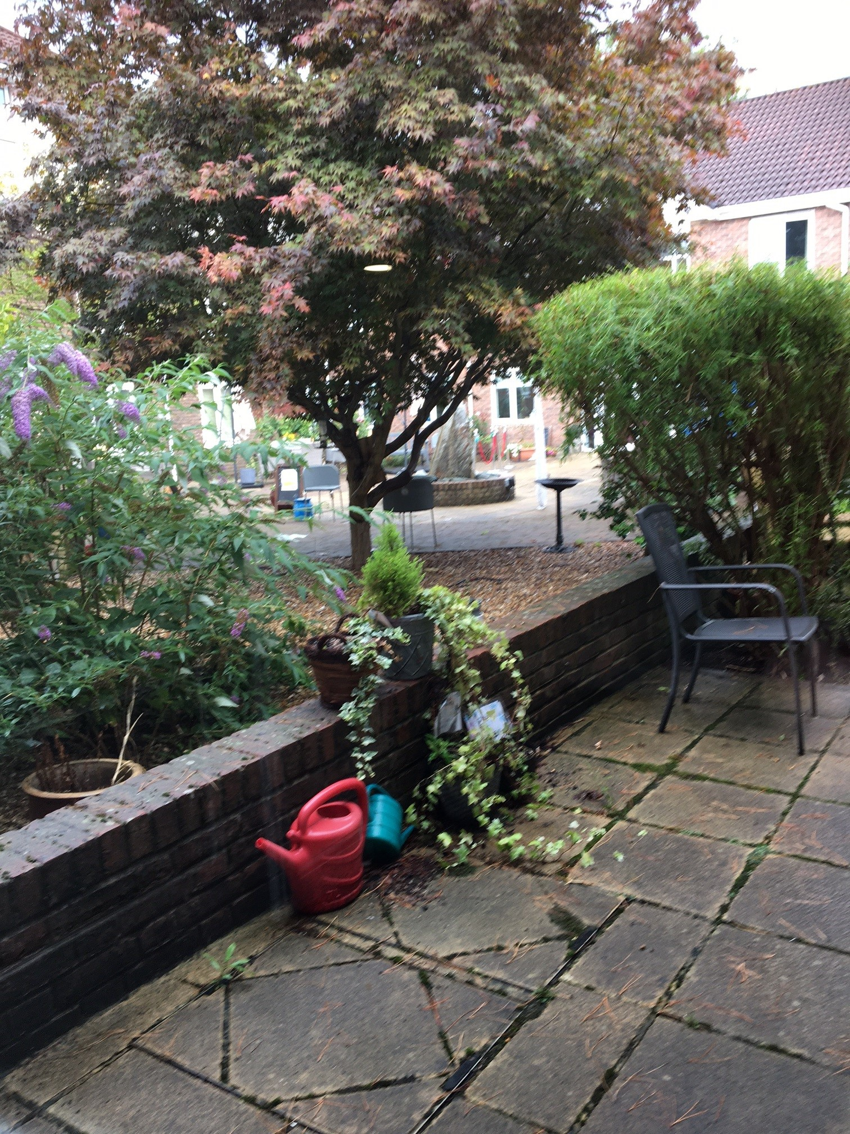

The laundry service
A system is available whereby the resident (or their family) can buy a set of buttons engraved with the resident’s name. The buttons are sewn into the resident’s garments, reducing the issue of lost items in the laundry. The registered manager reported that this had been very beneficial in terms of reducing lost laundry items. However, this was not mandatory, and not all families were prepared to pay for the service.
Recommendation: We recommend that Surrey County Council and Surrey County Council share this as good practice with other homes.

Staff
The manager told us that at the time of our visit the home was fully staffed and not using any agency staff on that day. He told us that occasionally they do use agency staff at night and sometimes during the day (and they had used more during the pandemic). On the main nursing unit, (Sunflower) we were told there are three nurses and eight carers during the day, and two nurses and four carers during the night. There is a Clinical manager who works across the Sunflower unit and Nursing dementia unit (Oak).
On the residential unit (Tulip Suite) – where there is capacity for twenty two residents, we were told there is one senior care officer, four care staff, one Senior care officer, two care staff. At night there is one senior care officer , one care staff.
On the residential dementia unit (Rose Suite) we were told there were thirteen residents, one senior care officer, two care staff during the day, and at night- one senior care officer and one carer.
The registered manager told us that the housekeeping team was fully staffed at the time of our visit. There are two members of the maintenance team and a head of residents’ services.
There is a receptionist and a weekend receptionist.

Covid measures
All Healthwatch Authorised Representatives provided negative Lateral Flow Test results on the day of our visit, and we all wore face masks. We saw evidence of Covid safety in the entrance hall, with disposable masks and hand sanitizer available.

What we heard

Who we heard from
We spoke to four residents and heard from five family members via our paper questionnaire which the care home had shared in advance of our visit. We spoke to eight members of staff.

Daily life
We heard positive feedback from residents. One person told us “ I am as happy as I can be”; others told us that they “pick and choose which activities” and another person told us they “enjoy reading the newspaper”.
Family members gave us positive feedback, one family member said:
“This was the best home I visited in 2021. Welcoming and a lot of open spaces. Friendly faces. I was very impressed when I saw their dementia unit”.
Bedroom doors were made to look like the front door of a house, and memory boxes were displayed alongside. On the dementia floor we were shown residents boxes and magazines which had been created by staff, with the input of family members, to tell the resident’s life story or significant memories, which a care worker could discuss with them.
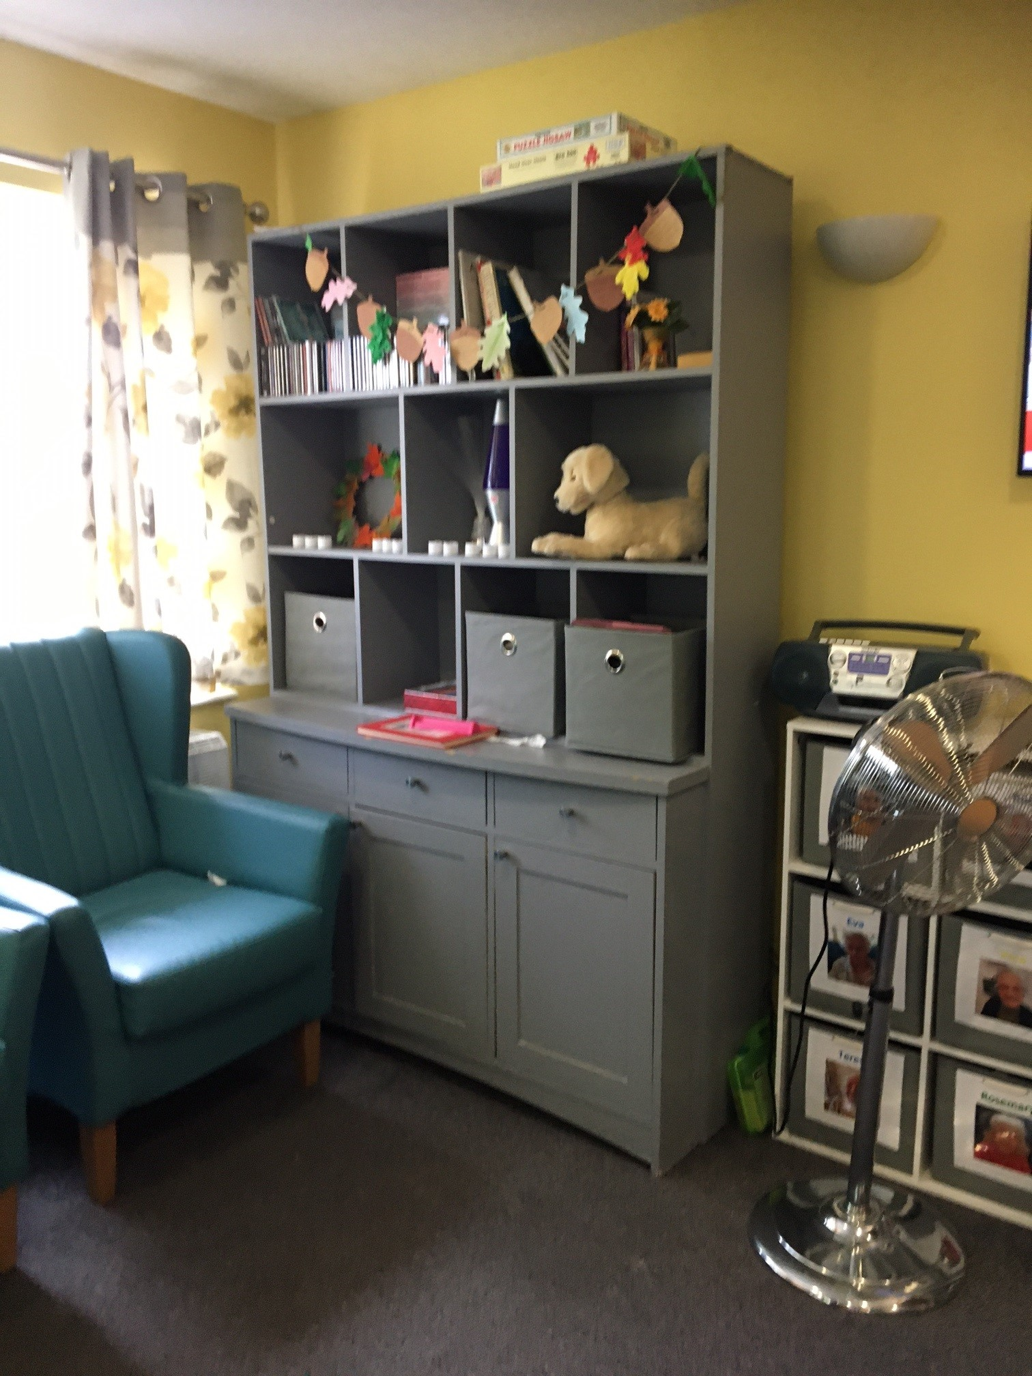
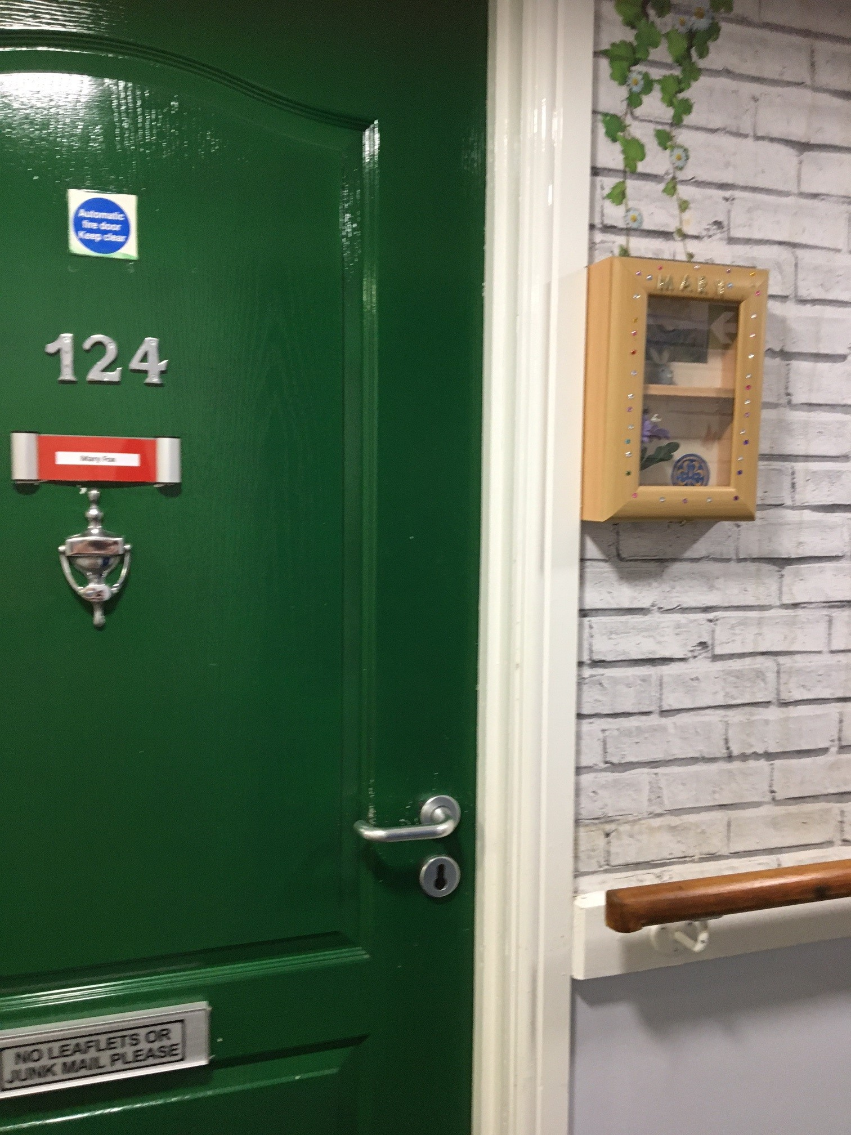

Food
We heard very positive feedback about the food. The catering is provided by an in house team.
“There is plenty of it, it’s very tasty and there’s a good variety”.
The registered manager told us that the menu is reviewed seasonally, and is on a three week rotation, the Chef has meetings with residents and their families to review what they like.
We were told there are always two choices for mains at dinner. At breakfast there are hot and cold choices. At lunch there are also two main options and soup.
They have also recently introduced ‘Night Bites’ for snacks after the evening meal.
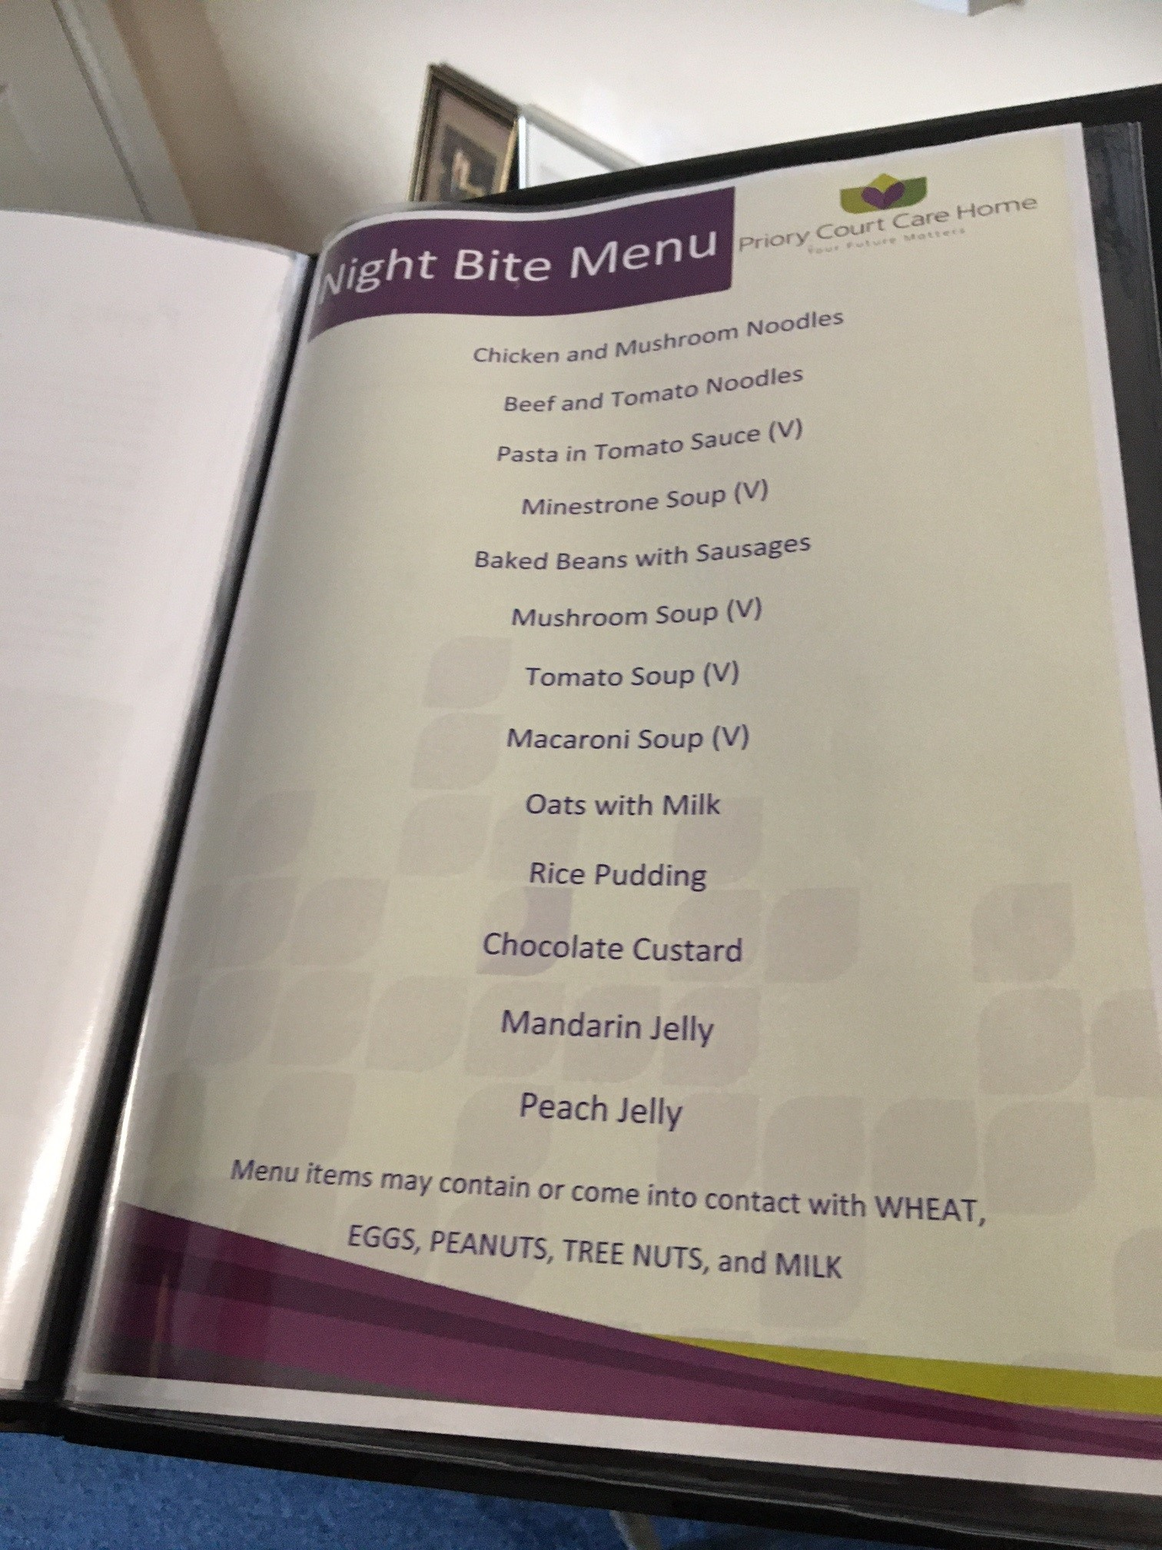
We also saw ‘Keeping Hydrated’ leaflets displayed in bedrooms.
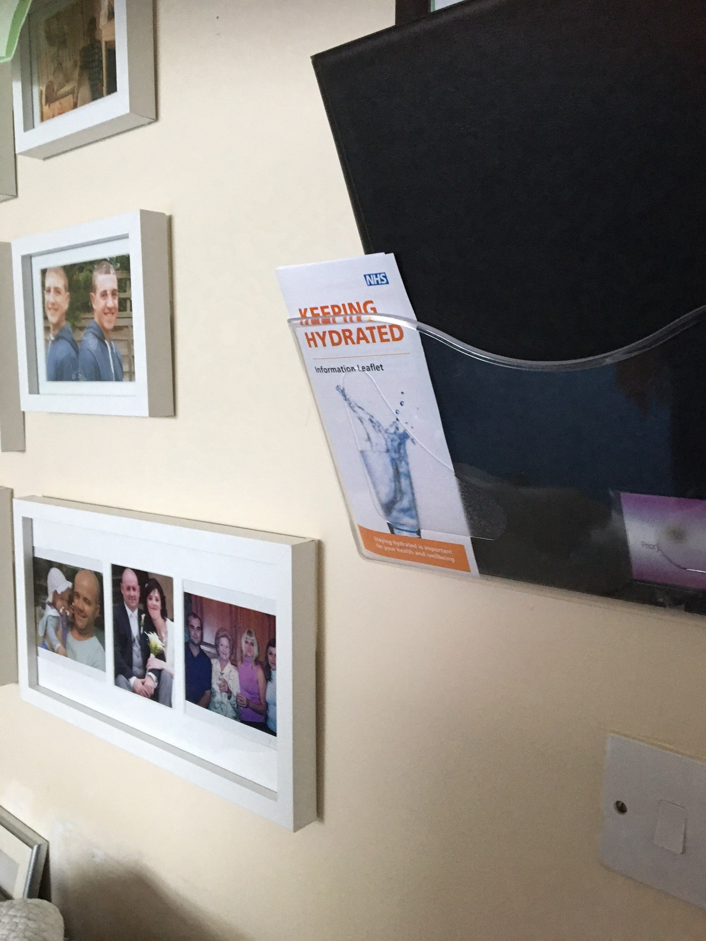

The manager told us that dieticians from CSH are providing training to the home’s chefs on fortifying food. Each department within the home has updated information on modified diets. GPs and CSH are working together locally to minimise the use of protein shakes.

Activities
The manager told us that they aim to have four lifestyle/activity team members – one per department, if possible, one for cover at weekends with activities, two per weekend and staff.

Staff told us that there were numerous plans being made for events and open days at the home in the coming months to encourage engagement with friends and family members.
A family member told us “There are regular activities to entertain residents and visitors”.

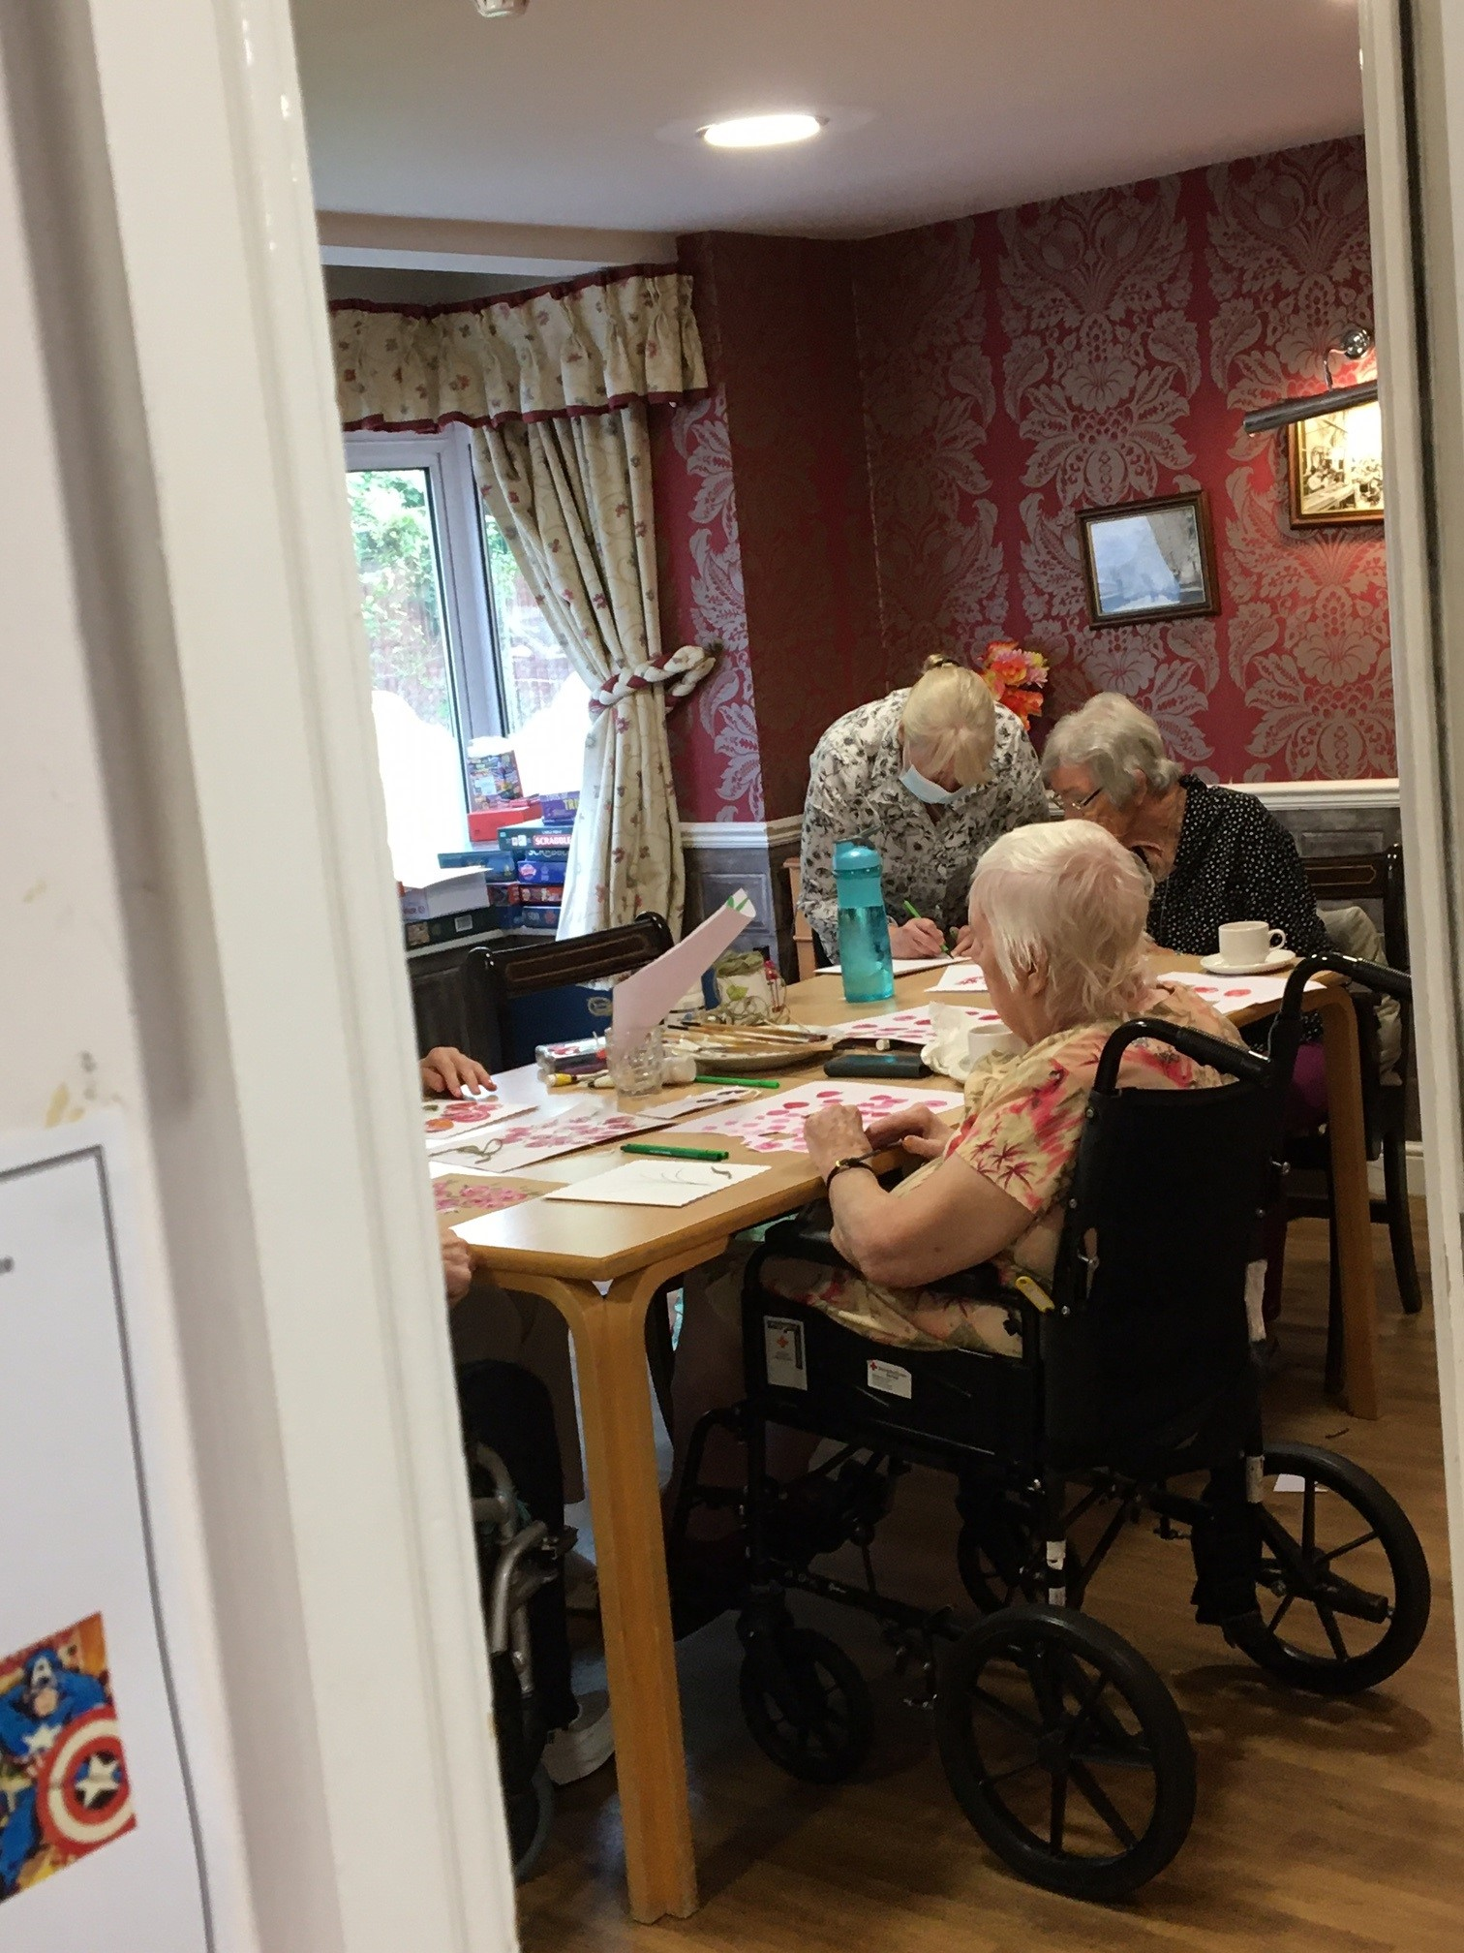
We saw evidence of activities- people doing arts and crafts during our visit and displays on the wall. We saw an area dedicated to doll therapy.
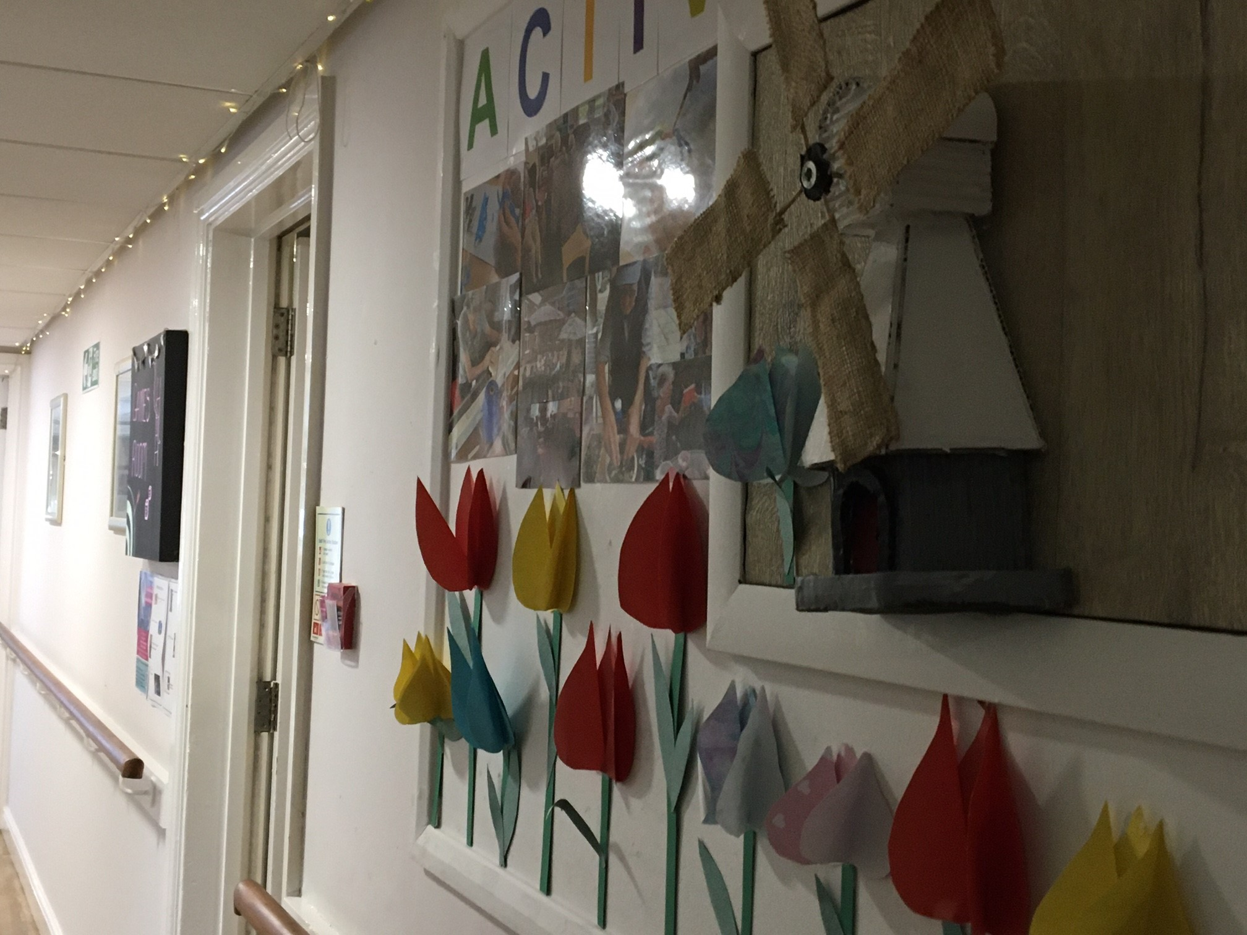

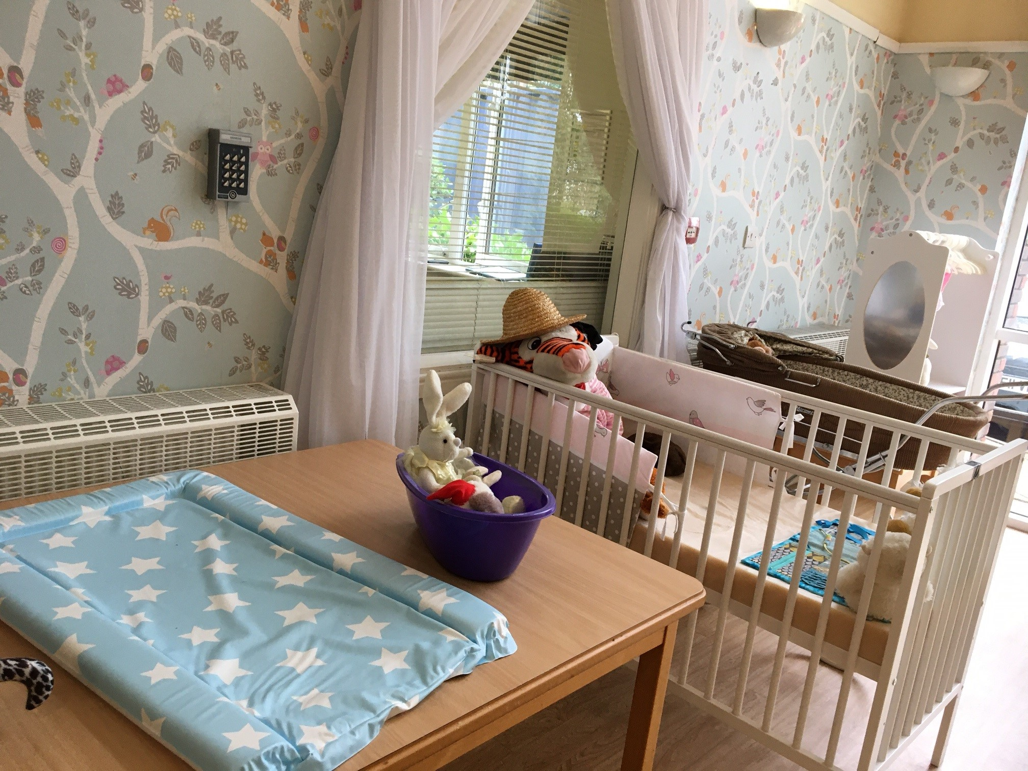
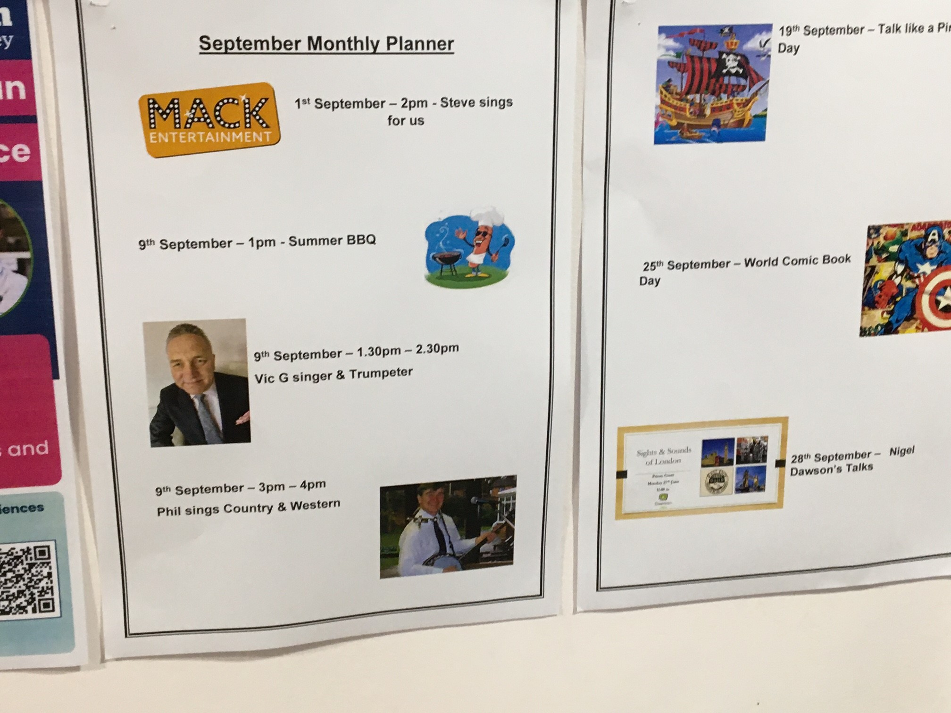

There are two regular hairdressers, who visit on Tuesday and Fridays, they have a booking system with 45 minute appointments.
The manager told us that the home is starting to take residents out to the local area again – they want to develop a relationship with a local barber shop to give residents a ‘proper’ barber shop experience, with proper shaves.

Care
Overall, we heard very positive feedback from family members about the care received. “Mum is always clean and presentable when I visit”.

Family members were not aware of any differences between daycare, nighttime care and weekend care.
“I generally visit during daytime so don’t see much of the care that goes on in the evenings, but no issues have come to notice”.

“Weekend staff are mostly the same as the weekday staff”.
Some people were aware of a named key worker,

“The key worker gives me update on my mother’s condition regularly, she makes it a point to see or meet with me when I visit”.
others were not, and this did not necessarily matter to them.
“I don’t know named senior carer involved with my mum. All staff are friendly and inform us if there are changes”.

We saw evidence that key worker names were displayed in some rooms but not all.
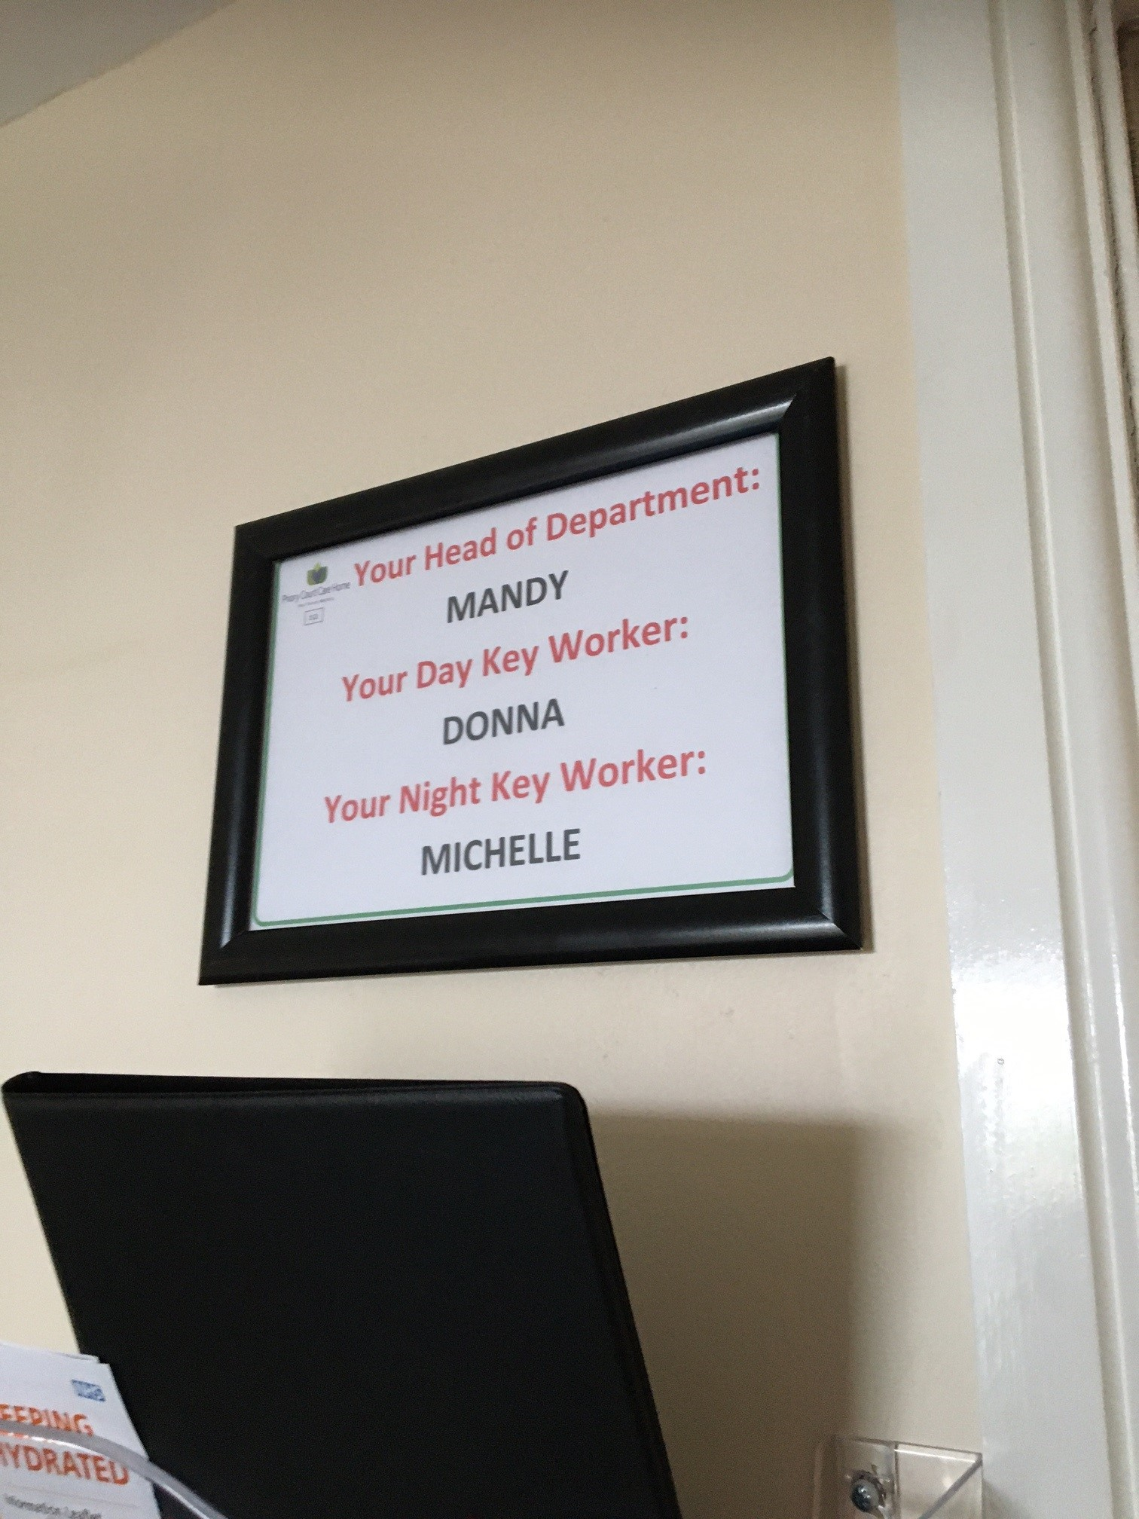

We heard that family members were aware of their resident’s care plan, many were involved in writing it.
“They’ve shown me the care plan of my mum and involved me. They took a lot of information to get to know my mum.”
The manager told us that they hold clinical risk meetings once per week where they discuss high risk residents.
They look out for any skin integrity problem/ UTIs /chest infections etc. and families kept up to date and informed.

The manager has introduced electronic records, and an I-pad is used for daily rounds. They hold one health and safety round, one activities round, mealtimes round and managers round. The manager told us “I invite carers to come with me and do a walk round, we watch out for health and safety issues, high hazards”.
The manager told us that by using the electronic data, he looks at trends analysis e.g., if there are twenty residents with expressed (challenging) behaviour he looks at records/graphs etc. and analyses who has the most episodes or incidents, and when it is– for example are they restless before lunch.
He looks at 3 months’ worth of data e.g., number of falls. He looks at day/time/staff x department for trends.
When we spoke to staff, they were also positive about the new software as it made it easier to maintain records and documentation.

Feedback from staff

We spoke to a range of staff, including the Registered Manager, Dementia Care Manager, Chef Manager, a nurse, receptionist and three care assistants.
Staff reported that Priory Court was a ‘lovely home’, and they were appreciative of the support they had from their managers. It was reported that managers would help when needed with any role in the home. Managers at the home were described as ‘approachable’ and it was noted they had an ‘open door’ policy - staff and residents were welcome to speak to them. A staff member commented on the ‘family feel’ to the home and said, ‘they like to talk, and I like to listen’ and said how much she enjoyed speaking with the people who live at the home.
Several staff spoke about the commitment to improvement at the home from the managers. One staff member said ‘they’re trying to improve it every day – they’re always coming up with new ideas’. Staff spoken with reported that there was a stable staff team, and this allowed for continuity of care. It was noted by several staff that they benefited from always ‘having a nurse on hand’ to ask for support if needed. One staff member said, ‘lots of our job is observation – paying attention to see how people are and if there are any changes we should be reporting’. Another staff member said, ‘it’s a good home – myself and my colleagues treat people with respect’. Teamwork was praised by a staff member who said ‘it lifts you up having a good team to work with’
Staff reported good relationships with the families of the people who lived at the home and said that they would raise any concerns with them or via email with the managers if this was what they wished to do.
It was apparent that having a dedicated Dementia Care Manager at the home was very beneficial. Recommendations had been by the Dementia Care Manager made concerning how the physical environment could be managed to meet the needs of people who have dementia who live at the home. The Dementia Care Manager was completing a post-graduate qualification that would help her to do her job effectively and ensure that practice in the home in relation to dementia reflected current best practice. The Dementia Care Manager described dementia care as her ‘passion’ and reported that she was fortunate to work with colleagues who shared her interest.
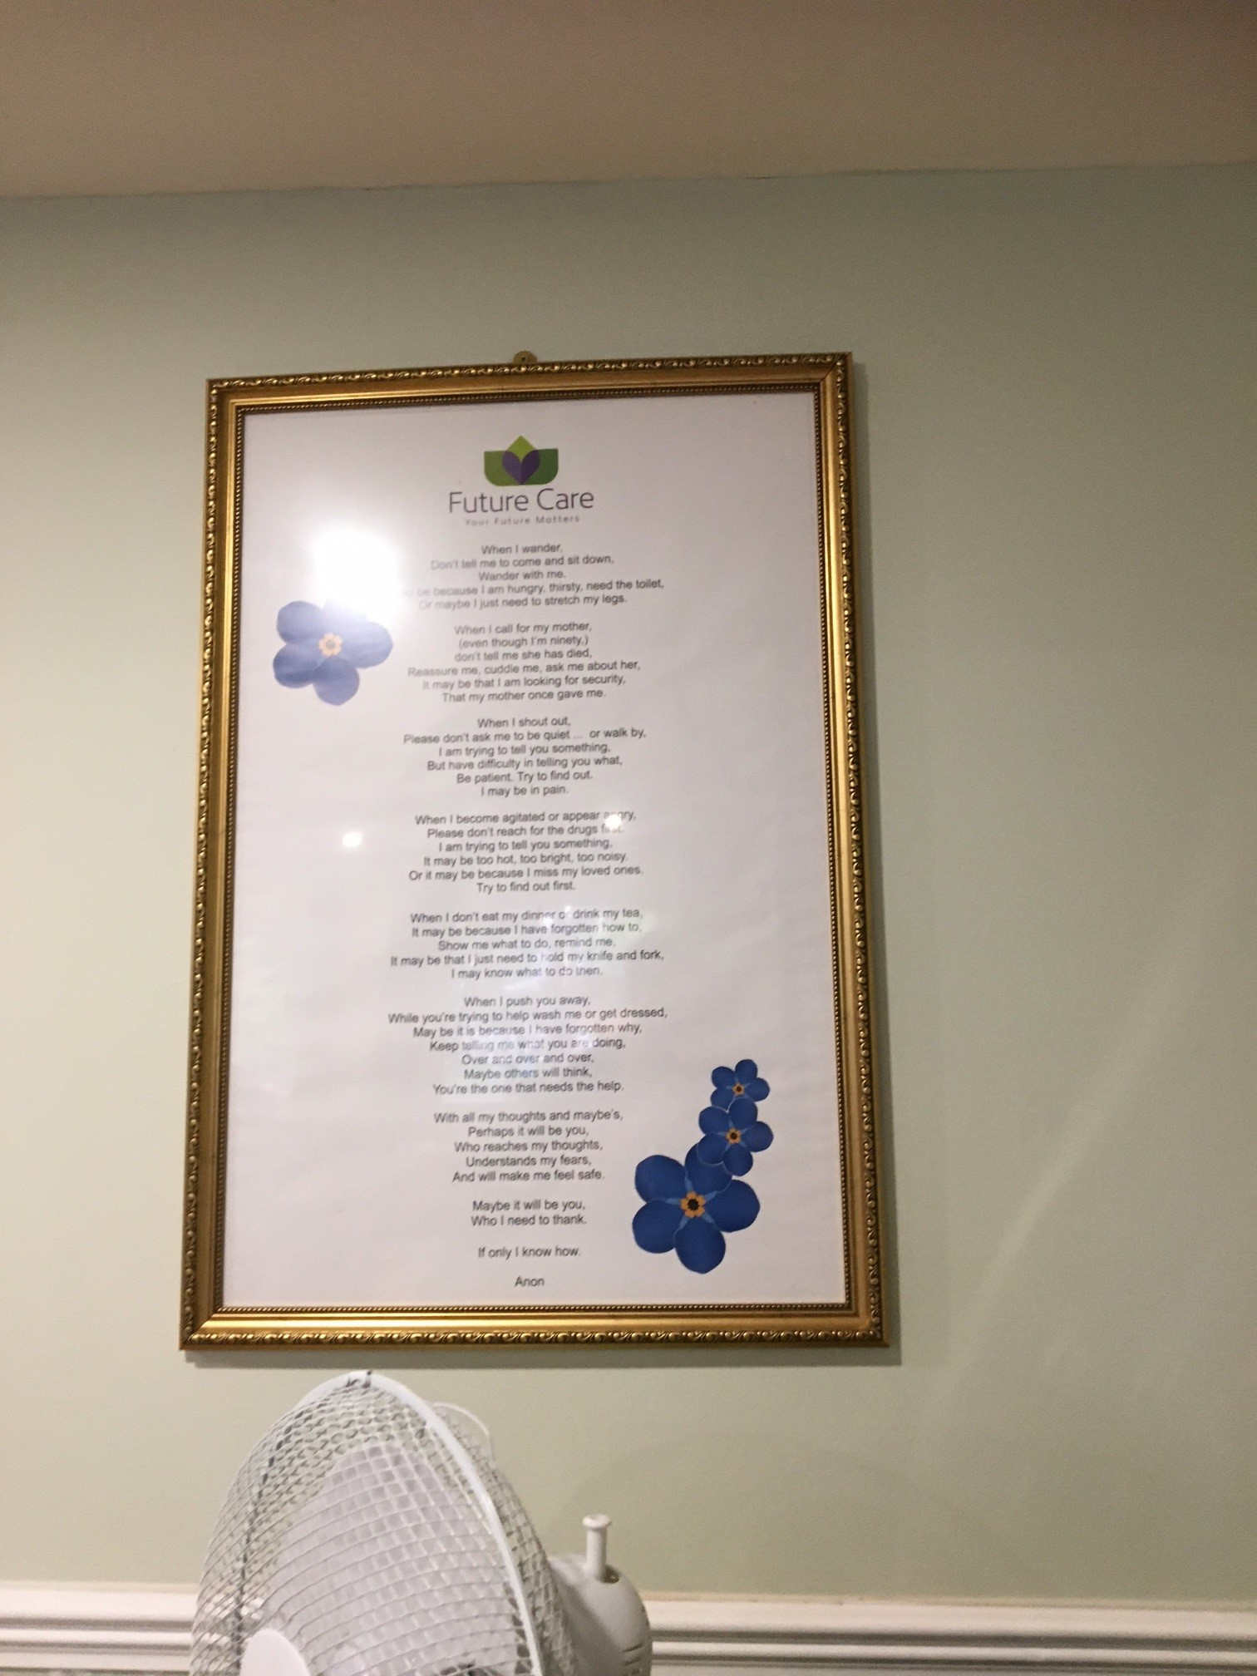
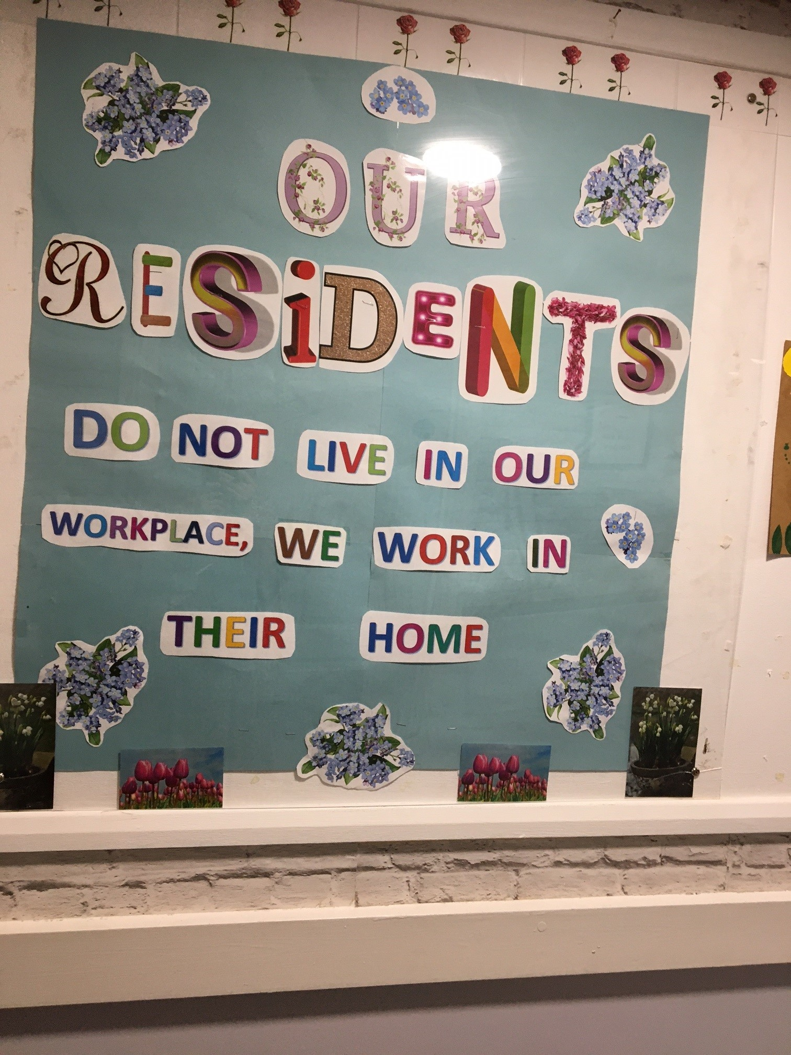

Visiting health care professionals
All residents have their own GP (of their own choice). Most are based at Fountain Surgery, but others are covered by Spring Street and Fitznells Manor.
We were told that the GP from Fountain comes out to visit on Fridays; the home sends a list in advance if they have any medical concerns about specific residents.
Fitznells and Spring Street will visit when requested by the home.
The manager told us that they have a very good relationship with the surgery.
Diabetic checks are done annually.

We heard that the chiropodist visits every 18 weeks. A podiatrist visits at the weekend.
The home is happy to use 111 at the weekends. They have not tried the star 6 line.
Occupational therapist /physiotherapist and speech and language therapists all visit via referrals through GP.
Surrey Downs Health and Care Partnership provides support for physio. The manager told us that he has identified a training need for Parkinson’s disease. He has also identified that the care home needs to minimise the risk of falls -therefore the staff need falls prevention training.
We were told that the domiciliary dentist visits once per year, they will recommend if a resident needs to be seen by a hygienist or hospital.

The Optician service is provided by vision call, they will visit as and when needed.
Audiology visits are via community /GP referral.

Visiting
We heard from family and friends that they are happy that visiting was back to pre- Covid arrangements
“I am very satisfied with current visiting arrangements, things are a lot better since covid, visiting has opened up again”.

Staying in touch
We heard that staying in touch with family members wasn’t an issue as visiting is so freely available. However, for those who don’t have family nearby they can use (and are helped to) their mobile phones to stay in touch.
Staff members also told us that residents were supported to stay in touch with families and this had been managed over the pandemic and now staff were pleased to be able to open up the home again. A staff member reported ‘it’s getting back to normal.’

Feedback
We heard that the staff and manager are always available to discuss any concerns.
‘Manager is always available to talk to.’
‘The Manager is on top of my concerns. I have had two so far and had been resolved quickly.’
‘Very approachable management always make themselves available if needed and will help in any way possible.’
Family and residents can request a meeting with staff via the I-pad which is installed in the entrance foyer.
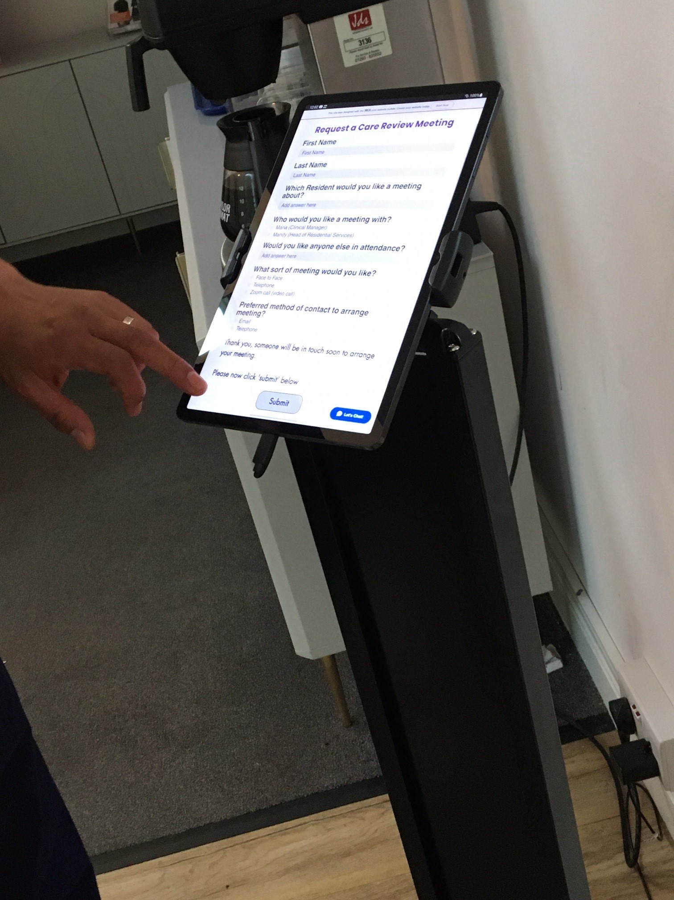

Staff told us that people were supported to raise concerns and make comments when they wished to do so. Information about how to raise concerns was on display and all of the staff spoken with were aware of the policies and would take action if concerns were raised. Staff would resolve minor issues if they were able to do so and would escalate to more senior managers if this was appropriate.

Staff reported good relationships with the families of the people who lived at the home and said that family members would raise any concerns with them or via email with the managers if this was what they wished to do.

Next steps
This report and the response from the service provider will be shared with commissioners and regulators of the service and will be published on our website.

Service provider response
Service Name: | Priory Court Care Home
Service Manager: | Rommel Villanueva
Visit date: | 9th September 2022
Factual accuracy
If you have any concerns about the factual accuracy of the report, please clearly identify the sections, content and corrections that are required in the space below:
Organisation response to the report
Please provide your response here. This will be included in the final report.
(THIS RESPONSE WILL BE PUBLISHED IN FULL)
What we found:
HEADINGS

Respondent Name:
Respondent Job Title:
Feedback on the visit
If would like to provide some feedback to Healthwatch Surrey on the visit itself, please provide this in the space below:

RESPONSES MUST BE PROVIDED WITHIN 10 WORKING DAYS OF RECEIPT OF OUR REPORT TO ENSURE THEY ARE INCLUDED IN THE FINAL PUBLISHED REPORT

Appendix

What is Enter & View?
Part of the local Healthwatch programme is to carry out Enter and View visits. Local Healthwatch representatives carry out these visits to health and social care services to find out how they are being run and make recommendations where there are areas for improvement. The Health and Social Care Act allows local Healthwatch Authorised Representatives to observe service delivery and talk to service users, their families and carers on premises such as hospitals, residential homes, GP practices, dental surgeries, optometrists and pharmacies. Enter and View visits can happen if people tell us there is a problem with a service but, equally, they can occur when services have a good reputation – so we can learn about and share examples of what they do well from the perspective of people who experience the service firsthand. All of our Authorised Representatives have a current DBS check in place.
Healthwatch Enter and Views are not intended to specifically identify safeguarding issues. However, if safeguarding concerns arise during a visit, they are reported in accordance with Healthwatch safeguarding policies. If at any time an Authorised Representative observes anything that they feel uncomfortable about they need to inform their lead who will inform the service manager, ending the visit.
In addition, if any member of staff wishes to raise a safeguarding issue about their employer, they will be directed to the CQC where they are protected by legislation if they raise a concern.

Purpose of Visit
The purpose of the visit was to listen to the views and experiences of people who live and work within the home.

Strategic drivers
Our Enter and View programme is one of our strategic priorities for 2022/2023, enabling us to hear the voices of seldom heard groups; on this occasion- care home residents.

What we did
The visit to Priory Court was an announced visit. Before the visit we gave the care home posters to display around the home to make staff, residents and their families aware of our visit. This poster included a QR code which links to our feedback form on our website. We saw the posters displayed when we visited. We also gave the home Healthwatch Surrey “Problem Praise Suggestion” leaflets, which residents and family members could use to send their feedback via post. We gave out Healthwatch Surrey branded thank you postcards to all of the people we spoke to.
.We spoke to four residents, and eight members of staff, five paper questionnaires were returned by post.
Four Authorised Representatives (ARs) of Healthwatch Surrey conducted the visit.
On arrival we were greeted by the registered manager. We explained what we would like to do. One member of our team was seated in a private area and staff members were brought in to give their feedback. One AR was shown around by the manager. Two ARs were shown around by another member of staff. On all occasions, we checked with staff who would have the capacity to talk to us. We were allowed to take photographs. All of the questions we asked were answered openly. We observed the surroundings to gain an understanding of how the home works and how the residents engaged with staff members and the facilities, these findings were recorded on observation sheets. We used a semi-structured questionnaire when talking to residents, family members and staff.
We explained to residents, their family members and staff that we were from Healthwatch Surrey and that we were gathering experiences of what it’s like to live at Priory Court, and particularly to find out whether they would know what to do if they wanted to give feedback about the service.

