Enter and View

Elmfield House Care Home

October 2022

Table of Contents
Table of Contents 2
1. Summary 3
1.2 Why we visited 3
1.3 Summary of key findings 4
1.4 Acknowledgements 4
1.5 Disclaimer 4
2. What we found 5
2.1 Description of service 5
2.2 Environment 5
2.3 Facilities 5
2.4 Staff 7
2.5 Covid measures 7
3. What we heard 7
3.1 Who we heard from 7
3.2 Daily life 7
3.3 Food and nutrition 7
3.4 Activities 8
3.5 Care 9
3.6 Staff 9
3.7 Visiting health care professionals 11
3.8 Visiting 13
3.9 Staying in touch 13
3.10 Feedback mechanisms 14
4. Next steps 16
5. Service provider response 17
RESPONSES MUST BE PROVIDED WITHIN 10 WORKING DAYS OF RECEIPT OF OUR REPORT TO ENSURE IT IS INCLUDED IN THE FINAL PUBLISHED REPORT 19
6. Appendix 20
6.1 What is Enter & View? 20
6.2 Purpose of Visit 20
6.3 Strategic drivers 20
6.4 What we did 20

Summary

Why we visited
Due to the pandemic, we have not been able to carry out any engagement at care homes, and therefore we have been concerned that the voice of care home residents has not been heard, and residents and families may be unaware of the existence of Healthwatch as their independent champion. Enter and View is one way Healthwatch Surrey can gather information about services and collect views of service users, their carers and relatives, as well as staff. We are working with Surrey County Council, Surrey Heartlands and CQC on our programme visits to care homes across Surrey and we will be carrying out one visit per month during 2022/23.
As well as giving residents an opportunity to share their general views of the care home, our focus is on finding out whether residents and families are aware of or have used any feedback mechanisms.
As well as the face-to-face visits we are also running a survey for friends and family – available at: https://www.smartsurvey.co.uk/s/HealthwatchSurreyCareHomeFamilyFriendsSurvey/ and as paper copies. This will run for a year, links to the survey will be distributed via Care homes own newsletters and promoted on Healthwatch Surrey’s communications and by other stakeholders.
Details of visit:
Service Address | Elmfield House
Service Provider | Elmfield Residential Home Ltd.
Date and Time | 21st June 2pm-4pm
Authorised Representatives | Katharine Newman, Sarah Browne, Errol Miller, Angus Paton, Virginia Fenton, Ellen Pirie.
Contact details | Healthwatch Surrey GF21, Astolat, Coniers Way, Burpham, Surrey, GU4 7HL  enquiries@healthwatchsurrey.co.uk  Helpdesk: Telephone: 0303 303 0023 (local rate number)SMS (text only): 07592 787533

Summary of key findings
Our overall impression was positive; residents, family and staff all appeared to be happy with the care, visiting arrangements and feedback mechanisms. The quote below is typical of the feedback we heard:
“We often pop in, our loved one always looks well cared for. We liked it instantly, we had a good rapport and consistent staff.”
We have one recommendation based on our visit:
Share with Healthwatch Surrey any issues with accessing dentistry for your residents.

Acknowledgements
Healthwatch Surrey would like to thank residents, their families, and the staff at Elmfield, for their contribution to our Enter and View programme.

Disclaimer
This report relates to findings observed on the specific date set out above. Our report is not a representative portrayal of the experiences of all residents, their families and staff, only an account of what was observed and contributed at the time.

What we found

Description of service
Elmfield House is an independent, family-run home which provides accommodation, nursing and personal care for up to 18 older people, with residential or dementia needs. Most residents have early to mid-stage dementia, if residents develop challenging behaviour they move elsewhere. The home is H shaped as it is 2 houses which have been joined together therefore it is not purpose-built. Accommodation is arranged over two floors.
Website: Residential Care Home Woking, Surrey - Elmfield House In Bisley
Provided by: Elmfield Residential Home Ltd.
Registered manager: Nicola Rachel Gillett
Capacity: 18 residents, currently 18. Two residents are funded by SCC.
We were told that there were no agency staff being used, and that there was a high staff retention.
Staff identified patients who would have capacity to speak to us on the day.

Environment
The accommodation is split across two floors, more able-bodied residents live on the first floor, with less mobile residents on the ground floor. Access to the first floor is via a narrow staircase with stairlift. There is no separate lift.
The home was very clean and fresh smelling. Most residents were out of their rooms.
We were told that bedrooms are deep cleaned once a week, including carpets.

Facilities
The lounge was being used when we visited, a regular singer was entertaining many of the residents.
The dining room was not being used (we visited between 2pm and 4pm).
The manager’s office is off the lounge. We were told that this had been moved to this location so that she could be on-hand for the residents, families and staff at all times.
All the bedroom doors displayed photos of the resident and their name. Nine residents have their rooms upstairs, and nine downstairs. All rooms have an ensuite WC and basin. The four downstairs rooms that were part of the extension in 2014, have walk- in showers. There is one shared bathroom and one shared shower room for fourteen residents.

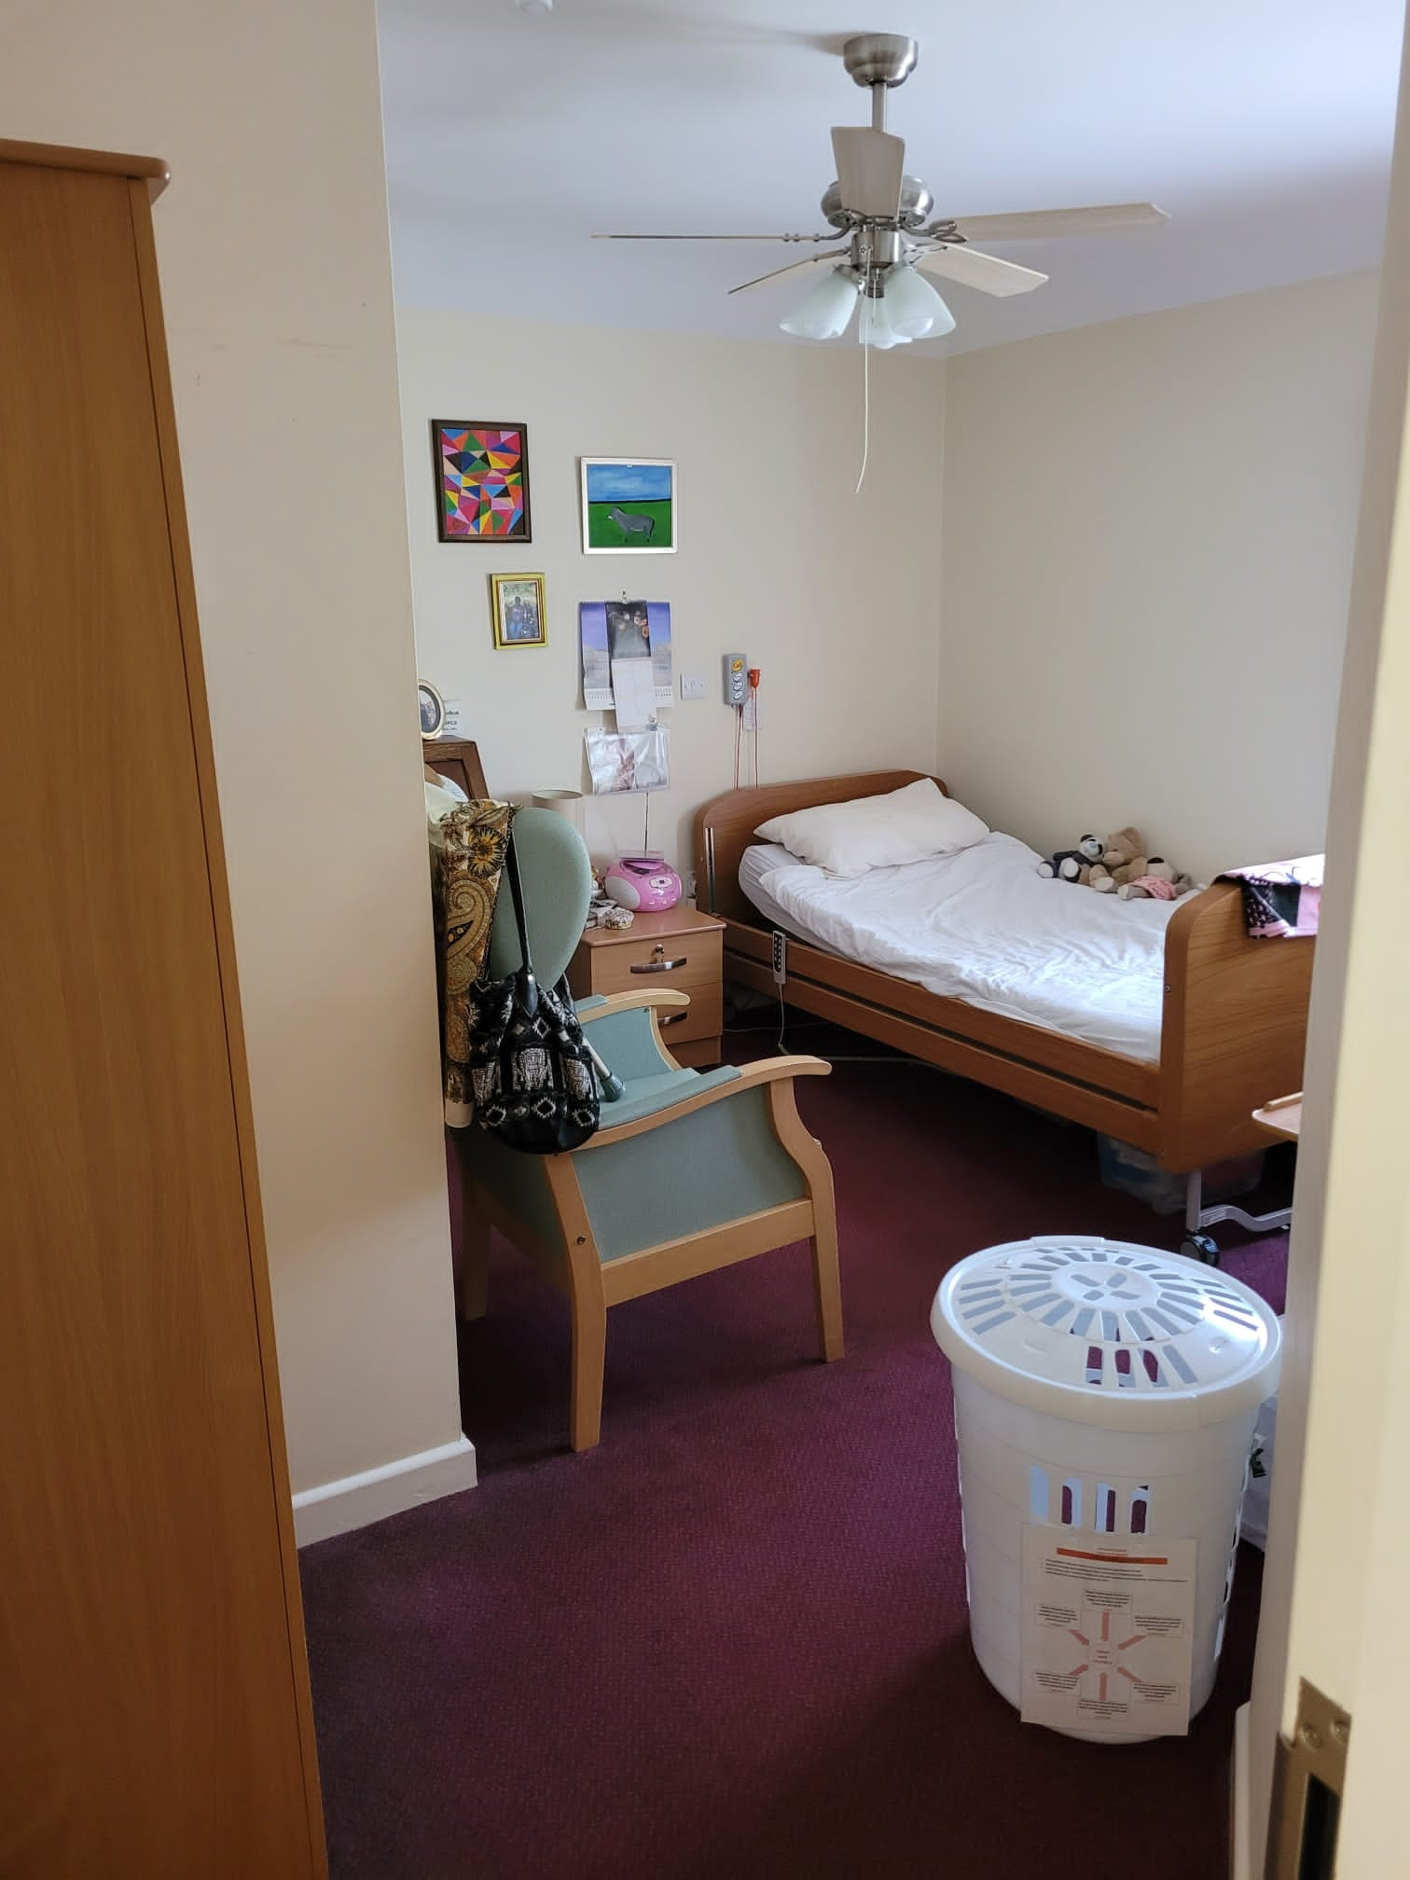

The lounge was cosy, with a large TV and opened out into the garden. The garden had seating and a gazebo which gave shade. Herbs were grown in the garden, which were used in the kitchen.
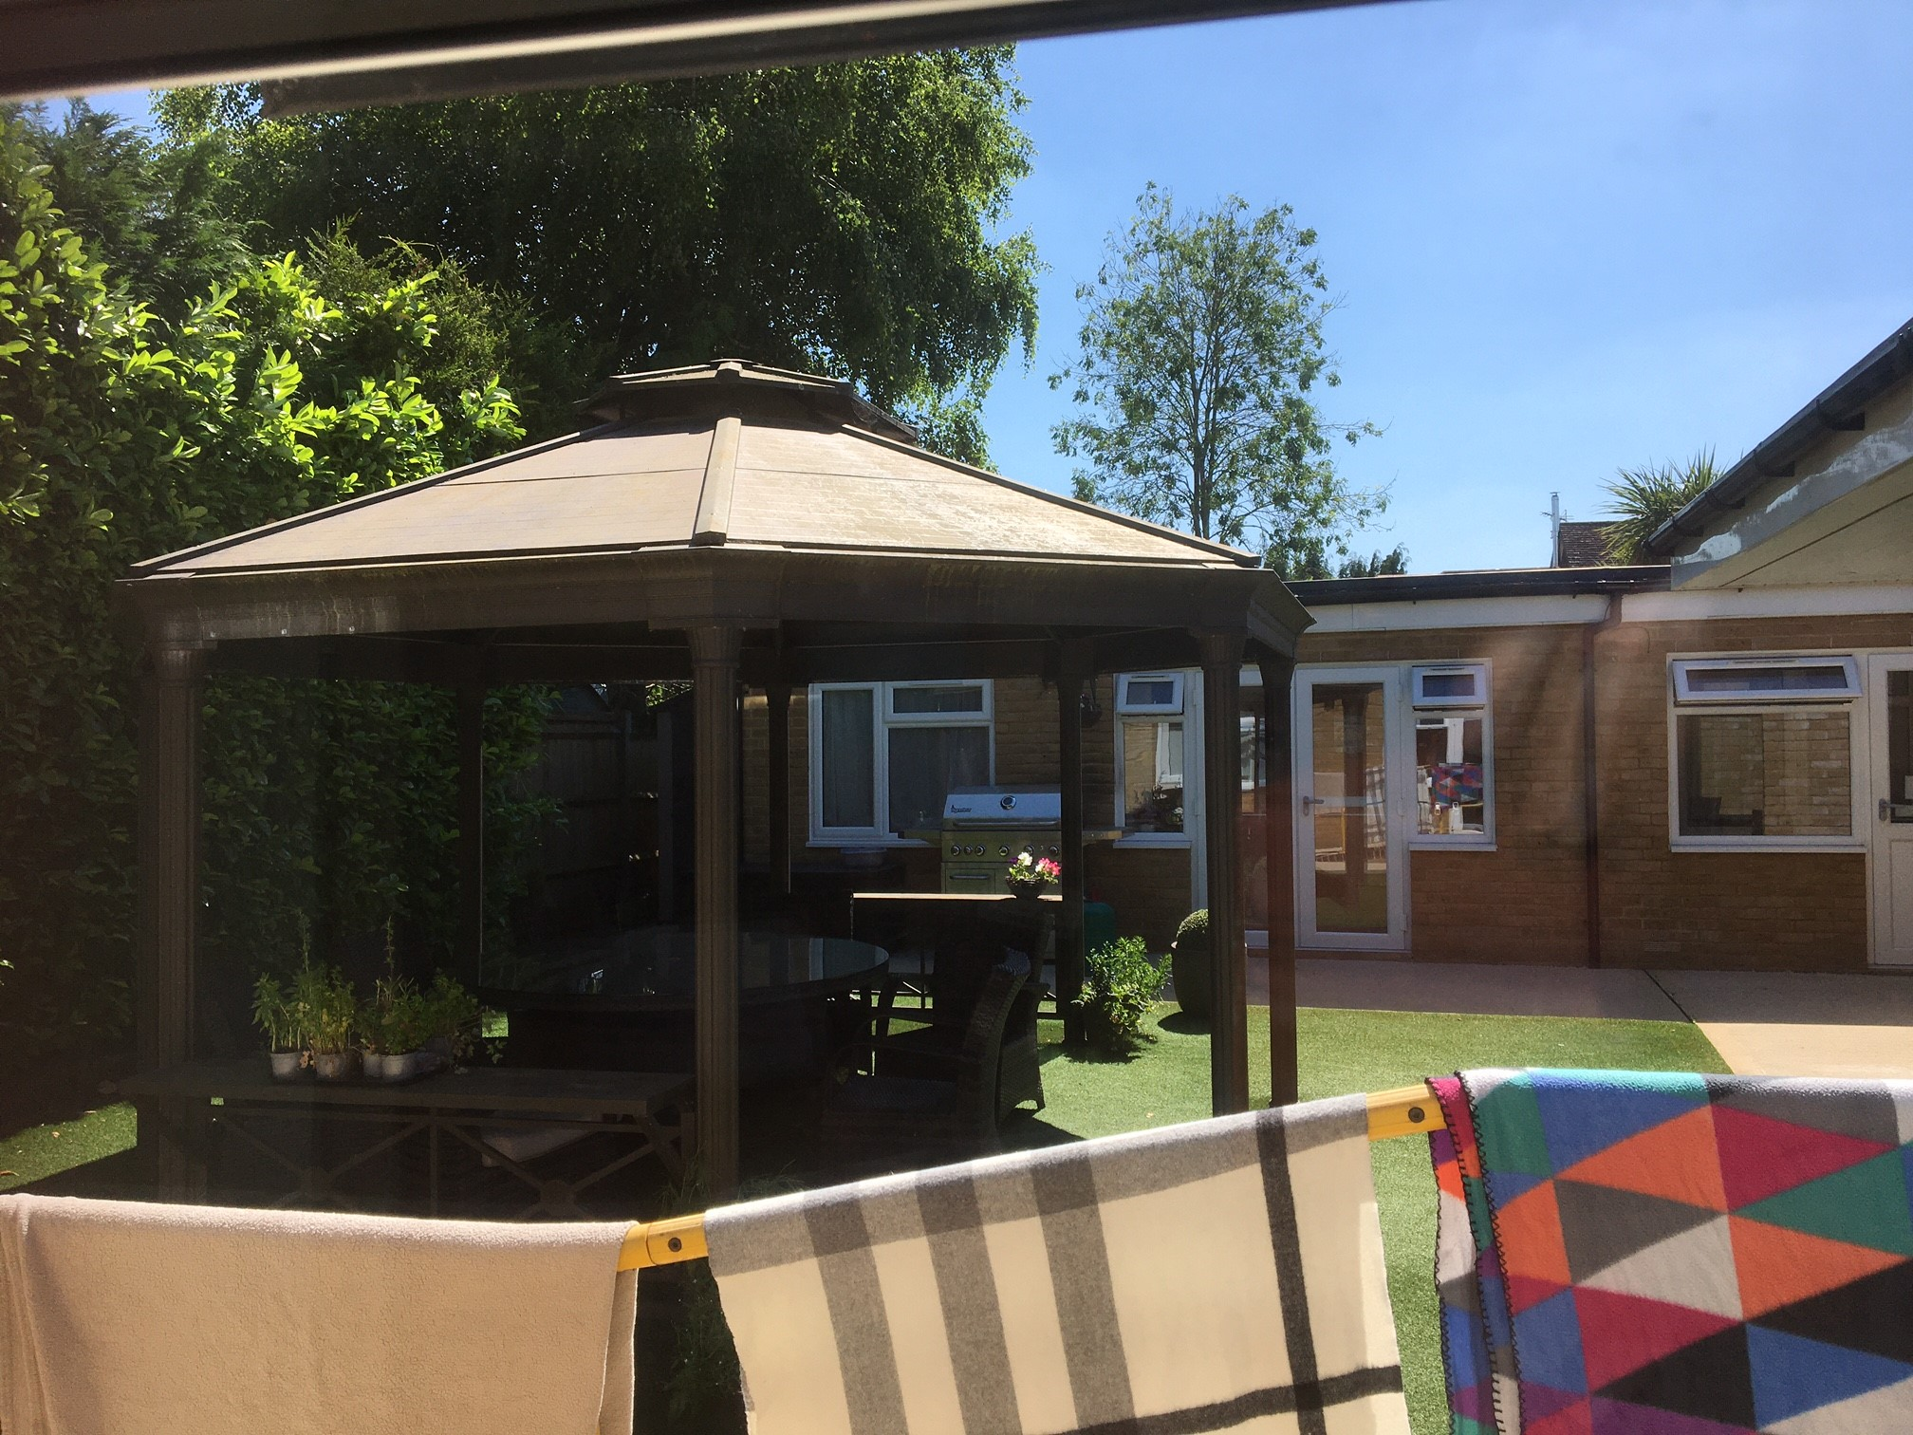

Staff
Staff were friendly and approachable, and clearly loved their work. Staff interacted well with each other, residents and families.

Covid measures
The manager was called in the morning to tell her that we all had negative Lateral Flow Tests. Healthwatch Surrey Authorised Representatives wore face masks.
Covid measures: All visitors to the home (staff, relatives, visitors, contractors) are all requested to take an LFD test prior to entry to the home. All visitors to wear clinical face masks.

What we heard

Who we heard from

We spoke to three residents and three family members. We spoke to six members of staff, including the manager, the chef, a kitchen assistant and three care assistants.

Daily life
Residents we spoke to were very happy with their care, as were their family members. Residents are encouraged to join in with the other residents with activities, however if a resident wants to stay in their room they have the freedom to do so.

Food and nutrition
There is an in house chef, which means the home can be flexible to meet residents’ needs. They have recently had themed menus such as Chinese and Mexican. They had held a BBQ for the Queen’s Jubilee. We heard evidence of catering to residents’ wishes:
“They give me porridge for breakfast because that’s what I like”.

We were shown the menu, which includes a choice of mains (3 per day , always including a non meat option). We were told that the menu is changed every 6 months. Before residents arrive, the manager told us that she does a pre-admission assessment, where their dietary needs are discussed. Two roast dinners per week, party food and fortnightly fish and chips from the local fish and chip shop are provided. Residents join in with making pizza.

Activities
Every day one staff member is ‘off the floor’ in order to run activities. There is no specific activities coordinator however this did not seem to be a problem.
We saw lots of displays showing residents taking part in activities, there are daily Facebook posts showing what residents have been doing. We heard about activities such as a weekly singer, visits from local school groups, cubs and brownies, a local horse, dogs and chickens. Regular faith related activities are provided for those who are interested.
“There’s plenty going on singing, games, skittles, soft ball, board games activities”
We were told that there are very strong connections with the local community, for example surplus flowers are donated from the local supermarket for flower arranging, residents attend “teas on the rec”. Young volunteers visit and lead activities as part of their Duke of Edinburgh Award. Examples of this are published in the care home’s newsletter and on their facebook page.
The manager told us that care is taken to provide activities which relate to residents’ interests – one resident used to work at Brooklands so they have had a visit there, one resident used to ride horses, and enjoys the regular visits from a local horse, one resident worked as a nurse, and she now enjoys taking the staff members’ blood pressure.
A range of ‘exercises’ such as skittles and soft ball also take place.
The home also recognizes that meaningful activities can be as simple as having a chat and looking at a photo album.

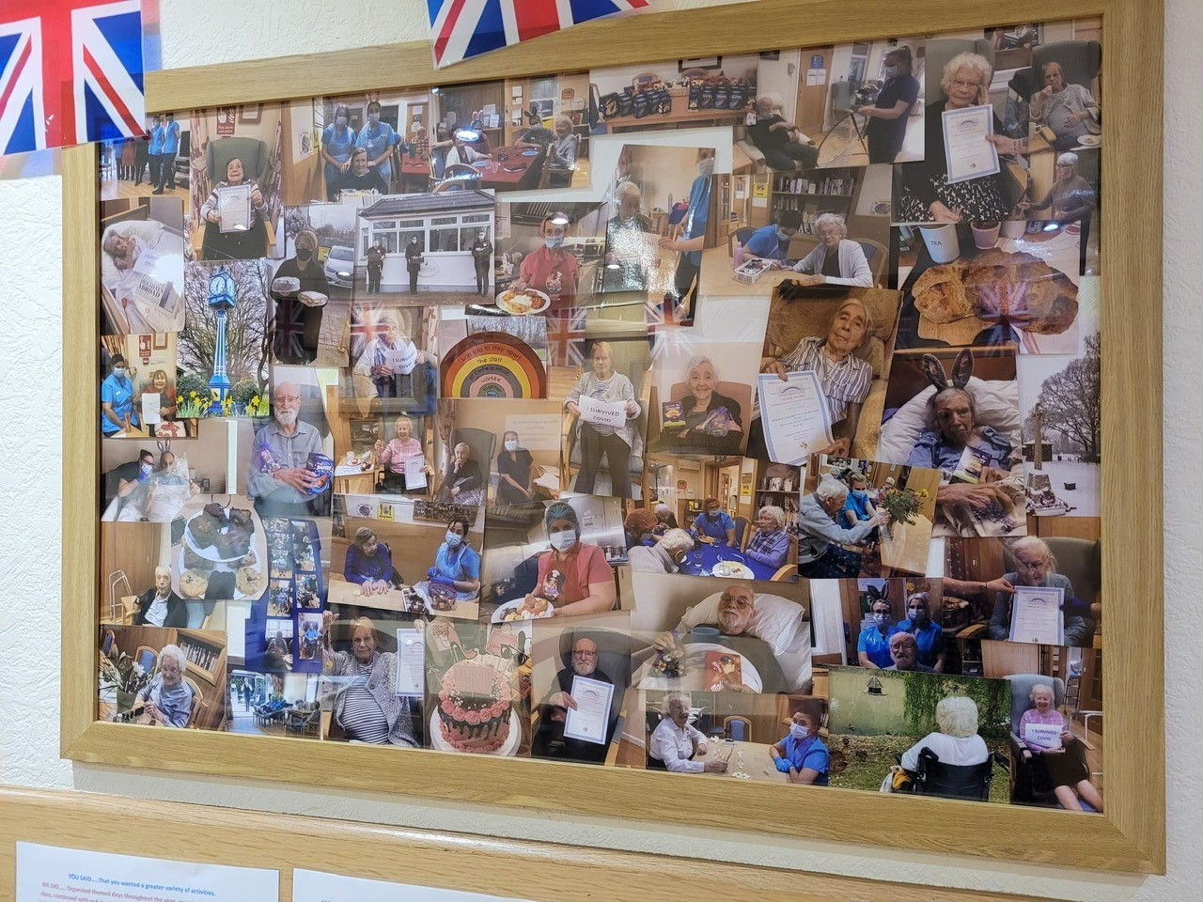

Care
The residents and families were all very satisfied with the care they received irrespective of whether it was daytime, nighttime, or weekend.
If a resident doesn’t fit in with the other residents the home can be flexible. They have recently introduced separate meal sittings for those who are more able bodied and those who need more help.

We asked whether residents or family members were aware of a named senior carer. Some people said they were, but generally it was felt that everyone cares.
We asked whether family members were aware of a personalized care plan, - some were aware:
“Their care plan is on the wall in their bedroom. I’ve looked and seen that our wishes are adhered to.”
Comment from Care Home Manager: to note: It is not the full care plan but a summary of needs and preferences to aid new staff understand preferred delivery of care and manual handling support.

Staff
We spoke to six members of staff.
All of the staff spoken with were positive about their experiences of working at the home.
Staff were exceptionally positive about their roles at Elmfield. When asked about their experiences of working in the home every staff member spoken with started by saying ‘I love my job’ or ‘I love it here.’
One staff member said it was a ‘home from home’. Another staff member said ‘the residents are like family.’
Staff were positive about the ‘family feel’ of the service and said they liked the fact that it was possible to form positive relationships with all of the residents and their families.
Staff were also positive about the support they received from their manager and the fact that she would also help when needed.
The manager regularly worked on shift to ensure she was familiar with residents’ care needs and the pressures on staff.
The manager told us ‘There’s lots of things I’m proud of with this team – some have really blossomed. We’re always looking to give people opportunities.’
Staff we spoke with confirmed that they were able to undertake further qualifications and gain knowledge and experience to help them in their careers
The home has suffered with staffing due to the mandatory vaccination rule, and subsequent U-turn. They lost several members of staff. Recently they have changed the shift patterns so that more senior staff are available at weekends.
The manager has worked at the home for twelve years and has been the manager for eight.
We heard that there is a waiting list of staff wanting to work at the home. The local military spouses are a good source of employees.

The new owner visits regularly. They and the other managers within the group have been a source of support for the manager of Elmfield.
It was evident that the provider was investing in the service – staff had received a pay rise and new furnishings were being provided. There were plans in place to increase management support with the introduction of a deputy manager post.

From families’ point of view, they gave positive feedback about the staff:
“The staff are very good and there are no agency staff.”
Many of the staff have worked there for several years – giving stability to residents and showing how much they enjoy working there.

Visiting health care professionals

There is a weekly ward round from Chobham and West End Surgery, which is provided by a pharmacist working within the practice.
The paramedic then liaises with the GP, who then prescribes and gives advice. This is a source of frustration for the manager, who believes it would be more efficient if the GP attended.
The “Care Home clinical lead document” published by NHS confederation – PCN Network PowerPoint Presentation (nhsconfed.org) states that The clinician leading the home round should have advanced assessment and clinical decisions skills and ensure that there is appropriate and consistent medical input from a GP or geriatrician.

COMMENT FROM Care Home Manager:
“Since your visit, this is still being done with the pharmacist but has been escalated as inadequate to the new practice manager, my clinical lead, her supervisor and CQC inspector. It is an on-going problem but I am optimistic that a solution will be concluded in the near future”.

The manager told us about some examples where the multidisciplinary team has been involved. One resident has struggled with her mental health. Working with the mental health team they have developed an action plan to encourage them to spend more time with other residents.
The community psychiatric nurse has provided dementia education and awareness for the residents. The SALT team, physio and district nurses also attend. Residents told us that the hairdresser visits as well as the chiropodist.
The manager told us that she has a good relationship with the clinical leads.

One resident who needs a wheelchair told us that she is struggling to access dental care.
“The dentist is a difficulty. I need a car for the wheelchair, it costs £148 for an adapted taxi. My daughter is sorting it out. From where I lived before the Bustler (local Woking community transport) would take you to the dentist. We are not in the right catchment here. I am trying to find another dentist”.
We observe from the “you said we did board” that dentists were reluctant to visit the home, (the reason given was that it is difficult to move dental equipment). Provision had been made for mobile residents to attend a local dentist with a staff member and escort. This is not so straightforward for a resident who cannot transfer from a wheelchair.
We have heard at a different care home visit that dental visits are provided on site.
Question to commissioners: how can you assure us that access to dental provision is equitable for all? What are the legal requirements for the provision of dental services in a care home?

The “Care Home clinical lead document” states that good practice features of the clinical lead role is to: “Work with primary, community and acute NHS services, and local authorities, to ensure appropriate input into the MDTs working with care homes is secured and consistent (to include dentist, optometrist, social workers as required).
NICE guidelines 2016 for oral care in care homes click here recommends the following:
1.5 Availability of local oral health services:
This recommendation is for health and wellbeing boards. 1.5.1
Ensure local oral health services address the identified needs of people in care homes, including their need for treatment. Identify gaps in provision. (See the recommendation on ensuring oral health is a key health and wellbeing priority in NICE's guideline on oral health: local authorities and partners.)
This includes: • general dental practices • community dental services, including special care dentistry (for more information see NHS information on dental treatment for people with special needs) • oral health promotion or similar services, in line with existing local arrangements • emergency and urgent out-of-hours dental treatment.
This recommendation is for care home managers. 1.5.2 Tell local Healthwatch and public health teams about any concerns you have about the availability of local dental and oral health promotion services.
Recommendation: Share with Healthwatch Surrey any issues with accessing dentistry for your residents.
Comment from Care Home Manager:
This was correct at the time of the visit. However, this problem has since been rectified. We sourced an onsite dentist called ‘At home dental’ who have visited the home on multiple occasions. This is quite costly so isn’t an option for all of the residents at Elmfield House.
The resident who raised the concern has since had effective treatment and her dental care needs have been met. Details of ‘At home dental’ have been shared with all residents and relatives for future reference if a resident is unable to access their usual dental practice for whatever reason (transport, mobility, escorts)

Visiting
We were told that there were no visiting restrictions at the time of our visit:
“My daughters can visit whenever they like.”
There were no restrictions on visiting and families were encouraged to visit as much as they wanted. A pod had been used to facilitate visits when there were restrictions on visiting due to the pandemic. Staff had also supported residents to use technology to stay in touch with family when visits had not been possible.

Staying in touch
One resident told us that she can call her family whenever she likes and they can call her.
Most communication from the home to the family seemed to be managed through the manager –the registered manager provides regular updates via email. Newsletters were used to keep families informed and aware of what was happening in the service. This included general newsletters and also specific updates for individual residents. “I receive a monthly report about hydration, nutrition and falls.”

There was a close relationship between staff and the families of the residents and staff reported that they got to know families well because they saw them so frequently. A staff member told us about how they knew it was important for one resident to speak with her husband to help her feel settled at the end of the day and this was always arranged.

Feedback mechanisms
There is a regular tenants coffee morning and a more formal residents meeting where any issues can be raised, such as missing laundry items and feedback about food.
Residents and family members are all happy to raise issues with any member of staff, and they will be resolved. Family members felt very confident that they’d know what to do, - which was generally to raise it with the registered manager, or with the owner. No one we spoke to had needed to raise a more formal complaint and therefore weren’t aware of any more formal feedback mechanisms . We saw a suggestions box in the dining room.

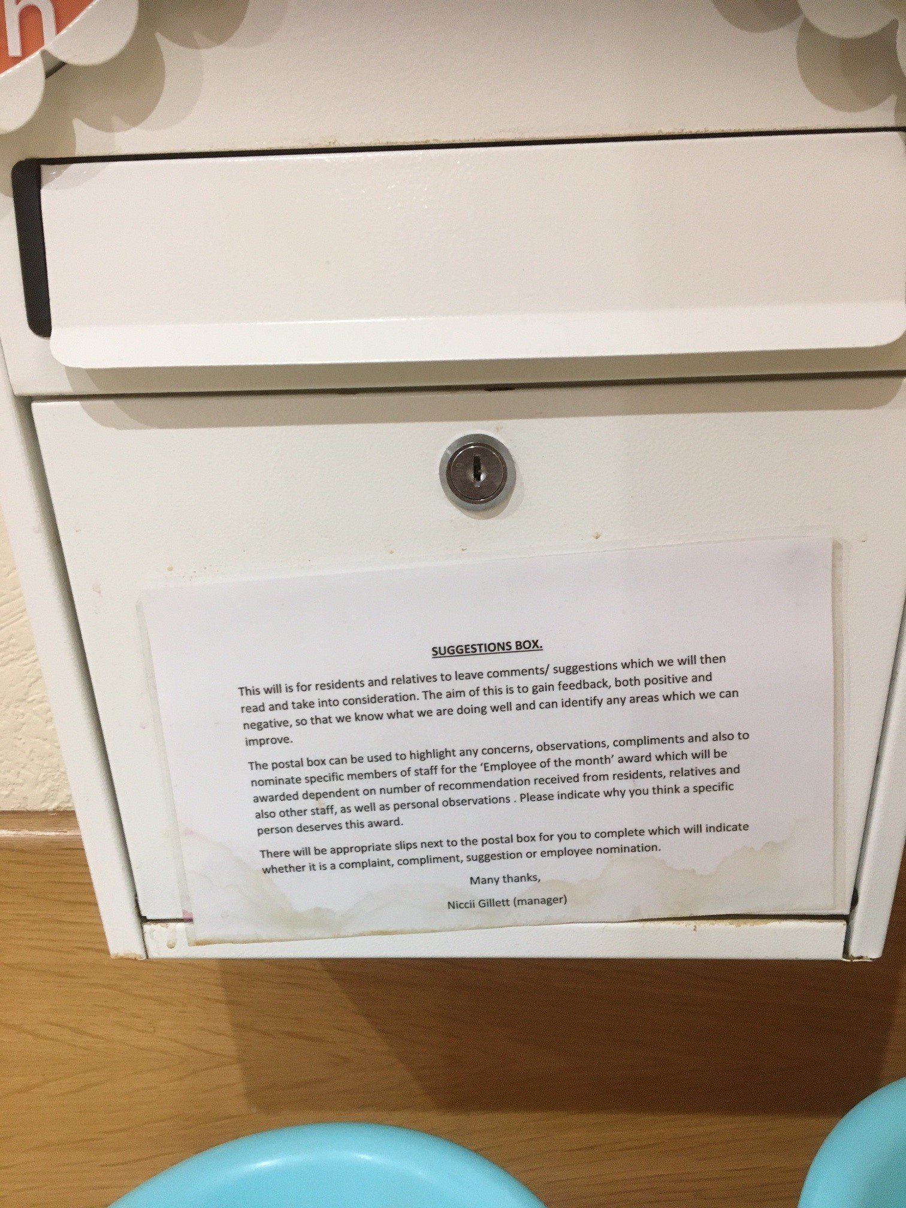

“If I wasn’t happy with something I would ask my carer, and tell my daughter, or go to the office.”
We asked about the process if a room e.g. on the ground floor became vacant. The manager explained that it would be offered to current residents first.

There was a good level of knowledge concerning the processes for managing complaints within the home and it was evident that staff took ownership and would aim to resolve any complaints and concerns as soon as possible. One staff member said ‘We speak to them and they will say little things that will let you know what we could do better’.
Staff were aware of the need to escalate concerns or complaints if they were not able to resolve them and the manager had processes in place to document and monitor complaints. This meant it was possible to identify learning from complaints.

Next steps
This report and the response from the service provider will be shared with commissioners and regulators of the service and will be published on our website.

Service provider response
Service Name: | Elmfield House
Service Manager: | Nicola Rachel Gillett
Visit date: | 20th June 2022
Factual accuracy
If you have any concerns about the factual accuracy of the report, please clearly identify the sections, content and corrections that are required in the space below:
The following comments have been incorporated into the main body of the report:
3.7 Visiting healthcare professionals page 11:
Since your visit, this is still being done with the pharmacist but has been escalated as inadequate to the new practice manager, my clinical lead, her supervisor and CQC inspector. It is an on-going problem but I am optimistic that a solution will be concluded in the near future.

3.7 Visiting healthcare professionals page 11: A resident stated that she was having difficulties accessing dental care.
This was correct at the time of the visit. However, this problem has since been rectified. We sourced an onsite dentist called ‘At home dental’ who have visited the home on multiple occasions. This is quite costly so isn’t an option for all of the residents at Elmfield House.
The resident who raised the concern has since had effective treatment and her dental care needs have been met. Details of ‘At home dental’ have been shared with all residents and relatives for future reference if a resident is unable to access their usual dental practice for whatever reason (transport, mobility, escorts)
Organisation response to the report
Please provide your response here. This will be included in the final report.
(THIS RESPONSE WILL BE PUBLISHED IN FULL)
What we found:
HEADINGS
2 What we found
I feel that your feedback has captured the home accurately with our homely feel and the photos reflect the coziness of the home. I am very proud of all the staffing team who are all excellent and very dedicated to their specific roles, the residents and the home. The housekeepers work tirelessly to ensure that the home is free from offensive scents and we often receive positive feedback regarding this.
Despite not being a purpose- built home, the facilities are fit for purpose and help promote our ‘home from home’ ethos.
The staff employed at Elmfield House are excellent and are very dedicated to their job roles, the residents and the home.

3 What we heard
Your feedback validates what we expected. Our residents are very happy here and are complimentary of the care they receive on a daily basis. .
Residents and relatives would certainly approach staff or the manager with any concerns and we pride ourselves on having an open- door policy and good relationships with those involved in the home.
Residents are fully involved in choosing activities, menu implementation and how they spend their time. Our residents receive person- centered care and staff are very aware of individual’s preferences, likes and dislikes. As an organization, we actively listen to the views of our resident and spend a lot of time identifying preferences and giving our residents a voice.
Staff recognize the benefits of stimulation and enjoy doing activities with our residents. Staff are encouraged to promote their own hobbies and interests.
The report captured our links to the community which we are very proud of and took several years to establish.
We are proud of our excellent relationships with multi-disciplinary teams and often receive positive feedback that their advice, guidance and recommendations are acknowledged and followed. We strive to invest in our staff to help them develop professionally and emotionally. Our team are valued and their dedication and efforts they contribute and it is common knowledge that staff enjoy coming to work.

Response to recommendations:
Prior to the report, we were already in the process of sourcing an on-site dental service. This had previously been a barrier for some residents with mobility impairments. Since the visit, we have had multiple visits to Elmfield House from ‘At home dental’ with residents successfully treated.
Another two residents have had dentist appointments in the community with staff escorting them. They were offered the “At home dental’ service but this was declined due to the financial costings being higher.

Our weekly ward round with the GP service has been a frustration where different personnel have been doing the weekly call instead of a GP. This was escalated to our clinical lead, their supervisor and the new practice manager. This has also been mentioned to our CQC inspector. A meeting has been scheduled for the end of August to hopefully resolve this.
Respondent Name: | Niccii Gillet
Respondent Job Title: | Registered Manager
Feedback on the visit
If would like to provide some feedback to Healthwatch Surrey on the visit itself, please provide this in the space below:
It was a pleasure meeting the team and I feel it was a productive visit.

RESPONSES MUST BE PROVIDED WITHIN 10 WORKING DAYS OF RECEIPT OF OUR REPORT TO ENSURE IT IS INCLUDED IN THE FINAL PUBLISHED REPORT

Appendix

What is Enter & View?
Part of the local Healthwatch programme is to carry out Enter and View visits. Local Healthwatch representatives carry out these visits to health and social care services to find out how they are being run and make recommendations where there are areas for improvement. The Health and Social Care Act allows local Healthwatch Authorised Representatives to observe service delivery and talk to service users, their families and carers on premises such as hospitals, residential homes, GP practices, dental surgeries, optometrists and pharmacies. Enter and View visits can happen if people tell us there is a problem with a service but, equally, they can occur when services have a good reputation – so we can learn about and share examples of what they do well from the perspective of people who experience the service firsthand.
Healthwatch Enter and Views are not intended to specifically identify safeguarding issues. However, if safeguarding concerns arise during a visit, they are reported in accordance with Healthwatch safeguarding policies. If at any time an Authorised Representative observes anything that they feel uncomfortable about they need to inform their lead who will inform the service manager, ending the visit.
In addition, if any member of staff wishes to raise a safeguarding issue about their employer, they will be directed to the CQC where they are protected by legislation if they raise a concern.

Purpose of Visit
The purpose of the visit was to listen to the views and experiences of people who live and work within the home.

Strategic drivers
Our Enter and View programme is one of our strategic priorities for 2022/2023, enabling us to hear the voices of seldom heard groups; on this occasion- care home residents.

What we did
The visit to Elmfield House was an announced visit. Before the visit we gave the care home posters to display around the home to make staff, residents and their families aware of our visit. This poster included a QR code which links to our feedback form on our website. We saw the posters displayed when we visited. We also gave the home Healthwatch Surrey “Problem Praise Suggestion” leaflets, which residents and family members could use to send their feedback via post. We gave out Healthwatch Surrey branded thank you postcards to all of the people we spoke to.
.We spoke to three residents, three family members and six members of staff.
Six Authorised Representatives of Healthwatch Surrey conducted the visit.
On arrival we were greeted by the registered manager. We explained what we would like to do. Two members of our team were seated in the manager’s office and staff members were brought in to give their feedback. Two ARs were shown into a ground floor bedroom, and spoke to the manager. They were then shown the garden and the lounge. Two ARs went upstairs and spoke to residents and family members in the dining room and lounge. On all occasions, we checked with staff who would have the capacity to talk to us. We were allowed to take photographs. All of the questions we asked were answered openly and enthusiastically. We observed the surroundings to gain an understanding of how the home works and how the residents engaged with staff members and the facilities, these findings were recorded on observation sheets. We used a semi-structured questionnaire when talking to residents, family members and staff.
We explained to residents, their family members and staff that we were from Healthwatch Surrey and that we were gathering experiences of what it’s like to live at Elmfield House, and particularly to find out whether they would know what to do if they wanted to give feedback about the service.

