

Insight Bulletin

March 2023

# About Healthwatch Surrey

One of the statutory duties of Healthwatch Surrey is to share residents’ experiences of health and social care with the people and organisations who make decisions about those services.

This bulletin highlights a selection of the themes we’ve heard about recently.

If you would like a paper copy of this document or require it in an alternative format, please get in touch with us.

# Praise and thanks

We hear from a wide range of people who are very happy with the care and support they have received.

I had to take my daughter to A&E at [hospital] 3 and a half weeks ago. My daughter went there (she has complex physical needs). There was a long wait but the nurses there recognised her and know that she is genuine. She needed a scan for a UTI but the machine was broken so she had the scan the next day. Ambulatory care unit is also very good as well. It so depends on the personality of the professional who is dealing with your loved one. When my daughter goes into hospital it is flagged that she has complex needs and what she will find difficult, so staff are aware of how best to deal with her. This has been in place for a few years as it started when I made a complaint to PALS. The patient experience team at [hospital] got involved and set this up.

Community Engagement, Carers Group

I have some positive feedback for the [local] adult social care team. Really good support. Our social worker left and we were then given a trainee – I was a bit wary but they have been really diligent. They do what they say they’ll do and this makes such a difference. I feel very supported by her.

Community Engagement, Carers Group

My husband has just died on xxx Ward and they have all been excellent.

Community Engagement, Hospital

I had an ECG this morning, walked straight in and got seen immediately. This was a referral from my GP. I waited 2 weeks for it. They gave me the referral via a remote consultation. I think it's been a really quick service.

Community Engagement, Hospital

And our favourite comment this month:

Gave birth to our first child at xxxx hospital in September 22. The level of care was excellent. Midwives are massively underappreciated. Post partem care could have been a bit better. The support from Milk cafes are excellent. **…. I'm sure the people reading this are doing a great job too and thanks for caring enough about public opinion to put this out there and pay the lovely lady who gave her time to collar us at the door to ask for input.**

Community Engagement, Family Centre

# “I want to stop this happening to anyone else” – motivation for giving negative feedback

We recently reviewed the cases of people who have used Independent Health complaints Advocacy (IHCA) to support them in making a formal complaint to a healthcare provider. One important finding is that people’s main motivation when complaining is often the desire to improve services for others, and this is something we hear about in our routine engagement:

Whilst he was under the machine [neonate/jaundice] lots of different people had seen him but no one recognised a problem until I got upset…[staff] immediately looked at the machine and flicked a switch, the machine had been on a low setting and should have been much higher. The head of the department came to speak to us and I complained about the delay in test results and the machine on the wrong setting, she apologised and has since made some changes and they have put labels on the machines to say they must be on the highest settings.

Community Engagement, Children’s Services

[Complaint about staff attitude] I am not seeking redress. I would like to make you aware of this incident in case there are similar complaints pointing to a pattern of behaviour that could require action regarding this doctor.

Website

In November we were really worried about him. Dad has never suffered with his mental health but his stay and treatment deeply affected him, he has now said he will never go in again. We have had a battle with ourselves as we understand how stretched the NHS is and really don’t want to complain but we do really want this to stop happening to anyone else.

Community Engagement, Family Centre

Our report makes the following recommendations:

1. Ensure information about the complaints process is accessible, especially on websites, and that there is clarity about the difference between negative feedback and a formal complaint
2. Ensure the IHCA is featured high on any complaints pages – those needing help are unlikely to scroll down several pages of dense text to find it. (Surrey Heartlands’ compliments and complaints page is an example of good placement [Compliments, complaints and feedback - ICS (surreyheartlands.org)](https://www.surreyheartlands.org/complaints-and-concerns))
3. Respond to those making a complaint in a timely manner, even if it is only with a “holding” message.

The full report can be found here : [Maximising the learning from complaints - Healthwatch Surrey](https://www.healthwatchsurrey.co.uk/report/maximising-the-learning-from-complaints/).

# Adapting to a different healthcare system – experiences from Ukrainian refugees

We visited a Ukrainian Hub recently and heard some concerns and distress caused by the differences in access, pathways and protocols between the Ukrainian healthcare system and the NHS:

In the Ukraine, I found a fibroid in my breast. The GP said I needed to have it removed. The GP in the UK said it’s not a problem and not to worry. I am now very worried and don’t know what to do. I have had a biopsy on it. I have a follow up face to face appointment with my GP soon but I am very worried if they say they won’t remove it. I may go back to Ukraine to have the operation.

Community Engagement, Ukrainian Hub

Registered with GP and took our daughter [5] there in Nov 2022 as she has adenoids and struggles with her breathing and coughs a lot. The GP referred us to an ENT consultant but we still have not heard and that was 3 months ago now. What do we do to chase it up?Next week I am also going back to the doctor as I have MS and I have no medication left. I have been before and asked for medication but they wouldn’t give it to me.

Community Engagement, Ukrainian Hub

I called 999 a few months ago and was holding on for 45 minutes. I gave my son Ibuprofen and Paracetamol and his temperature of 39 wasn't coming down. He is 6.

In the end, I gave up and left it. He started to feel better. I needed an ambulance again for my mother and called 999. She had woken with dizziness and sickness. I was really worried. After 2 hours waiting for an ambulance, I called 999 again. They said they were very busy and to wait. All anyone says here is to wait. In our country we don't have to wait like this, we are seen.

Community Engagement, Ukrainian Hub

We hear similar concerns from those arriving from other areas:

I came from Syria, I have four children… Here going to the Doctor is different than Syria, before Syria became unsafe, there I could go to the Doctor 5 times a day if I wanted to.

Community Engagement, Community Hospital

# The reality of life as a carer

We hear many experiences from unpaid carers. Even those receiving support are carrying a heavy emotional and practical burden, and these experiences illustrate how close some families are to carer breakdown:

I’m starting to feel very stressed about things. I had a chest infection recently and last week I had norovirus and I’m worried about what will happen to my husband if I get ill. I have my own health problems [vertigo, cancer survivor, gout, coeliac]. When I’m stressed and not sleeping [due to sleep apnoea] it just all catches up with me. … I don’t need anything, I’m just doing everything as always and I always have done so I carry on doing it…I never realised how much I was doing. You just carry on and it becomes a little bit more and a little bit more. *(Cared for person is in receipt of care; carer will be receiving an assessment)*

Community Engagement, Carers’ Group

My brother [who lives with the carer] is ok. He has carers and it works very well.

I have to do everything for my father. His scoliosis is so bad that he screams with pain. He can’t walk and uses a wheelchair. He has an electric bed but he can feed himself if I cut up his food. He is incontinent and wets the bed every day. I have to then strip it all and wash absolutely everything – the protective sheets, the rubber ones, all the sheets and then the blankets and his pyjamas. Every day. I soak everything in the bath and then squeeze it out and out in the washing machine. He refuses to have a catheter and takes it out. I pay extra for pads as the prescription ones are useless, but even these are no good.

I have had to give up work to look after him.

Community Engagement, Carers Hub

I am the sole carer for my mother who is 74 and is physically disabled since 2014. She then had a stroke in April 2022. Although I have a brother and a sister, I have no family support from them and so I have nobody to fall back on and no break from caring for mum. …. I am now absolutely struggling and it’s taking its toll on me health wise. I feel guilty for feeling like this. Me time is just not there. …

She won’t go to a day centre as they are strangers. I take her everywhere with me – even the cinema.

Taking responsibility for my mother is a cultural thing [carer is Pakistani] I am the eldest and as I am not married and have no family, this falls to me…

When my father died, my mother came to live with me. …. I eventually had to give up my job to care full time and this was natural for me but I didn’t realise the emotional stress and the lack of friends that this would bring. My mother is very supportive and does encourage me to go out and I never want her to feel that she is a burden.

One-to-one with carer

# Why supporting maternal mental health matters – a report from Healthwatch England

As part of their wider maternal mental health workstream, Healthwatch England have reported on the delivery of postnatal consultations, using the experiences of over 2,600 people who have had a baby and responses to FOI requests to ICBs, Trusts and GP surgeries. The findings highlight several challenges: these include weakness in delivery of postnatal consultations by GPs and struggles to access timely support when it is needed.

While this is a national report we urge our local ICSs to consider the relevance of the recommendations locally:

1. Integrated Care Systems (ICSs) should monitor the delivery of six to eight-week postnatal consultations as part of their primary care commissioning responsibilities.

2. The Medical Licensing Assessment being introduced from 2024 should check understanding of the importance of postnatal mental health and the mental health element of the postnatal consultation.

3. The section of the GP contract on delivery of postnatal consultations should be updated to include mention of signposting to specialist and community mental health services and point to best practice guidance around carrying out open-ended discussions.

4. As part of its Maternity Transformation Programme, NHS England should consider what additional support and guidance it can provide for GPs to have quality conversations about mental health at the six to eight-week postnatal consultation.

5. Deliver the Long-Term Plan commitments on improving access to specialist community perinatal mental health services.

The report can be accessed here [Briefing (healthwatch.co.uk)](https://www.healthwatch.co.uk/sites/healthwatch.co.uk/files/20230315%20Left%20unchecked%20briefing.pdf)

# Gathering and sharing our insight

We heard from 111 people in March. Notably, we have heard many positive experiences of quality of care. The word cloud below shows the different themes we received experiences about, with the top one being quality of care, then waiting times, mental health, referrals and transport and travel.

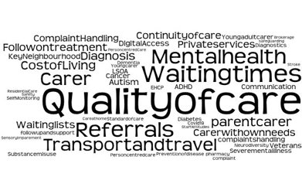

## Who have we shared our insight with?

If we hear a case of concern regarding patient safety, we immediately signpost the sharer to the appropriate body and escalate the case with the provider/commissioner.

We have shared insight in the following meetings in March:

**System meetings**​

* Surrey Heartlands QPAC​
* Surrey Heartlands Primary Care Access​
* Surrey Heartlands JIG​

**What We’ve Heard meetings**​

* East Surrey Hospital​
* North West Surrey Alliance​
* Public Health ​

**Other meetings**​

* Ashford St Peter’s Hospital Patient Monitoring Experience Group​
* East Surrey Engagement Network​
* Surrey Heartlands Integrated Urgent Care Clinical Governance Advisory Group​

## Who are we hearing from?

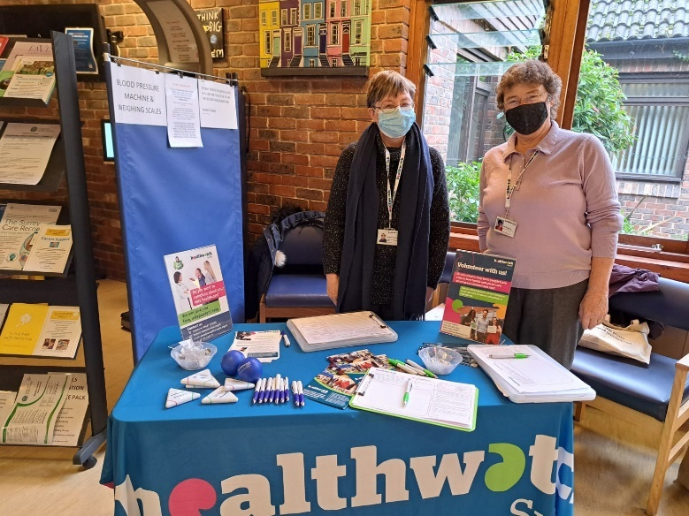

Our spotlight for engagement sessions in March was Guildford & Waverley and we will be in Surrey Downs in April (detailed in the table below).

Please note: these dates may be subject to change.

|  |  |  |  |
| --- | --- | --- | --- |
| **Date​** | **Place​** | **Time​** | **Surrey Area​** |
| 03.04.23 | **Epsom Hospital Oak Suite** (Outpatients Reception), Epsom (Public) | 10.00-12.00 | Surrey Downs |
| 05.04.23 | **Wellbeing cabin. Royal Surrey County Hospital,** Guildford (Attendees of wellbeing cabin only) | 11.00-13.00 | Guildford & Waverley |
| 18.04.23 | **Spire Café**, Farnham United Reformed Church, Farnham (Public) | 11.00-13.00 | Guildford & Waverley |
| 18.04.23 | **Beehive Café and Community Fridge,** Lower Green Community Hub, Esher (Public) | 9.30-11.20am | Surrey Downs |
| 19.04.23 | **Dorking Christian Centre café and Community Fridge,** Dorking (Public) | 10.30-12.30 | Surrey Downs |
| 24.04.23 | **Merland Rise Café and Community Fridge,** Merland Rise Church, Tadworth (Public) | 10-12pm | Surrey Downs |
| 28.04.23 | **Leatherhead Community Centre**, **Action for Carers hub,** Leatherhead (Action for Carers Group members only and Public visiting the café) | 10.30- 12.30 | Surrey Downs |

To share an experience with us, people can also contact our Helpdesk in the following ways:

Phone: 0303 303 0023

SMS (text only): 07592 787 533

Email: [enquiries@healthwatchsurrey.co.uk](mailto:enquiries@healthwatchsurrey.co.uk)

Share your feedback via our website: <https://www.healthwatchsurrey.co.uk/feedback-centre/>

**Friends and Family Care Home Survey**

Please share our survey for friends and family of those living in care homes. The survey can be accessed via this QR code or found on our website - [Friends and family care home survey - Healthwatch Surrey](https://www.healthwatchsurrey.co.uk/friends-and-family-care-home-survey/).

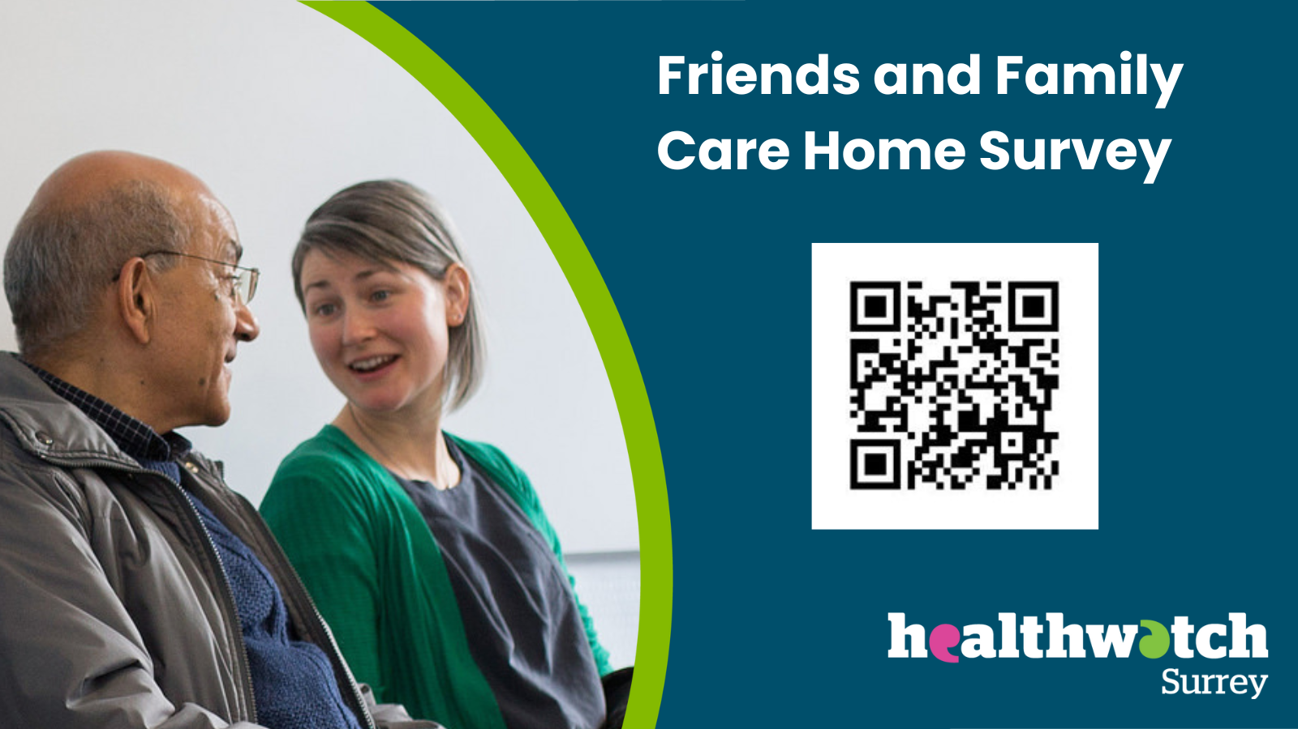

# Our distribution list

If you would like to be added to or removed from the distribution list for this Insight Bulletin, please contact our Communications and Involvement Officer [vicky.rushworth@healthwatchsurrey.co.uk](mailto:vicky.rushworth@healthwatchsurrey.co.uk)