Enter and View Programme

Beaumont Lodge Nursing Home

  - February 2023
If you would like a paper copy of this document or require it in an alternative format, please get in touch with us.

Contents
1. Summary 4
1.2 Why we visited 4
1.3 Summary of key findings 5
1.4 Acknowledgements 5
1.5 Disclaimer 5
2. What we found 5
2.1 Description of service 5
2.2 Environment 6
2.3 Facilities 6
2.4 Staff 9
2.5 Covid measures 10
3. What we heard 10
3.1 Who we heard from 10
3.2 Daily life 10
3.4 Activities 13
3.5 Care 14
Personalised care plans 15
3.6 Staff feedback 16
3.7 Visiting health care professionals 17
3.8 Visiting 17
3.9 Staying in touch 18
3.10 Feedback mechanisms 18
4. Next steps 20
5. Service provider response 21
6. Appendix 22
6.2 What is Enter & View? 22
6.2 Purpose of Visit 22
6.3 Strategic drivers 22
6.4 What we did 23
Healthwatch Surrey – Contact us 24

1. Summary

1.2 Why we visited
During the pandemic, we were not able to carry out any face-to-face engagement at care homes, and therefore we have been concerned that the voice of care home residents has not been heard, and residents and families may be unaware of the existence of Healthwatch as their independent champion. Enter and View is one way Healthwatch Surrey can gather information about services and collect views of service users, their carers and relatives, as well as staff. We are working with Surrey County Council, Surrey Heartlands and CQC on our programme visits to care homes across Surrey.

As well as giving residents an opportunity to share their general views of the care home, our focus is on finding out whether residents and families are aware of or have used any feedback mechanisms.

In addition to face-to-face visits, we are also running a survey for friends and family – available at: https://www.smartsurvey.co.uk/s/HealthwatchSurreyCareHomeFamilyFriendsSurvey/ and as paper copies. This will run for a year; links to the survey will be distributed via Care homes’ own newsletters and promoted on Healthwatch Surrey’s communication channels and by other stakeholders such as Surrey County Council’s Surrey Matters publication.

Details of visit:
Service Address | Beaumont Lodge Nursing Home 19-21 Heatherley Road, Camberley GU15 3LX
Service Provider | Beaumont Lodge Ltd.
Date and Time | 13th December 2022, 1400-1600
Authorised  Representatives | Katharine Newman, Sarah Browne, Louise Daborn.
Contact details | Healthwatch Surrey GF21, Astolat, Coniers Way, Burpham, Surrey, GU4 7HL  enquiries@healthwatchsurrey.co.uk  Phone: 0303 303 0023 (local rate number)  SMS (text only): 07592 787533

1.3 Summary of key findings
Overall, residents and their families seemed happy with the care they receive, the environment and how to share feedback. The staff who we spoke to were also happy.

We have two recommendations based on our visit:
- Ensure that the same pureed food options are not offered for lunch and dinner on the same day, and consider offering the standard menu in a liquidized format.
- Ensure that families and residents are aware of the formal complaints process. There could be a risk of over reliance on the activities coordinator to escalate issues.

1.4 Acknowledgements
Healthwatch Surrey would like to thank residents, their families, and the staff at Beaumont Lodge Nursing Home, for their contribution to our Enter and View programme.

1.5 Disclaimer
This report relates to findings observed on the specific date set out on P3. Our report is not a representative portrayal of the experiences of all residents, their families, and staff, only an account of what was observed and contributed at the time.

2. What we found

2.1 Description of service
Address: Beaumont Lodge Nursing Home 19-21 Heatherley Road, Camberley GU15 3LX
Website: beaumontlodge.com
Provided by: Beaumont Lodge Ltd.
Registered manager: Emma Golby.
Capacity: According to CQC, Beaumont Lodge Nursing Home is a care home providing nursing and residential care for up to forty-three people including people living with dementia.
At the time of our visit in December 2022 there were thirty-one residents, one was in hospital. There are five Discharge to Assess beds commissioned by SCC.
Some residents were self-funded, some were funded by Surrey and some by Hampshire County Council.
The registered manager told us that seven or eight residents would have capacity to speak to us, and 13 residents had dementia.

2.2 Environment
Beaumont Lodge is a large house, with accommodation split across three floors. Access to the first and second floor is via a staircase and a spacious lift.
The home was very clean and fresh smelling, the décor was clean.
The atmosphere was tranquil and quiet.
Residents were up and dressed and busy/happy.
Bedroom doors were open.
We saw evidence that our visit was expected, with our posters displayed throughout the home.

2.3 Facilities
The lounge had plenty of armchairs, a TV and piano. At the time of our visit, it was being used by some residents who were taking part in a Christmas quiz. When we left, a pantomime was being performed by entertainers.
We were told there is also an upstairs lounge which was converted from a bedroom in 2020. The resident pictured below asked for her photo to be included in our report.
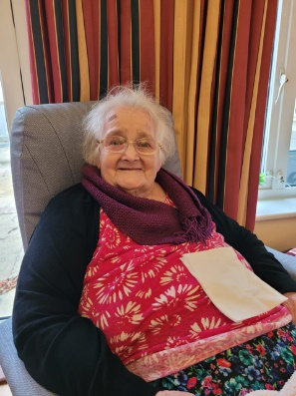

The dining room, which was not being used when we visited (between 1400 and 1600) was set up with twelve chairs and four tables. We were told that some residents choose to eat in the lounge, and some eat in their rooms. We were told that the dining room is also used as a quiet area for visitors.

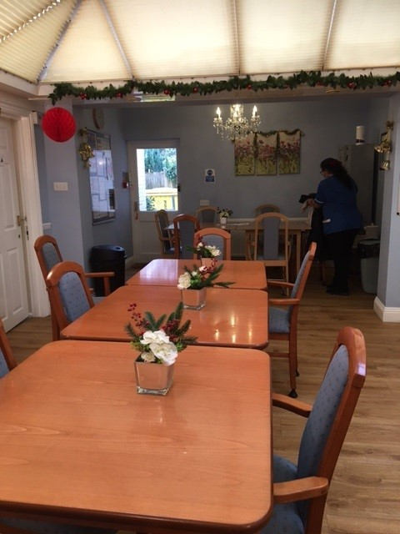

In the bedrooms, we saw evidence of personal décor including art, photographs, plants, birthday cards and soft furnishings. Most bedrooms are en suite (they include a WC and basin but no shower); there are three rooms without en suites. The bathrooms which we saw had grab rails and raised WCs.

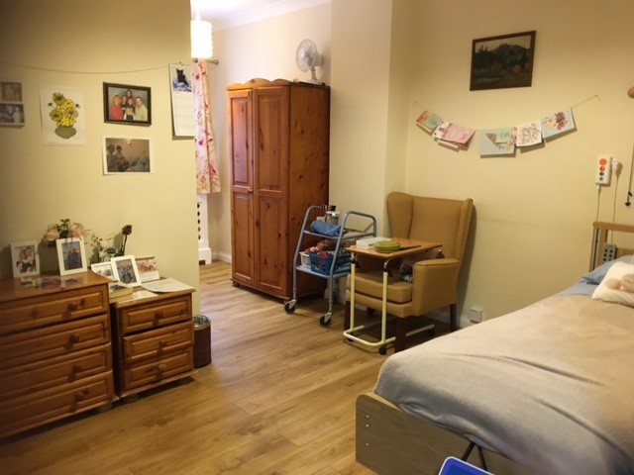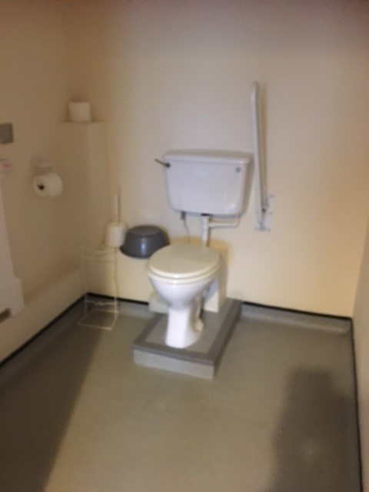

There are two wet rooms on the ground floor, two wet rooms on the first floor and one bathroom (with bath and hoist) on the second floor.
All residents share a wetroom/bathroom.

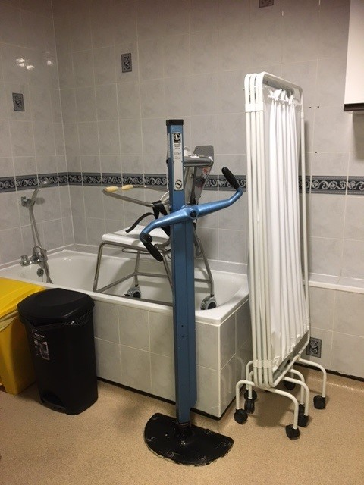

N.B. when we entered any bedrooms, we did so in pairs, we asked permission of the resident and the door was left open.

The visiting room was small and contained three chairs.

The manager told us that there are thirteen communal wheelchairs in the home. Some residents have their own, some use Zimmers/rollators, and some residents are mobile. There were wheelchair parks at different points around the home.
The manager told us that there is enough equipment for everyone’s needs to be met whether they wanted to be in or out of their rooms.

We saw dementia friendly signage throughout the home.

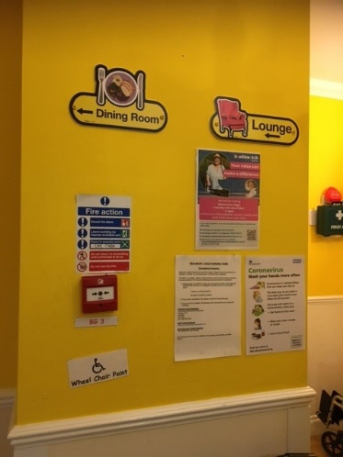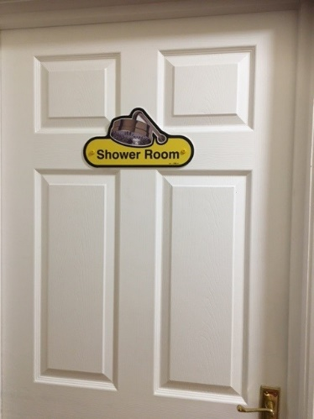

2.4 Staff
The registered manager told us that several members of staff had worked at Beaumont Lodge for over 14 years. She told us that they currently do not use agency staff, they do have some temporary staff, and some staff are part time. If a need arises, (e.g., a covid outbreak), the registered manager told us that the staff will fill any gaps in the rota.
We were told that there are two nurses on duty during the day and one at night.
We were told that the staff work in teams, one senior carer and one junior work together and look after five residents.

The staff appeared to be very dedicated, one carer said:
“I sleep well if I think I have done a good job. It’s an important job.”

Another staff member told us:
“It’s my second home. The best thing about it is being with the residents, and I enjoy every day as best I can. Some residents are younger than me, so I have perspective on what’s important. I respect my elders and treat everyone with the kindness that I would expect to receive.“

2.5 Covid measures
On arrival, we showed the registered manager evidence of our negative lateral flow test results. We all wore face masks during our visit. We saw evidence of covid safety in the entrance hall, with disposable masks and hand sanitizer available. There was also a sanitisation station on the first floor.

3. What we heard

3.1 Who we heard from
We spoke to seven residents on the day of our visit, the activities coordinator advised which residents would have capacity to speak to us and remained with us during the interviews. We received three completed family and friends questionnaire by post. We spoke to six members of staff, including the activities coordinator, four carers, and the registered manager.

3.2 Daily life
We heard very positive feedback from residents, with good camaraderie among some residents, and the staff receiving a lot of praise.

One resident said:
“I think it’s lovely here, the staff are good, nothing is too much trouble, and I have friends here.”

Another told us:
“It’s nice, I like the company, I like the young girl carers. I have a giggle, I get on with the other residents.”

In terms of staying in or leaving their room, residents’ needs appeared to be met. We were told that if a resident wants to stay in their room, the staff are happy for them to do so.

One resident said:
“It is quiet here, it’s ok. During the day I do some knitting and watch horror films, I prefer to be alone in my room, I will sometimes go downstairs.”

Another resident told us:
“I haven’t asked to stay in my room, but I think they’d be ok for me to do that. I get worried if I’m on my own.”

3.3 Food
We heard very positive feedback about the food. A weekly food plan was displayed on a notice board, and the next meal was written up on a white board in the dining room. If residents didn’t like the food an alternative would be provided.

“The food is excellent, roast chicken is my favourite.”

Another resident told us,
“The food is very good, I usually clean my plate. I don’t ask for anything different.”

Another resident said,
“If I fancy something different, they will get it for me.”

Another resident told us:
“I have my meals in my room The food is ok, sometimes I don’t like it, I get it changed.”

We heard that residents could eat in their rooms, the lounge or in the dining room.
We were told by the registered manager that all the food comes from one company. We were told that residents have tasting sessions and choose what they want. If a resident wants something different, it will be provided, and if a resident wants to eat at a different time, this is allowed.

However, we did notice that the pureed food menu was quite repetitive. For example, the same liquidised option is offered for lunch and dinner on the same day.
As well as swapping the pureed food options, we also recommend that staff could offer the standard menu in a liquidised format as an alternative option.

Recommendation:

- Swap around the pureed food menu, and consider offering the standard menu in a liquidized format.

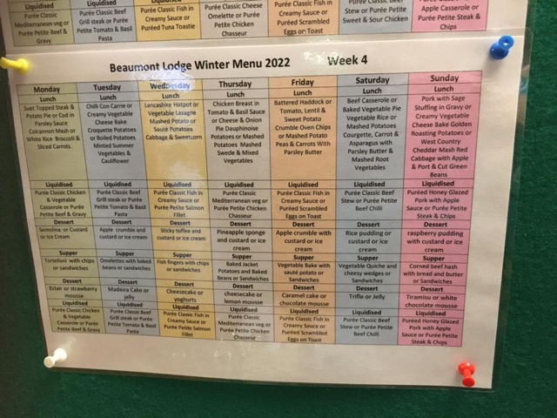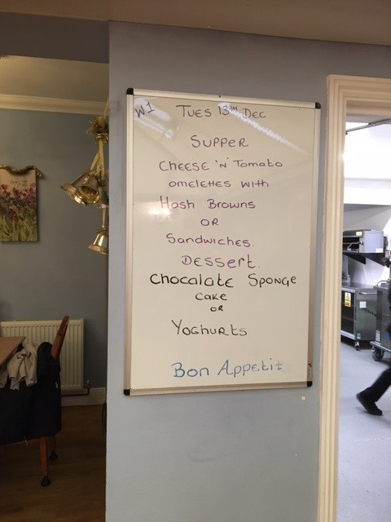

3.4 Activities
We saw evidence of activities - including a notice board which displayed the activity plan. While we were in the home, a Christmas quiz was being played (via the TV). Later, during our visit we saw entertainers performing a pantomime.
Residents we spoke to were clear that they could choose whether they wanted to participate in activities, and that their needs were catered for, they all appeared to be content with what was offered.
Residents told us about the different activities they take part in:

One resident told us:
“I like knitting, I make scarves for other residents and blankets for Cats Protection League.“

Another told us:
“I like a singsong, I’m nosey, I like to know what’s going on.”

Another resident told us:
“I don’t get involved so much, but I like to watch.”

Another said:
“I sit in the lounge and do any activities. I don’t like staying in my room much.”

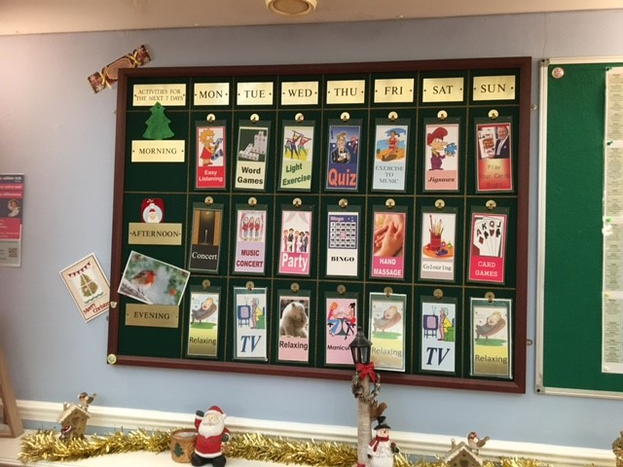

Some people told us that they prefer to stay in their rooms and don’t want to join in with the activities.

Another resident told us that sometimes she stays in her room and sometimes she goes downstairs:

“During the day I watch telly, I go downstairs. I don’t get involved in the activities expect the pub quiz. The staff are happy for me to stay in my room.”

We were told by a member of staff that they’d recently held activities to celebrate Nepal Day (many of the staff are Nepalese). We were told by a staff member that a singer, hairdresser and a fitness trainer visit regularly.

The registered manager told us that it is too risky to take residents out on trips. However, they can take all the residents into the garden at the back of the property.

3.5 Care
Overall, we heard that residents and family members were happy with the care received at Beaumont Lodge.
We spoke to two residents who preferred to stay in their rooms.

One resident told us:
“Daytime care is very good. If they come in to do anything, they tell you what they are going to do, so you’ve got a choice and you can say no.”

Another resident said:
“I have a buzzer if I need it, or I shout. The response is quick enough.”

They both said there was no difference with weekend or night-time care.

Residents who we spoke to in the lounge agreed that care is very good.
One resident told us:
“Someone’s always here during the day. At night-time, if I ring the bell, there’s a quick response. Weekends is no different to weekdays.”
Another resident said:
“I’m well looked after; the nurses go past and pop their head through the door.”

Most residents or family members told us that they weren’t aware of having a named senior carer.
“I don’t have a named senior carer; they all look after me.”

This is in line with what the registered manager told us – the staff work in teams; each section of the home has one senior carer and one junior carer. On average there are five residents to one carer (depending on need).

A resident told us:
“I have a folder and they write in that every day”.

A family member told us:
“The staff are very friendly, helpful, and caring. They are always cheerful, and nothing is too much trouble.“

A member of staff told us:
“We observe the residents. We tell the nurse if we think the resident’s mobility has worsened, if they are not eating or if they have difficulty swallowing If there are any behaviour changes, we report to the nurse.”

We were told that any medical updates are given to the residents’ families by the nurse.

Personalised care plans
We saw a member of staff from head office uploading residents’ care plans to a new care home record keeping system.
From January, each carer will have a device to update a resident’s record, which family members will be able to access.

3.6 Staff feedback
We spoke to six members of staff, the registered manager, the activities coordinator and four carers.

The registered manager told us that she had been in post for a year, she told us that they don’t use agency staff. She told us that some staff members have worked there for fourteen years, and the clinical manager as worked there eighteen years. We met the activities coordinator who told us she had worked there twenty-two years.

The registered manager told us that she is part of Surrey Care Association, and networks with other local care home managers.

There was very positive feedback from the staff, some had worked there for many years, but we also spoke to some staff who were employed relatively recently.
One carer said:
“It feels like home.”

There was a clear delineation of roles and responsibilities. Carers were very clear that they would refer medical issues to nurses, and that they update families from the care side, whereas nurses update on the nursing side.

It appeared that there was a good team ethic, with staff willing to cover shifts.

I work weekdays but I’m willing to help out if needed. Teamwork is very good”.

Another staff member told us:
“I like to come in, even when I’m not on shift. I am always thinking about the residents.”

Staff (carers and the activity coordinator) told us that they help residents to stay in touch with family members, and they will sometimes escort residents to hospital appointments.
They told us that if a resident’s needs change, they will update their personalised care plan and check with the nurse in charge.

In terms of feedback, they were open to hearing from residents:

“If a resident isn’t happy, tell me, staff are like a family, if I’ve made a mistake, tell me.”

If a resident had a problem, care staff would escalate to the nursing team or the manager, if they can’t fix the issue themselves.

3.7 Visiting health care professionals
We were told by the registered manager that there is a monthly cycle of GP visits, most residents are patients of Camberley Health Centre. On week 1 & 2, the GP visits, week 3 is a virtual visit, and there are no visits on week 4. The care home sends a list of residents who need to be seen in advance to the surgery. Between visits the nurse will call the GP if a resident needs them.

We were told that physios visit, some are private, and some are from the hospital.
We were told that the dentist visits when required, and is booked by the nurse. Similarly, other healthcare professionals such as podiatrist and speech and language therapists and mental health professionals visit when required.

3.8 Visiting
Visiting seems to be working well, with access at pre-covid levels.

One resident told us
“My family can come to visit whenever they want to.”

Family members all told us that they were happy with visiting arrangements.

"There are no problems, I am always welcome.”

And another said,
“I am happy with the visiting arrangements there are no restrictions.”

3.9 Staying in touch
It was clear from speaking to both residents and staff that residents were able to stay in touch with their families; some could make their own calls, and others had help from staff members.
One resident told us:
“My family visit and I can stay in touch by phone, I ask for help from the carers. My son video calls me in my room.”

All the carers we spoke to said they helped residents with phone calls or video calls. The activities coordinator told us she helped residents write letters to family who live overseas.

Residents told us that staff stay in touch with family members and they let them know when they’ve spoken to them.
We heard that families often ask to speak to the activities coordinator for updates about their family member.
The activities coordinator told us
“During covid we would contact residents’ families every day.”

3.10 Feedback mechanisms
There appears to be good communication between residents, their families, staff and the manager.
The complaints procedure was clearly displayed in several locations.

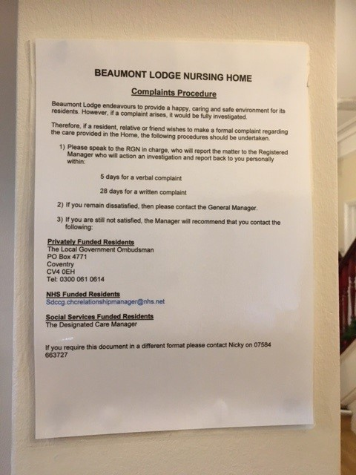

All residents and family members who we heard from said that if they raised a concern, it would be acted upon, and that they knew what to do if they had an issue.

One resident told us:
“I complained that they were getting me up too late, and staff brought it earlier.”
Several residents told us that if they had a problem, they’d raise it with the activities coordinator, who clearly has a good rapport with many of the residents.
“I’d speak to [named activities coordinator]. If nothing improves, she would go to the manager.”

Another resident told us:
“If I’m not happy, I’d complain, to [named activities coordinator] or the manager.”
Another said “If I had a problem I’d tell [named activities coordinator].

N.B. the activities coordinator was present during all of these interviews, so perhaps the residents refer to her as she was ‘top of mind’.

Residents clearly feel very comfortable with sharing any issues with the activities coordinator. However we would recommend that residents are reminded of the formal complaints process, and alternative pathways to escalate problems. We are concerned that there is an over reliance on the activities coordinator.

All staff we spoke to had a good understanding of the need to manage complaints and concerns – they would try to resolve minor issues themselves and would escalate more significant concerns to the nurses or the manager.

A resident told us:
“If I wasn’t happy, I’d speak to a nurse. I haven’t needed to raise a concern but I’m sure they’d listen.”

A family member fed back:
“I am confident in how to escalate a problem if I’m not happy. The manager is very approachable and any concerns are dealt with quickly. I have raised a concern and I was very happy with the process. “

One staff member said:
“If there was a problem with a resident, the resident will inform the manager or the nurse in charge”.

Recommendation:
- Remind residents of the complaints procedure. There could be a risk of over-reliance on the activities coordinator to escalate issues.

4. Next steps
This report and the response from the service provider will be shared with commissioners and regulators of the service and will be published on our website.

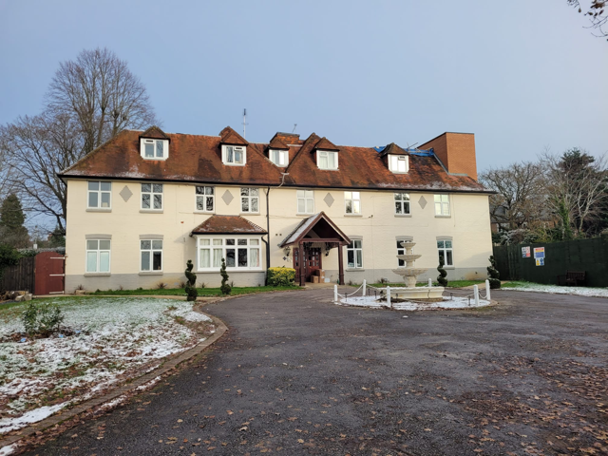

5. Service provider response

Service Name: | Beaumont Lodge
Service Manager: | Emma Golby
Visit date: | 13th December 2022
Factual accuracy
If you have any concerns about the factual accuracy of the report, please clearly identify the sections, content and corrections that are required in the space below:
The amendments have been made within the body of the report.
Organisation response to the report
Please provide your response here. This will be included in the final report.
(This response will be published in full)
What we found:
As at 22.2.23 no response received.
Respondent Name:
Respondent Job Title:
Feedback on the visit
If would like to provide some feedback to Healthwatch Surrey on the visit itself, please provide this in the space below:
Responses must be provided within 10 working days of receipt of our report to ensure it is included in the final published report.

6. Appendix

6.2 What is Enter & View?
Part of the local Healthwatch programme is to carry out Enter and View visits. Local Healthwatch representatives carry out these visits to health and social care services to find out how they are being run and make recommendations where there are areas for improvement. The Health and Social Care Act allows local Healthwatch Authorised Representatives to observe service delivery and talk to service users, their families and carers on premises such as hospitals, residential homes, GP practices, dental surgeries, optometrists and pharmacies. Enter and View visits can happen if people tell us there is a problem with a service but, equally, they can occur when services have a good reputation – so we can learn about and share examples of what they do well from the perspective of people who experience the service firsthand. All our Authorised Representatives have a current DBS check in place.

Healthwatch Enter and View visits are not intended to specifically identify safeguarding issues. However, if safeguarding concerns arise during a visit, they are reported in accordance with Healthwatch safeguarding policies. If at any time an Authorised Representative observes anything that they feel uncomfortable about they need to inform their lead who will inform the service manager, ending the visit.

In addition, if any member of staff wishes to raise a safeguarding issue about their employer, they will be directed to the CQC where they are protected by legislation if they raise a concern.

6.2 Purpose of Visit
The purpose of the visit was to listen to the views and experiences of people who live and work within the home.

6.3 Strategic drivers
Our Enter and View programme is one of our strategic priorities for 2022/2023, enabling us to hear the voices of seldom heard groups; on this occasion- care home residents.

6.4 What we did
The visit to Beaumont Lodge was an announced visit. Before the visit we gave the care home posters to display around the home to make staff, residents and their families aware of our visit. This poster included a QR code which links to our feedback form on our website. We saw the posters displayed when we visited. We also sent the home some paper questionnaires and pre paid envelopes to share with friends and family.

We spoke to seven residents, six members of staff, and three family and friends’ paper questionnaires were returned by post.

Three Authorised Representatives (ARs) of Healthwatch Surrey conducted the visit.

On arrival we were greeted by the registered manager. We explained what we would like to do. One member of our team was given a tour by the registered manager and spoke to one resident in their bedroom. The door was open, and the registered manager was outside. The AR was then seated in the visitors room and staff members were brought in to give their feedback. Two ARs were shown into the lounge to speak to residents who were there. The activities coordinator indicated which residents would have the capacity to talk to us and remained with us during the interviews. We were allowed to take photographs. All the questions we asked were answered openly. We observed the surroundings to gain an understanding of how the home works and how the residents engaged with staff members and the facilities, these findings were recorded on observation sheets. We used a semi-structured questionnaire when talking to residents, family members and staff.

We explained to residents, their family members and staff that we were from Healthwatch Surrey and that we were gathering experiences of what it’s like to live at Beaumont Lodge, and particularly to find out whether they would know what to do if they wanted to give feedback about the service.

Healthwatch Surrey – Contact us

Website: www.healthwatchsurrey.co.uk
Phone: 0303 303 0023
Text/SMS: 07592 787533
Email: enquiries@healthwatchsurrey.co.uk
Address: Freepost RSYX-ETRE-CXBY, Healthwatch Surrey, Astolat,
Coniers Way, Burpham, Guildford, Surrey,GU4 7HL

@HW_Surrey
@healthwatch_surrey
/healthwatchsurrey
Healthwatch Surrey

