Insight Bulletin

  - January 2023

About Healthwatch Surrey
One of the statutory duties of Healthwatch Surrey is to share residents’ experiences of health and social care with the people and organisations who make decisions about those services.

This bulletin highlights a selection of the themes we’ve heard about recently.

Praise and thanks
We frequently hear from people who are very happy with the care and support they have received.

I had a stroke 5 weeks ago. The care has been excellent. I’m back here today for my follow up checks up. I feel like I’m getting a complete MOT. The after care at the hospital is excellent. I also had occupational therapy at home after my stroke but I’ve been discharged from that now as my hand is getting much better.
Community Engagement, Hospital

My dad had pre-op assessment for cataract surgery on 11th August and we were told that he would hear about a date for surgery … within a couple of weeks. After a month I started chasing. … No one phoned me back. I sent an email to PALS team on 12th Sept and within 2 hours I had a phone call back from Ophthalmology office and surgery date was booked for 13th Oct. Very helpful person on phone, said my dad was well down the list and they hadn’t realised the impact on his quality of life until my email to PALS. Very impressed with PALS action and I sent them an email to thank them.
Shared with us via our website

I’ve recently moved into the area, I’ve moved in with my partner, she is deaf and I’m a part time carer for her, I very often have to call up on her behalf or take calls for her. I registered at her GP surgery, it was easy and straight forward. I registered online and didn’t have to go in. They have transferred all my medication over and I’m getting meds from a tiny place called the xxx pharmacy, they are really good.
Community Engagement, Community Fridge

I keep an eye on Mum now, I guess you could say I’m her carer. She has had amazing care from her GP surgery. She was able to see her GP, I went with her to her appointment where Mum was referred to hospital for a heart monitor. At hospital Mum had good care, they fitted the heart monitor, reviewed results and spoke to her about it - it was all very quick, all within a week or so.
Community Engagement, Community Fridge

Children's services have been so lovely - [My daughter] has been in and out of hospital over the past 2 years and her paediatric consultant has been great. My younger daughter was born 16 months ago at the same hospital and neither of us would be here without the maternity team. They saved both of our lives.
Community Engagement, GP surgery

Barriers to GP access

We continue to hear from people whose communication needs are not being met when trying to book a GP appointment. The variety of experiences we hear highlights the need for surgeries to offer a range of contact options – email, phone, face to face – to meet different patient access needs, and for special arrangements to be made for some patients.

Whenever we try and ring to make an appointment we are told to make an appointment online, but we do not have access to online.
Experience leaflet returned to Healthwatch Surrey

The only way I can get an appointment is to phone and you can't go into the surgery or email etc. I sometimes spend half an hour on the phone to try and get an appointment. This is all well and good but I'm on a pay as you go phone and I don't have a landline. The wait uses up all my credit for the month and I can't afford to buy more. I am very good at budgeting.
Email to Healthwatch Surrey

Whenever we ring they do not give an appointment over the phone and we are always told to book online. The patient is not fluent in English and is currently unable to book an appointment over the phone.
Experience leaflet returned to Healthwatch Surrey

Went in [to GP] and asked at reception for an appointment regarding my hearing aids they couldn't make the appointment and said I had to go home and phone in.
Community Engagement, Community Café

Anxiety, distress and mistrust – the impact of not communicating with compassion
Compassion is one of the six NHS values. While we do hear from people who have been treated with compassion, sadly we also hear of occasions where staff have been judgemental, uncaring and have lacked empathy:

[Patient referred to hospital for tests] No-one there explained what the tests were for or followed up afterwards to make she understood what was happening. She said that she felt like a test object as all they did was take the blood and do the tests but not talk to her. She felt very alone…. She has mental health issues and this all made her more anxious, the not knowing or being reassured. She had a colonoscopy and again, no-one explained the procedure or followed up. … she didn't see or talk to a doctor or a consultant all that time. She found this really difficult due to her mental health and it added to her anxiety….At one stage she was talking about her last wishes and funeral arrangements. This was so upsetting.
Community Engagement, Nursery School

As a first time mum I didn’t find my midwife great, I didn’t feel heard by her and wasn’t keen on the way she delivered news to me, she tended to give me the worst case scenario each time and that gave me anxiety. The midwife I had also commented every time I came to the appointment on how ‘massive’ I was, it turned out later in the pregnancy that this was undiagnosed excess amniotic fluid. … I had stated on my birthing plan no pethidine and I mentioned I was doing hypnobirthing, the midwife was dismissive of me, she said ‘we’ll see when the contractions come’ it felt condescending. With the no pethidine it was because I have had funny reactions to medicines.
Community Engagement, Church Group

My husband had 8 falls in 7 days… I called an ambulance the last time. They took him to A&E at St Peters and he then fell there. It took 5 members of staff to get him up and they used a hoist…
He was then taken to the assessment centre. The doctor there was so angry with me. He made me cry. He told me that my husband shouldn't be in hospital. He was so horrible to me. He said that my husband is medically fit but he isn't.
Community Engagement, Carers Hub

…each of [social care assessors] have an assumption about us as a family based on their own biases and prejudices. One wrote that I live on a private estate - what's that got to do with the care and support that my child needs?
Community Engagement, LD parent/carer group

The impact of the wider determinants of health
In our visits to community organisations who support families we’ve heard the impact that living conditions and rising costs have on people’s health:

There is mould in the kids’ bedrooms and in my bedroom. It is cold but I am having to leave the windows open to get some air in the room. My 5-year-old has a cough and struggles with his breathing. I have a cough too. I have complained to [the social housing company] but nothing. I have to change the sheets a lot as they are damp and mouldy. It’s horrible. The children are squeezed into a room and are sleeping on mattresses on the floor pushed up right against the walls. It's not nice for them. …. It’s very hard when you have six children.
Community Engagement, Homestart

[person being cared for] had a series of strokes and can’t walk, can’t see well. He used to have carers but has stopped them as he couldn’t afford them. …I do everything for him… I’m 78 now though and there are times I just can’t do it. We are waiting to hear back from Adult Social Services about getting him carers again. Our case is with the finance team and we are waiting to hear back from them.
Community Engagement, Carers Group

My 12-year-old needs a blood test. The GP told him to have one, but they won’t do the blood test at the surgery. They won’t do it at St Peters hospital as he’s under 18. I have to drive him to Ashford Hospital. This will use up all of my petrol for the week, I just can’t afford it but I have to.
…I live with a controlling husband. I can’t leave as I have nowhere to go and I have no money. I have two children. I can’t afford anything…
Community Engagement, Homestart

On a national level, Healthwatch England have published results of a poll showing that people are increasingly avoiding NHS appointments and prescriptions due to spiralling costs of living.

Gathering and sharing our insight

Who have we shared our insight with?
If we hear a case of concern regarding patient safety, we immediately signpost the sharer to the appropriate body and escalate the case with the provider/commissioner.

This month we have shared our insight with:
- Surrey Heartlands Quality, Performance and Assurance Committee
- Frimley Quality Collaborative
- Surrey Heartlands Access Meeting (also shared with Joint Intelligence Group)
- Surrey and Borders Partnership NHS Foundation Trust
- Ashford and St Peter’s Hospitals PMEG
- Healthwatch England

We have also been represented at the following places to provide a perspective on services:
- Surrey Heartlands PCCC
- Frimley PCCC
- Multi Professional Reference Group for recommissioning of Children’s Community Services
- Health and Social Care Committee Inquiry into NHS Dentistry
- LD Partnership Board

Who are we hearing from?
Our spotlight for engagement sessions in January was East Surrey and we will be in North West Surrey in February.

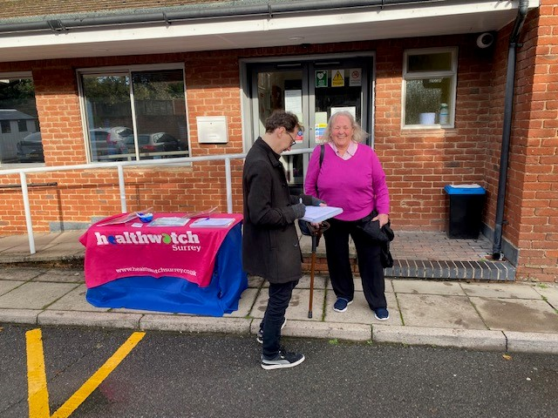

Date | Place | Time
01.02.23 | Hythe Baby Bubble Group, Runnymede Family Centre | 10.30 – 12.00
06.02.23 | Ashford Hospital (Outpatients) | 10.00 – 12.00
07.02.23 | Lighthouse, Ukrainian Hub, Woking | 11.00 – 13.00
20.02.23 | Holy Trinity Community Fridge, Knaphill, Woking | 9.30 – 11.30
23.02.23 | White Gates Care Home, Laleham  (Enter and View)  Group members or residents only | 10.45 – 13.00
28.02.23 | Woking Sexual Health Clinic, Woking Community Hospital | 10.00 – 12.00
TBC | Spelthorne Youth Café | 10.00 – 12.00

Please note: these dates may be subject to change.
To share an experience with us, people can also contact us in the following ways:
Phone our helpdesk: 0303 303 0023
Send an SMS to our helpdesk: 07592 787 533
Email: enquiries@healthwatchsurrey.co.uk
Share your feedback via our website: https://www.healthwatchsurrey.co.uk/feedback-centre/

Friends and Family Care Home Survey

Please share our survey for friends and family of those living in care homes. The survey can be accessed via this QR code or found on our website - Friends and family care home survey - Healthwatch Surrey.

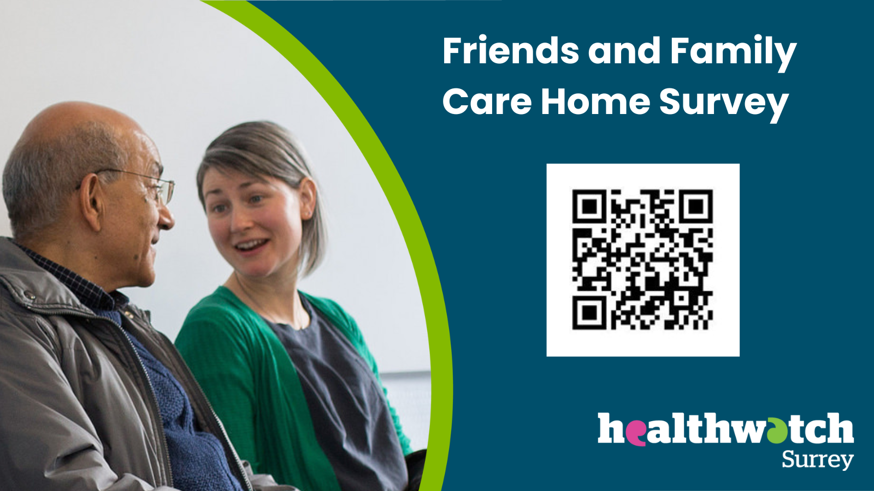

Our distribution list

If you would like to be added to or removed from the distribution list for this Insight Bulletin, please contact our Communications and Involvement Officer vicky.rushworth@healthwatchsurrey.co.uk

If you would like a paper copy of this document or require it in an alternative format, please get in touch with us.

